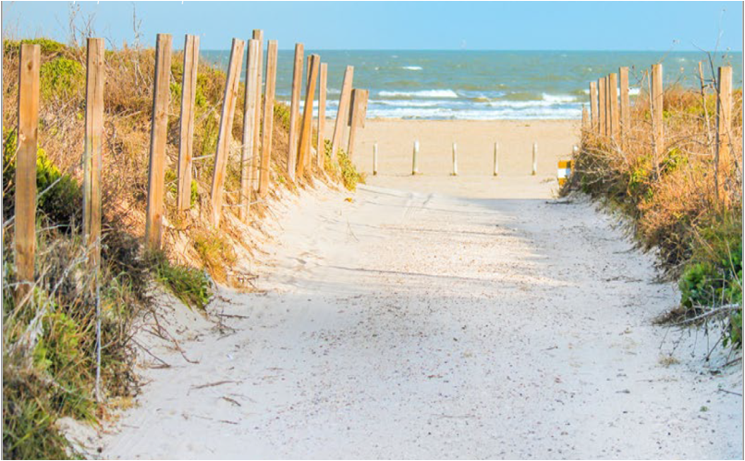
Coastal Management Program Assessment and Strategy
2026 to 2030


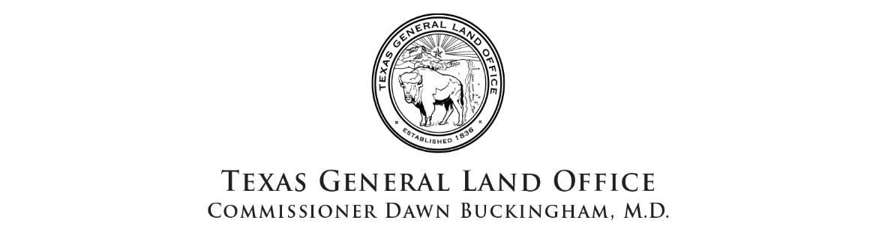

Table of Contents
Table of Contents 2
List of Figures 4
List of Tables 5
List of Acronyms 6
Introduction 8
Executive Summary 9
Summary of Recent Section 309 Achievements 12
Program Updates on the 2020 – 2025 309 Strategies: 12
Development of the Texas Sediment Management Plan 12
Regional General Permit (RGP) for Beach Nourishment 13
Phase I Assessment 14
Wetlands 15
Resource Characterization 15
Management Characterization 18
Enhancement Area Prioritization 22
Coastal Hazards 23
Resource Characterization 23
Management Characterization 34
Enhancement Area Prioritization 37
Public Access 38
Resource Characterization 38
Enhancement Area Prioritization 42
Marine Debris 43
Resource Characterization 43
Management Characterization 49
Enhancement Area Prioritization 49
Cumulative and Secondary Impacts 51
Resource Characterization 51
Management Characterization 59
Enhancement Area Prioritization 61
Special Area Management Planning 62
Resource Characterization 62
Management Characterization 62
Enhancement Area Prioritization 63
Ocean Resources 64
Resource Characterization 64
Management Characterization 68
Enhancement Area Prioritization 69
Energy and Government Facility Siting 71
Resource Characterization 71
Management Characterization 80
Enhancement Area Prioritization 81
Aquaculture 82
Resource Characterization 82
Management Characterization 83
Enhancement Area Prioritization 84
Phase II Assessment 85
Wetlands 85
In-Depth Resource Characterization 85
Relative Sea Level Rise 87
Drought 89
Fresh Water Inflow Standards 90
In-Depth Management Characterization 91
Wetland Assessment and Mapping 91
Watershed or Special Area Management 92
Wetland Technical Assistance, Education, and Outreach 92
Wetland Protection and Restoration 93
Identification of Priorities: 94
Enhancement Area Strategy Development 95
Coastal Hazards 96
In-Depth Resource Characterization 96
Coastal Storms 96
Flooding 98
Erosion 98
Coastal NPS Pollution 99
In-Depth Management Characterization 99
Management Planning Programs or Initiatives 102
Research, Mapping, and Education Programs or Initiatives 102
Identification of Priorities 106
Enhancement Area Strategy Development: 107
Texas Coastwide Reference Monitoring System (T-CRMS) 109
5-Year Budget Summary by Strategy 115
Summary of Stakeholder and Public Comment 115
References 116

List of Figures

Figure 1. Coastal Hazard Mitigation Plans by Region (Peacock et al. 2009). 24
Figure 2. This map was obtained from the Texas Hazard Mitigation plan (2023) and features the historical severe coastal flooding (left) and losses (right) by county. 25
Figure 3. Hurricane Risk Areas for Texas Coastal Counties (Texas Hazard Mitigation Plan, 2000-2021). 26
Figure 4. 2023 United States National Seismic Hazard Map (Image from USGS), This hazard map is a simplified 2% in 50-year probability of exceedance map for fixed VS30 760 m/s. 27
Figure 5. Imagery of Rollover Pass in Bolivar Peninsula Pre-Ike 2008 (top left), post Ike 2008 (top right), and the recovering shoreline in 2009. Images obtained from Texas Geographic Information System (TxGIO), formally Texas Natural Resource Information System. 28
Figure 6. Long-term shoreline changes (1930s to 2019) of the Texas Gulf coast from research by the University of Texas Bureau of Economic Geology (Paine and Caudle, 2021). Eroding areas are shown in orange to red tones. 29
Figure 7. This map shows historical sea-level rise trends as published by NOAA (http://tidesandcurrents.noaa.gov/sltrends/) and historical shoreline change rates as calculated by the BEG (http://www.beg.utexas.edu/coastal/morphodynamics.php). Larger arrows signify negative or landward movement of the shoreline. 30
Figure 8. Distribution of Na/Cl molar ratio in the Gulf Coast aquifer of Texas (Chrowdhury et al., 2006). Na/Cl ratios of saltwater intrusion are usually lower than the marine values (~0.86 molar ratio) and high molar ratios (>1) typically characterize anthropogenic sources (Baer, 1999). Saltwater intrusion is documented for the Texas coast but, its occurrence is not likely to cause significant injury or loss to facilities or infrastructure and is found to be a medium risk hazard 31
Figure 9. The map was obtained from the Texas Hazard Mitigation Plan (2023) and features counties at greatest tornado risk (2000-2021). Most of the Texas coastal counties lie within medium - high range of tornado activity. 32
Figure 10. The map was obtained from the Texas Hazard Mitigation Plan (2023) and features historic losses (2000-2021 by counties from tornado and severe storms. 33
Figure 11. Secretarial Drought Designation Map. 34
Figure 12. This map shows the locations of the remaining 188 derelict vessels in the coastal environment that the GLO, Oil Spill Prevention and Response Division has documented. 48
Figure 13. Housing density maps, showing a visual increase in population density from the years 1970, 2000, and 2030. Source: Landscope America Atlas, 2014 (NatureServe). 52
Figure 14. New Residential Housing Units in Texas Counties, 2021. Texas Demographic Center. 53
Figure 15. Texas Priority Conservation Areas, Environmentally Sensitive Shoreline, and Ecologically Unique Rivers. Source: Landscope America Atlas, 2014 (NatureServe), defined by The Nature Conservancy. 54
Figure 16. Texas Species Critical Habitat along the Texas coastal shore. Source: Landscope America Atlas, 2014 (NatureServe). Texas General Land Office created the Texas Gulf Coast Species / Habitat layer in 1995. 54
Figure 17. Texas Wind Turbines (FAA). Source: Landscope America Atlas, 2014 (NatureServe). The Federal Aviation Administration (FAA) created the Texas Windmills layer, Updated March 2012. 55
Figure 18. Texas Municipal Solid Waste Sites and Landfills. Landscope America Atlas, 2014 (NatureServe). The Texas Commission on Environmental Quality (TCEQ) created the Municipal Solid Waste Sites and Landfills Layer in April 2007. 56
Figure 19. 100-year floodplain. Source: Texas Coastal Community Planning Atlas, 2014. 56
Figure 20. Location of Section 404 wetland permits, designated by the U.S. Army Corps of Engineers jurisdiction, indicating permits for development in the Coastal Boundary Zone, 2021-2023. 57
Figure 21. Real-Time Transmission Congestion Costs. From ERCOT 2023. 73
Figure 22. Texas Sea Ports. Source: txdot.gov. 74
Figure 23. The geologic trends of potential geothermal reservoirs in the Gulf Coast, Texas (Esposito and Augustin, 2012). 79
Figure 24.Texas Demographic Center (2022). Projections of the Total Population of Texas and Counties in Texas, 2020-2060 (0.5 Migration Scenario). 86
Figure 25. Heat map showing net loss (orange) and gain (blue) of various wetland classes between 1996-2010 in the upper Texas coast including coastal counties of Brazoria, Harris, Galveston, and Chambers. Image from (Geotechnology Research Institute, 2014). 87
Figure 26.The relative sea level trend is 6.6 millimeters/year with a 95% confidence 88
Figure 27. The relative sea level trend is 4.21 millimeters/year with a 95% confidence 89
Figure 28. The relative sea level trend is 6.05 millimeters/year with a 95% confidence 89
Figure 29. The U.S. Drought Monitor (2000–present) depicts the location and intensity of drought across the country. Authors from NOAA, USDA, and the National Drought Mitigation Center produce a new map based on their assessments of the best available data and input from local observers. 90
Figure 30. Estimated return period in years for hurricanes passing within 30 nautical miles of various locations on the U.S. Coast. Image from Blake and Gibley (2011). 97
Figure 31. Estimated return period in years for major hurricanes passing within 50 nautical miles of various locations on the U.S. Coast. Image from Blake and Gibley (2011). 97
Figure 32. Screen view of the Coastal Communities Planning Atlas featuring FEMA 100 yr flood risk zones (purple) and hurricane risk zones (category 2). 103

List of Tables

Table 1. Prioritization of enhancement areas. 9
Table 2. Summary of Disaster Declaration for Texas Coastal Counties 2019-2024. Note that a single disaster could have resulted in declarations from multiple counties. Data from FEMA. 25
Table 3. Summary for severe coastal flooding events in the state of Texas, 2000-2021. 26
Table 4. GLO Debris Removal Results 2020 - 2025 46
Table 5. Texas Adopt-A-Beach Program beach clean-up results, 2020 –2024. 46
Table 6. Texas Adopt-A-Beach Program trash data, 2020 – 2023. 46
Table 7. Annual Crab Trap Removal Program results: 2015 – 2023. 48
Table 8. RSLR rates reported from NOAA Sea Level Rise Trends for Galveston Bay, Freeport, and Rockport Tide gauges. 88

List of Acronyms

ADA – Americans with Disabilities Act
BOEM – Bureau of Ocean Energy Management
BRD – Bycatch reduction devices
BUDM – Beneficial Use of Dredged Material
BSEE – Bureau of Safety and Environmental Enforcement
C-CAP – Coastal Change Analysis Program
CCT – Clean Coast Texas
CDR – Community Development and Revitalization
CEPRA – Coastal Erosion Planning and Response Act
CFR – Code of Federal Regulations
CMP – Texas Coastal Management Program
COM – Cultivated Oyster Mariculture
CRMS – Coastwide Reference Monitoring System
CWA – Federal Clean Water Act
CZM – Coastal Zone Management
CZMA – Coastal Zone Management Act
DEIS – Draft Environmental Impact Statement
DWP - Deepwater Port
ENOW – Economic: National Ocean Watch
EPA – Environmental Protection Agency
ERCOT – Electric Reliability Council of Texas
FEIS – Final Environmental Impact Statement
FEMA – Federal Emergency Management Agency
FERC – Federal Energy Regulatory Commission
GBF – Galveston Bay Foundation
GIS – Geographic Information Systems
GLO – Texas General Land Office
GOMESA – Gulf of Mexico Energy Security Act
HRI – Harte Research Institute
KAST – Kills and Spills Team
LNG – Liquid Nitrogen Gas
NFWF – National Fish and Wildlife Foundation
NMFS – National Marine Fisheries Service
NOAA – National Oceanic and Atmospheric Administration
NRDA – Natural Resource Damage Assessment
NPS – Non-point source pollution
OBA - Texas Open Beaches Act
OCM – Office for Coastal Management
OCS – Outer Continental Shelf
OSSF – Onsite Sewage Facilities
RESTORE – Resources and Ecosystems Sustainability, Tourist Opportunities, and Revived Economies of the Gulf Coast States Acts
RGP – Regional General Permit
RSLR – Relative Sea Level Rise
SAMP – Special Area Management Plan
SMP – Sediment Management Plan
SQ. MI. – Square miles
SSRA – Significate Sediment Resource Area
TAC – Technical Advisory Committee
TCEQ – Texas Commission on Environmental Quality
TCRMP – Texas Coastal Resiliency Master Plan
T-CRMS – Texas Coastwide Reference Monitoring System
TPWD – Texas Parks and Wildlife Department
TSSWCB – Texas State Soil and Water Conservation Board
TWDB – Texas Water Development Board
USACE – U.S. Army Corps of Engineers
USDA – U.S. Department of Agriculture
USFWS – U.S. Fish and Wildlife Service
USGS – U.S. Geological Survey
WOTUS – Waters of the United States

Introduction

The Coastal Zone Management Act (CZMA) of 1972 established the National Coastal Zone Management (CZM) program to preserve, protect, restore and enhance the nation’s coastal resources. The CZM program, administered by the National Oceanic and Atmospheric Administration (NOAA), is a voluntary federal-state partnership that provides the basis for protecting, restoring and responsibly managing the nation’s diverse coastal resources. To address the need for a comprehensive approach to the management of coastal natural resources in Texas, the Texas Coastal Management Program (CMP) was developed. The Texas CMP was accepted into the national CZM program in 1997, after the Texas Legislature passed the Coastal Coordination Act in 1991. The Texas General Land Office (GLO) administers the CMP, which is a networked program of the state natural resource agencies. The mission of the CMP is to improve management of the state's coastal natural resource areas and ensure the long-term ecological and economic productivity of the coast.

Section 309 of the CZMA, as amended in 1990 and 1996, establishes a voluntary grants program to encourage states with federally approved CMPs to conduct a self-assessment to identify, develop and implement strategies to strengthen and enhance their programs in nine areas. These enhancement areas include: 1) wetlands, 2) coastal hazards, 3) public access, 4) marine debris, 5) cumulative and secondary impacts, 6) special area management plans, 7) ocean resources, 8) energy and government facility siting, and 9) aquaculture. As a condition of receiving 309 CMP grant funding, the CMP must submit a Section 309 Assessment and Strategy Report to NOAA every five years. The report provides an assessment of the CMP in the nine enhancement areas, identifies program priorities, and proposes strategies that lead to tangible program enhancements for the identified high priority areas over the subsequent five years. The 309 Assessment & Strategy process provides an opportunity for the Texas CMP, with input from key stakeholders and the public, to determine where strategic opportunities exist for enhancing the CMP in identified high priority enhancement areas.

The Section 309 Assessment process is broken down into a high-level Phase I assessment performed for all nine enhancement areas, and an in-depth Phase II assessment and strategy development performed for high priority areas identified through the Phase I process.

The Phase I (High-Level) Assessment of the CMP evaluated the nine enhancement areas, using key stakeholder input and analysis of available data, to rank the enhancement areas as a high, medium, or low priority for Texas’ program. The Phase I Assessment (1) determined the extent to which problems and opportunities for program enhancement exist within each of the enhancement area objectives; (2) determined the effectiveness of existing management efforts to address identified problems; and (3) identified high priority needs for program enhancement in coordination with the Office for Coastal Management (OCM), key stakeholders and the GLO. For enhancement areas ranked medium or low, no further assessment was required. For enhancement areas ranked as high priority, a second Phase II (In-Depth) Assessment was completed, followed by strategy development for those areas.

The Phase II (In-Depth) Assessment and Strategies development explored potential problems, opportunities for improvement, and specific needs of high priority enhancement areas. The Phase II Assessment process is designed to lead to one or more programmatic change that address high priority needs, (as defined by the Code of Federal Regulation (CFR) 15 CFR 923.123a see “Eligible Activities” in Section 3).

Executive Summary
The Phase I (High-Level) Assessment included a characterization of the resources and changes since the 2021-2025 Assessment; a management characterization of current and recent changes of statutes, regulations, polices or case law as well as relevant programs; and a prioritization of high, medium, or low of the nine enhancement areas with an explanation for each prioritization. The table below summarizes the prioritization for all nine enhancement areas. Enhancement areas ranked as “High Priority” were further assessed during the Phase II Assessment process. Following the Phase II Assessment, strategies were developed to address high priority issues identified.

Table 1. Prioritization of enhancement areas.
Enhancement Area | Prioritization
Wetlands | High
Coastal Hazards | High
Public Access | Medium
Marine Debris | Medium
Cumulative & Secondary Impacts | Medium
Special Area Management Planning | N/A
Ocean Resources | Medium
Energy & Government Facilities | Medium
Aquaculture | Medium

Wetlands
Wetlands are coastal areas that are inundated or saturated in sufficient duration such that they support vegetation and life adapted for saturated soil conditions. Wetlands serve as valuable habitat and storm surge buffers, enhance water quality, supply food, and provide recreation and cultural value. This valuable habitat is disappearing at an increasing rate. Wetlands are negatively impacted by reduced water quality and quantity, increased contamination due to runoff, development, subsidence resulting from water withdrawal, and hydrologic changes. During the Technical Advisory Committee meetings for the Texas Coastal Resiliency Master Plan (TCRMP) in 2017, the issue most closely related to wetlands, Altered, Degraded, or Lost Habitat, scored the second highest out of all coastal issues polled, and stakeholder engagement resulted in a rating of 3/3, the highest of all enhancement areas reviewed. Given these findings, wetlands are assessed as a high priority enhancement area for the CMP. Therefore, a Phase II Assessment was conducted and strategies were developed to address identified priorities and needs.

Coastal Hazards
Texas is subject to significant coastal hazards that include flooding, coastal storms (and associated storm surge), shoreline erosion (including bluff and dune erosion), and drought. To a lesser extent, Texas is vulnerable to land subsidence, saltwater intrusion, tornadoes, and possible geological hazards (e.g., tsunamis, earthquakes). Coastal hazards are of particular concern due to Texas’ growing population, the importance of coastal economic activity, and the value of natural coastal ecosystems. Coastal hazards are assessed as a high priority enhancement area for the CMP and warrant resiliency planning and coastal hazard mitigation to protect and preserve the vitality of the Texas coast. Stakeholder engagement resulted in a rating of 2.88/3, earning a high ranking. A Phase II Assessment was conducted and strategies were developed to address identified priorities and needs.

Public Access
Public access considers increased opportunities for use of Texas beaches and shoreline, including recreational opportunities such as boat access sites, scenic area access, fishing access points, and coastal trails and boardwalks. Preserving public access to Gulf facing beaches is a priority in Texas and is codified in the Open Beaches Act. Public access is assessed as a medium priority enhancement area for the CMP, and stakeholder engagement resulted in a rating of 2.0/3 due to all the recent work undertaken by the GLO in previous 309 strategies; therefore, a Phase II Assessment was not necessary.

Marine Debris
Marine debris on the Texas coast originates from land-based and ocean-based sources. Marine debris is a significant issue worldwide, as well as in Texas. The Ocean Conservancy continues its efforts at the federal level to address this challenge, and at the state level, successful marine debris removal programs include the GLO’s Adopt-A-Beach Program and the Monofilament Recovery and Recycling Program, which is coordinated by Texas Sea Grant. While federal and state marine debris programs are effective, more education and outreach funding are needed to advance the discussion about the harmful and lasting effects of marine debris. Stakeholder engagement resulted in a rating of 2.71/3, ranking as medium, so a Phase II Assessment was not necessary.

Cumulative & Secondary Impacts
Cumulative and secondary impacts of coastal growth and development include the collective effect on various individual uses or activities on coastal resources, such as coastal wetlands and fishery resources. These impacts pose threats to ecosystem health and function, and the services they provide to human populations. Significant coastal population increases, with a similar rise in housing construction, have led to substantial land cover change, stressing already sensitive coastal environments. Despite all these stressors, the Texas CMP made significant strides towards tackling these issues in the last 309 Assessment with the success of its coastal non-point source pollution strategy. In addition to these successes, stakeholder engagement resulted in a rating of 2.66/3, giving this enhancement area a medium ranking. Therefore, a Phase II Assessment was not necessary.

Special Area Management Planning
The Texas Legislature amended the Coastal Coordination Act in 1995 to specifically prohibit the CMP from developing or approving a special area management plan, including a plan for an area designated under the national estuary program. This prohibition has not changed since 1995. A priority assessment for this enhancement area is not applicable in Texas, and a Phase II Assessment was not necessary.

Ocean Resources
Ocean resources, including fish and wildlife, commercial and recreational fishing, oil and gas exploration, shipping, and tourism have a high economic value and human demand; the livelihood of coastal populations depends on these resources. Oil production in Texas exploded in the last five years, with huge demands from oil companies to build export terminals and install thousands of miles of pipeline (see Energy and Government Facility Siting). This expected growth in the oil export industry will put enormous stress on ocean resources. Given this, ocean resources are designated as a high priority enhancement area for the Texas CMP because of the booming oil industry and the large amount of restoration expected to take place in the State over the next decade. Stakeholder engagement resulted in a rating of 2.60/3, giving this enhancement area a medium ranking. Therefore, a Phase II Assessment was not necessary.

Energy & Government Facility Siting
Energy and government facility siting encompasses energy transport (pipelines, electrical grid, ports, etc.), energy facilities (for oil and gas, natural gas, coal, nuclear, and renewable energy technologies), and government facilities. These facilities are of tremendous economic importance to the state and the nation. Technological advances and newly discovered and tapped resources enable continued growth in the energy sector. Energy and government facility siting received a stakeholder engagement rating of 2.4/3, a medium ranking, as the energy industry is currently addressing issues in these areas. Therefore, a Phase II Assessment was not necessary.

Aquaculture
With future population increases and demand for sustainable sources of protein, aquaculture will continue to grow in importance. Stakeholder engagement resulted in a rating of 2.60/3. However, there is concern about the ramifications of offshore aquaculture on ocean resources, making the enhancement area a medium priority, an increase since the last Section 309 assessment and strategy, so a Phase II Assessment was not necessary.

Proposed Strategy
The Texas CMP proposes a strategy to enhance and address the identified two high priority enhancement areas. This strategy will involve the development of guidelines for a Coastwide Reference Monitoring System (CRMS) for Texas.

Stakeholder and Public Comment
Input for review was requested through emails and a survey to CMP networked resource agencies, selected stakeholders, and coastal partners. Once the draft of this document is reviewed and approved by NOAA by July 11, 2025, it will be posted for a 30-day comment period, and the final document will address all comments received.

Conclusion
This assessment and prioritization of enhancement areas, coupled with the proposed strategies, derived through collaboration and input of coastal stakeholders, will address the most critical issues identified along the Texas coastal zone and strengthen the Texas CMP. Through Section 309 funding, the GLO will continue to further the commitment to protect, enhance and restore the state’s coastal natural resource areas. The GLO will also coordinate with applicable CMP networked agencies and coastal partners to procure and produce the proposed strategies in the most economical and efficient manner.

Summary of Recent Section 309 Achievements

Program Updates on the 2020 – 2025 309 Strategies:

Development of the Texas Sediment Management Plan
The GLO is creating the Texas Sediment Management Plan (SMP) to combat coastal erosion, with the ultimate goals of maintaining the important ecosystem services of coastal environments and enhancing resiliency of Texas coastal communities. The GLO plans to release new iterations of the SMP every four years to incorporate new data and policy directions.

The SMP’s main goals are to provide guidance on how to:
- Identify and develop sediment borrow areas.
- Efficiently permit and authorize sediment placement projects, including dredging of sediment borrow areas.
- Improve tools for the inventorying of sediment resources and project planning.
- Appropriately allocate sediment resources.
- Effectively monitor sediment resources, budgets, and transport.
- Develop or modify policy to protect access to and optimize the use of sediment resources.
- Define state priority areas to best focus limited financial and sediment resources.

Primary Goal | Primary Method
Identify and Develop sediment borrow areas | desktop studies, reconnaissance- and design-level geophysical and geotechnical surveys
Permit and Authorize sediment placement projects | obtain regional general permits and/or individual permits; agency coordination
Improve tools for sediment inventory and project planning | enhancements to the Texas Sediment Geodatabase and Coastal Resources Management Viewer
Allocate sediment resources | develop matrix to guide the pairing of borrow and placement areas
Monitor sediment resources, budgets, and transport | standardized protocols for routine, post-placement, and post-storm monitoring
Develop or Modify Policy for sediment resources | Intra- and inter- agency coordination; data sharing
Define state priority areas for sediment placement projects | develop prioritization model to define state priority project areas

Writing of the SMP document is currently underway, with an anticipated completion in late 2026. Ongoing project efforts that support the SMP development include: long-shore sediment transport studies; geophysical surveys to search for offshore sediment resources in both state and federal waters; data-driven, need-based prioritization of Texas’s bays and shorelines; coastwide investigation of barrier island breaching susceptibility; best practices in modeling sediment transport and budget along the Texas coast; sediment placement database/dashboard creation; and development of a sediment inventory of upland dredge material placement area resources.

Additionally, SMP development has resulted in a desktop study researching sediment impounded in reservoirs and resulted in GLO standing up a Reservoir Sediment Working group. Internally, the GLO is reviewing and considering agency rule changes to further protect sediment resources. Over the last five years, the GLO has stood-up multiple working groups to ensure comprehensive sediment management guidance for efficient and effective coastal resiliency efforts within Texas.

Regional General Permit (RGP) for Beach Nourishment

GLO staff applied for a RGP for beach nourishment to the U.S. Army Corps of Engineers (USACE) in December 2023. This RGP will only permit sediment placement (not borrow area excavation) at eligible areas that include all critically eroding areas with a public beach easement and without an existing individual permit for beach nourishment. The current, planned, limiting criteria listed in the draft RGP includes a coastwide maximum annual cumulative nourishment length of 18 miles and individual project maximum lengths of seven (7) miles for standard/maintenance nourishment and 10 miles for storm response nourishment (applicable with evidence of 50% beach template loss). In April 2024, the RGP application was deemed administratively complete and went into internal USACE review. The Public Notice was posted in June 2024 with public comments received in August 2024. The U.S. Fish and Wildlife Service (USFWS) requested a Section 7 Consultation in February 2025 and the GLO’s RGP team is working with USACE and the USFWS to complete reviews, comments, and final Biological Opinions. The GLO anticipates RGP approval by fall 2025.

Phase I Assessment

Wetlands

Section 309 Enhancement Objective: Protection, restoration, or enhancement of the existing coastal wetlands base, or creation of new coastal wetlands. §309(a)(1)

Note: For the purposes of the Wetlands Assessment, wetlands are “those areas that are inundated or saturated at a frequency and duration sufficient to support, and that under normal circumstances do support, a prevalence of vegetation typically adapted for life in saturated soil conditions.” [33 CFR 328.3(b)]. See also pg. 14 of the CZMA Performance Measurement Guidance for a more in-depth discussion of what should be considered a wetland.

Phase I (High-Level) Assessment: (Must be completed by all states.)
Purpose: To quickly determine whether the enhancement area is a high-priority enhancement objective for the CMP that warrants a more in-depth assessment. The more in-depth assessments of Phase II will help the CMP understand key problems and opportunities that exist for program enhancement and determine the effectiveness of existing management efforts to address those problems.

Resource Characterization
- Using the tables below as a guide, provide information on the status and trends of coastal wetlands. Be as quantitative as possible using state or national wetland trend data. The tables are information presentation suggestions. Feel free to adjust column and row headings to align with data and time frames available in your state or territory. If quantitative data is not available for your state or territory, provide a brief qualitative narrative describing wetlands status and trends and any significant changes since the last assessment.

2016 NOAA Land Cover Atlas data was used for publication of this report.

Current state of wetlands in 2024 (acres): ___3.8 million____________________

Coastal Wetlands Status and Trends
Change in Wetlands | 1996-2016 | 2011-2016
Percent net change in total wetlands (% gained or lost)* | -0.66 | -0.67
Percent net change in freshwater (palustrine wetlands) (% gained or lost)* | -0.98 | +1.37
Percent net change in saltwater (estuarine) wetlands (% gained or lost)* | -3.11 | -4.19

How Wetlands Are Changing
Land Cover Type | Area of Wetlands Transformed to Another Type of Land Cover between 1996-2011 (Sq. Mi.) | Area of Wetlands Transformed to Another Type of Land Cover between 2011-2016 (Sq. Mi.)
Development | -35.58 | -8.17
Agriculture | -9.01 | -1.83
Barren Land | -12.92 | 0
Water | -52.85 | -34.81

NOAA C-CAP Wetland Change Assessment
This wetland change assessment is largely based on the 1996-2011 and 2011-2016 NOAA Coastal Services Center County Landcover Change Reports produced by the Coastal Change Analysis Program (C-CAP). NOAA C-CAP reports were obtained for each of the 18 coastal counties and summary data was tabulated (see Appendices A and B). In Texas, wetlands account for a significant portion of the land area within the 18 coastal counties – covering 764.50 square miles (sq. mi.) (State of Texas Coastal Nonpoint Source Pollution Control Program, 2019). Wetlands serve as floral and faunal habitat, support biodiversity, provide ecosystem services (such as water quality enhancement, nursery and foraging resource, and storm surge buffers), function as recreational areas, and add cultural value to the coastal-living experience. In Texas coastal counties, a total of 110.16 sq. mi. of wetland were lost between 1996-2011 and 44.81 sq. mi. were lost between 2011-2016, per NOAA C-CAP. Observation of NOAA C-CAP wetland change data show that wetland loss varies by county and may be the result of loss to open water, which is most common in the southernmost counties, or loss to development, as is the case in the northeast Harris and Jefferson counties.

The southern-most Texas counties include Cameron, Willacy, Kenedy, and Kleberg counties. This region boasts extensive tidal flats that serve as critical environment for the endangered piping plover population, as well as a large amount of important estuarine habitat in the Laguna Madre and Bahia Grande wetland basins. While Kenedy and Kleberg counties have experienced minimal wetland loss, between 1996 – 2016 Willacy and Cameron counties, lost a total of 14.1 sq. mi, while Willacy lost 13.24 sq. mi., corresponding to unconsolidated shore converting to open water, associated with shoreline erosion.

The Central Texas region, counties of Nueces, San Patricio, Refugio, Aransas, Calhoun, Victoria and Jackson, contain numerous bays, including Corpus Christi, Aransas, and Copano bays, as well as barrier islands of North Padre Island and Mustang Island. Wetland environments in the region support diverse fish and wildlife, fishing, hunting, birding, and other recreational activities and are critical to the local economy as they are home to numerous wildlife management areas and migratory and recreational birds. The region experienced minimal wetland loss (Significant loss did occurr near the mouth of the Nueces River) mostly to unconsolidated shore and on portions of Mustang Island due to development. In Calhoun County, the most significant losses and gains occurred in the prairie pothole wetland area of the Ingleside strand plain and beach shoreline erosion on Matagorda Peninsula. In Victoria Country, most of the wetland losses are associated with wetland conversion to open water in Rupley Lake. Lastly, in Jackson County, 0.94 sq. mi were lost from 1996-2016.

The region of the upper Texas coast, including the counties of Matagorda, Brazoria, Galveston, Harris, Chambers, Jefferson, and Orange, collectively have experienced some of the largest wetland losses in the state. Erosion, subsidence, storm surge combined with insufficient freshwater inflows, heavy shipping traffic, and other industrial uses are causing rapid wetland loss. One notable difference in the upper Texas coast is that much of the wetland changes are due to development. In Galveston County, wetland losses to development accounted for -6.37 sq. mi. of wetland area, observed mostly within Galveston Island and Bolivar Peninsula, as well as in the vicinity of League City. In Harris County, wetland losses from 1996-2016 amounted to -22.31 sq. mi.; the largest cumulative wetland loss of all Texas coastal counties. Chambers County, 1.10 sq. mi of wetlands were lost from 2011-2016 In Jefferson County, 10.15 sq. mi. of wetlands were lost primarily to development (-3.34 sq. mi.) from 1996-2016 in the northeastern part of the county, and to open water (-3.58 sq. mi.) in the vicinity of Sea Rim State Park. The Gulf shoreline of Texas Point National Wildlife Refuge experiences some of the highest Gulf-shoreline retreat rates in Texas and continues to lose wetland area to marine processes.

Other Wetland Assessment Reports
Many of the changes in wetlands are due to their conversion to another wetland type, or even gained through restoration and mitigation practices. Although, wetlands gained as a result of restoration cannot be readily quantified with C-CAP, further analysis of C-CAP data can provide information of wetland-to-wetland change. For example, it is of high priority and concern that some shrub-scrub areas in Cameron County be restored to the historical ecosystem of high marsh grasses. Similarly, low marsh environments in the Central coast are changing from predominantly Spartina grasses to increasingly greater densities of mangroves.

A report from the United States Geological Survey (USGS) and Environmental Protection Agency (EPA), “Emergent Wetlands Status and Trends in the North Gulf of America,” summarized available literature since the 1970s (EPA 2015). From the report, Texas has 435.4 sq. mi. of estuarine emergent wetlands and 857.97 sq. mi. of palustrine emergent wetlands in coastal Texas. The report also indicates that Texas experienced an average annual net loss of 8.4 sq. mi. of all vegetated coastal wetlands from the mid-1950s to the early 1990s, and projected sea level rise places an additional 1,214.5 sq. mi. of coastal wetlands at risk. The loss of estuarine emergent wetlands in Texas has been caused by loss or conversion to estuarine subtidal bays, palustrine emergent wetlands, lacustrine reservoirs, and other forms of land development (NOAA, 2024). These changes have occurred as a result of submergence, erosion, and subsidence caused by underground water, oil and gas extraction, and the creation of dredge spoil sites, roads, levees, and other man-made developments along the coast. The loss of palustrine emergent wetlands results from loss or conversion to agricultural land, urban and rural development; palustrine farmed land, lacustrine reservoir construction, and natural succession to scrub-shrub and forested land. Some emergent wetland change was caused by the invasion of the non-native species.

Texas CMP Performance Measures show Texas experiencing 22.25 sq. mi. of wetland loss between 2019 – 2023. In a positive trend, data showed wetland gain of 28.12 sq. mi. for a net increase of 5.86 sq. mi. of wetlands.

Wetland Loss Between 2019 – 2023, square miles
 | Nearshore Wetlands | Tidal Wetlands | Other Wetlands | TOTAL
2019 | 1.10 | 0.20 | 0.40 | 1.71
2020 | 2.22 | 2.97 | 2.42 | 7.61
2021 | 4.61 | 2.14 | 0.57 | 7.32
2022 | 1.96 | 0.65 | 0.16 | 2.78
2023 | 1.57 | 0.52 | 0.71 | 2.81
TOTAL | 11.49 | 6.48 | 4.27 | 22.24

Wetland Gain Between 2019 – 2023, square miles
 | Nearshore Wetlands | Tidal Wetlands | Other Wetlands | TOTAL
2019 | 0.00 | 0.00 | 5.72 | 5.72
2020 | 0.03 | 2.74 | 2.74 | 5.52
2021 | 0.27 | 0.17 | 9.76 | 10.21
2022 | 0.00 | 0.20 | 0.70 | 0.90
2023 | 0.06 | 0.00 | 5.67 | 5.74
TOTAL | 0.37 | 3.13 | 24.61 | 28.11

The GLO, between 2019 – 2023, used CZM funding to restore 0.12 sq. mi. CZM funding was also used to create living shorelines believed to contribute to the creation of an additional sq. mi. of wetland habitat.

Management Characterization
- Indicate any significant changes at the state or territory level (positive or negative) since the last assessment that could impact the future protection, restoration, enhancement, or creation of coastal wetlands.

Significant Changes in Wetland Management
Management Category | Significant Changes Since Last Assessment  (Y or N)
Statutes, regulations, policies, or case law interpreting these | Y
Wetlands programs (e.g., regulatory, mitigation, restoration, acquisition) | Y

- For any management categories with significant changes, briefly provide the information below. If this information is provided under another enhancement area or section of the document, please provide a reference to the other section rather than duplicate the information.
  - Describe the significance of the changes;
  - Specify if they were 309 or other CZM-driven changes; and
  - Characterize the outcomes or likely future outcomes of the changes.

In 2001, the U.S. Supreme Court decision in Solid Waste Agency of Northern Cook County v. the Army Corps of Engineers eliminated Clean Water Act (CWA) jurisdiction over isolated waters that are intrastate and non-navigable, where the sole basis for asserting CWA jurisdiction is the actual or potential uses of the waters by migratory birds that cross state lines. The 2001, and subsequent Supreme Court rulings, left isolated wetlands with limited protection. In 2015, the EPA and USACE jointly released a proposed rule to clarify the scope of “Waters of the Unites States” (WOTUS) with the aim to increase jurisdictional protection under the CWA for streams and wetlands. The proposed change aimed to clarify the jurisdiction of the CWA and have a positive impact on the management and protection of wetlands. In 2019, the EPA and USACE published a proposed rule change to the WOTUS definition. The new rule would only provide protection to wetlands if the wetland has direct hydrologic connection to another WOTUS, under this proposed rule change, the USGS estimated that the rule would remove federal protections for 18 percent of stream and river miles and 51 percent of wetlands (E&E News 2018).

In 2023, the EPA and USACE issued a final rule to amend the final WOTUS rule definition. The new rule, WOTUS is interpreted to mean the waters defined by the familiar 1986 regulation, to view the published final rule, click here.

Sackett v. EPA, 143 S. Ct. 1322 (2023)
The Supreme Court’s decision in Sackett vs. EPA, concerning the application of the CWA which was passed in the 1970’s to protect and restore US waters. At issue is which wetlands the CWA protects, and which wetlands are left unprotected. The CWA protects “navigable waters” a term that is defined to mean WOTUS. The Sackett decision significantly narrows the scope of protection for WOTUS because it excludes from protection adjacent wetlands and other adjacent waters. In doing so, the Court eliminates the “significant nexus test” and relies instead upon “the continuous surface connection test” to determine whether wetlands or other adjacent waters are subject to CWA requirements. See, 143 S. CT. at 1341. Specifically, the majority states that “a wetland must have continuous surface connection to” a water body like a stream, lake, or ocean such that there is “no clear demarcation” between the two. As a result, wetlands that do not have a “continuous surface connection” to a perennial, traditional waterway will no longer be subject to CWA jurisdiction. The Court also noted that there could be exceptions where the connection does not exist for a portion of the year, but the connection would still be viewed as continuous such as in the case of low tides or dry spells.

Texas Impacts
The Sackett decision will reduce USACE’s jurisdiction over wetlands in Texas. This will include private development projects in Texas which previously would have required a USACE permit for adjacent wetland that previously would have been covered under the CWA. With respect to Texas, shortly before Sackett was decided, EPA published a new definition of navigable waters which went into effect on March 20, 2023. Texas and Idaho filed a preliminary injunction against EPA to prevent the rule from going into effect which was granted by the court. After the Sackett decision, Texas cited the case to bolster its original arguments in State of Texas et al. v. United States Environmental Protection Agency et al., (in the U.S. District Court for the Southern District of Texas, case No. 3:23-cv-00017) to assert that the EPA rule issued in December 2023 to protect seasonal streams and wetlands was overly broad and would hurt Texas industry due to burdensome permitting and regulatory hurdles.

Living Shorelines Initiative
The Living Shoreline Protection 309 strategy from the 2021 – 2025 Assessment and Strategy Report was planned for five years and revolved around four sub-strategies: 1) Assessment of Living Shorelines; 2) Updates and Improvements to Estuarine Shoreline Assessment; 3) Living Shoreline Recommendations for Texas; and 4) Living Shoreline Outreach and Education.

This strategy strove to increase the use of living shorelines by local governments and private property owners to address erosion issues and enhance and restore habitat and water quality. The GLO worked to streamline the living shoreline application and permitting process and generally promote the use of living shorelines via guidance documents and technical assistance to communities and decision-makers. The GLO promoted the use of living shorelines as an alternative to traditional, “hard” shoreline management techniques through a series of living shoreline workshops aimed at improving the public’s understanding of the benefits of living shorelines, provide an idea of the feasibility of living shoreline implementation, and give them ideas on how they can make policies and management practice changes that would promote the use of living shorelines in their communities.

This strategy also helped streamline the living shoreline permitting process provided by the GLO’s Permit Service Center by developing additional outreach materials to provide technical assistance to entities interested in living shoreline use. The GLO will also make changes to Texas Administrative Code 155 to waive fees for applicants proposing to complete a living shoreline project. The new code states that structures associated with living shorelines have no rent.

From July 2019 to August 2024, the following activities to promote the use of living shorelines were completed:
- Review of existing living shoreline literature and practices and identification of best practices and procedures.
- Summary report of findings from existing literature review on current shoreline management strategies and examples of living shoreline best management practices and procedures from comparable states.
- Public awareness and opinion survey about shoreline management strategies.
- Data analysis based on survey results.
- A suggested Native Vegetation Planting List, with variation by coastal habitat.
- Living Shoreline Permitting Tip Sheet for Property Owners.
- Three Outreach Workshops (Corpus Christi, Victoria, Texas City).
- Living Shoreline Permitting Process Guidance.
- Comprehensive “Guide to Living Shorelines in Texas” manual.
- Outreach workshops (virtual) to promote and discuss the completed manual.
- Online living shoreline suitability model developed in collaboration with the Harte Research Institute (HRI) and Galveston Bay Foundation (GBF).
- Two in person “Dine and Discuss” presentations and one virtual presentation in collaboration with GBF to discuss the online living shoreline suitability model and living shoreline case studies.
- GLO pro-bono coastal boundary survey pilot project for public entities planning to install a living shoreline.
- Literature review of (1) living shoreline monitoring metrics and (2) research on Texas living shorelines.
- Living shorelines website that contains helpful resources for landowners that would like to install a living shoreline on their property. The website includes the following:
  - Map of all known Texas living shoreline projects
  - Case study map showcasing specific living shorelines, their project details, and project pictures
  - Online living shoreline suitability model
  - “Guide to Living Shorelines in Texas” manual
- Updated the Texas Administrative Code to include a definition of “living shorelines”.
- Updated the Texas Administrative Code to encourage living shoreline installation by:
  - Waiving the annual GLO lease rent fee for a breakwater associated with living shorelines
  - Waiving the GLO lease application fee for living shorelines
- Formed the Texas Living Shoreline Committee, which includes members from federal agencies, state agencies, nonprofits, and universities that work directly with Texas living shorelines and meets semiannually.
- Contributed to a Gulf of America Alliance grant awarded to all five Gulf states to identify permitting barriers to installing living shorelines. Deliverables completed for this grant include:
  - Guides to required permitting for Texas living shorelines, including detailed instructions for how to complete the required permit forms
  - Summary of permitting barriers to installing living shorelines in Texas
  - One in-person workshop discussing the living shoreline permitting process with landowners
- Inspected living shoreline sites along the Texas coast.
- Assisted with planning and implementing the Restore America’s Estuaries 2023 Living Shorelines Technical Transfer Workshop.

Large-scale Wetland Restoration
As a result of the Deepwater Horizon Oil Spill Settlement, numerous resources became available to the state of Texas to invest in wetland restoration and land acquisition. Below is a short summary of some of the work related to wetlands using this funding:

National Fish and Wildlife Foundation (NFWF)
To date, NFWF has awarded more than $203.5 million from the Gulf Environmental Benefit Fund for 60 restoration projects in the state of Texas. These projects were selected for funding following extensive consultation with the Texas Parks and Wildlife Department (TPWD), the Texas Commission on Environmental Quality (TECQ), the GLO, the USFWS and NOAA. A full list of projects can be found here.

Resources and Ecosystems Sustainability, Tourist Opportunities, and Revived Economies of the Gulf Coast States (RESTORE) Act
- Texas Beneficial Use/Marsh Restoration ($948k)
  - The state of Texas Beneficial Use of Dredged Material (BUDM), Project Design Fund Phase I project is located in Orange, Jefferson and Galveston Counties Texas. It facilitated BUDM through careful site selection, survey data collection, preparation of engineering and design plans, environmental compliance and permitting. The primary goal was to create shovel-ready restoration sites that, when fully implemented, will transform areas that have subsided into open waters back to tidally influenced coastal wetlands. Work on this project was completed in 2022.
- Matagorda Bay System Priority Landscape Conservation ($6M)
  - Matagorda Bay System Priority Landscape Conservation Project aims to conserve strategic lands adjacent to the Matagorda Bay/San Antonio Bay complex to help ensure long-term native diversity, productivity and resiliency of the entire bay estuary complex. In this activity, the State of Texas is expected to acquire approximately 6,500 plus acres of high-quality coastal habitats including emergent marshes, tidal flats, lagoons and coastal prairie with several miles of frontage on the Matagorda Bay system.

Natural Resource Damage Assessment (NRDA)
Since the NRDA program's inception, natural resource restoration projects valued at more than $260 million have been implemented or are planned on behalf of the public as a result of NRDA settlements for the restoration of injured natural resources. In relation to the Deepwater Horizon Oil Spill NRDA settlement, the Texas Trustee Implementation Group is currently implementing 22 restoration projects (an additional 12 projects have been completed or closed) in two early restoration plans, and two post-settlement restoration plans, allocating approximately $146 million in Texas to compensate for lost recreational use of natural resources, water quality injury to coastal habitat injury to sea turtles, and injury to birds.

Enhancement Area Prioritization
- What level of priority is the enhancement area for the coastal management program?
High __X__
Medium _____
Low _____

- Briefly explain the reason for this level of priority. Include input from stakeholder engagement, including the types of stakeholders engaged.

The sensitivity of wetlands to coastal development and climatic stressors has manifested major changes in the past few decades. These changes have impacted the critical ecosystem services wetlands provide (e.g., surge protection, downstream flooding, and ecosystem support for fisheries). It is estimated that the wetlands in the Galveston Bay region of Texas provide storm protection benefits worth over $2 billion annually. Coastal wetland loss is still occurring at a startling rate due to development, erosive events and storm surge (Texas Water Journal, 2023). The current amount of wetland restoration occurring is insufficient to mitigate the rate of loss. Better mapping of potential marsh migration pathways is needed to compensate for the effects of relative sea level rise and loss of wetland storm surge protection. While living shorelines are good alternatives to other hard erosion control structures such as bulkheads, their widespread implementation by private landowners is hindered by the high costs of required coastal boundary surveys. The need for increased monitoring and data collection in coastal areas is paramount in ensuring wetland management and restoration. This review has brought to the forefront the vast number of negative impacts wetlands experience, much of which is due to lack of data, or out-of-date data on water circulation, important estuarine species, and hydrogeologic change. A comprehensive monitoring program, developed at the appropriate scale (spatial and temporal), is critical for establishing baseline wetland conditions, assessing project impacts and effectiveness, and providing the data required for designing, engineering, permitting, and evaluating restoration projects. This includes transdisciplinary research that integrates biological, hydrological, land use, and policy analysis.

Coastal Hazards

Section 309 Enhancement Objective: Prevent or significantly reduce threats to life and property by eliminating development and redevelopment in high-hazard areas, managing development in other hazard areas, and anticipating and managing the effects of potential sea level rise and Great Lakes level change. §309(a)(2)
Note: For purposes of the Hazards Assessment, coastal hazards include the following traditional hazards and those identified in the CZMA: flooding; coastal storms (including associated storm surge); geological hazards (e.g., tsunamis, earthquakes); shoreline erosion (including bluff and dune erosion); sea level rise; Great Lake level change; land subsidence; and saltwater intrusion.

Phase 1 (High-level) Assessment: (Must be completed by all states.)
Purpose: To quickly determine whether the enhancement area is a high-priority enhancement objective for the CMP that warrants a more in-depth assessment. The more in-depth assessments of Phase II will help the CMP understand key problems and opportunities that exist for program enhancement and determine the effectiveness of existing management efforts to address those problems.

Resource Characterization
- In the table below, indicate the general level of risk in the coastal zone for each of the coastal hazards. The following resources may help assess the level of risk for each hazard. Your state may also have other state-specific resources and tools to consult. Additional information and links to these resources can be found in the “Resources” section at the end of the Coastal Hazards Phase I Assessment Template:
  - Texas Multi-Hazard Mitigation Plan
  - Coastal County Snapshots: Flood Exposure
  - Coastal Flood Exposure Mapper
  - Sea Level Rise Viewer/Great Lakes Lake Level Change Viewer
General Level of Hazard Risk in the Coastal Zone
Type of Hazard | General Level of Risk (H, M, L)
Flooding (riverine, stormwater) | H
Coastal storms (including storm surge) | H
Geological hazards (e.g., tsunamis, earthquakes) | L
Shoreline erosion | H
Sea level rise | H
Great Lakes level change | n/a
Land subsidence | L
Saltwater intrusion | M
Other -Tornado | L-M
Other - Drought | M-H

- If available, briefly list and summarize the results of any additional data or reports on the level of risk and vulnerability to coastal hazards within your state since the last assessment. The state’s multi-hazard mitigation plan or risk assessment or plan may be a good resource to help respond to this question.

The Coastal Hazard assessment is primarily based on the State of Texas Hazard Mitigation Plan (2023 update). Other regional hazard mitigation plans were referenced including: The Southeast Texas Regional Planning Commission Regional Hazard Action Plan (2023), Houston-Galveston Area Council Regional Hazard Mitigation Plan (2023), Texas Colorado River Floodplain Coalition Mitigation Plan (2021), Guadalupe-Blanco River Authority Hazard Mitigation Plan (2018), Coastal Bend Mitigation Action Plan (2019), Status and Trends of Coastal Vulnerability to Natural Hazards Project Annual Report for Phase 5, Hazard Mitigation Action Plan for the Rio Grande Border (2023). The regional coverage for each of the hazard mitigation plans is shown in Figure 1.

The following sections provide a review of the major hazards affecting Texas coastal counties. The Federal Emergency Management Agency (FEMA) Disaster Declarations Summary categorizes the federally declared disasters in the coastal zone from 2019-2024 (Table 2). Hurricane and tropical storms account for the largest number of disasters declared. These are followed by floods, fire and wildfire hazards, severe storms and tornados, and freezes. Other hazards highlighted in the various hazard mitigation plans and relevant to this discussion include geologic hazards, shoreline erosion, land subsidence, saltwater intrusion, and drought.

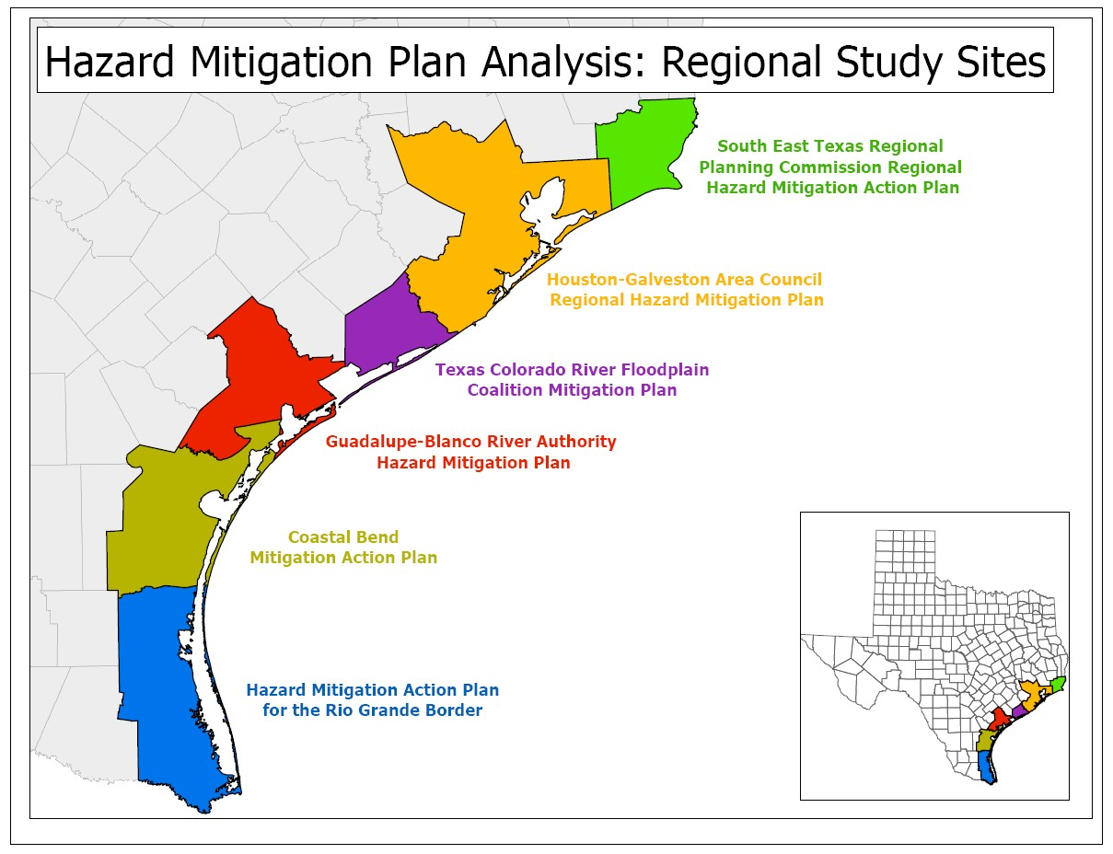
Figure 1. Coastal Hazard Mitigation Plans by Region (Peacock et al. 2009).

Table 2. Summary of Disaster Declaration for Texas Coastal Counties 2019-2024. Note that a single disaster could have resulted in declarations from multiple counties. Data from FEMA.
Summary of FEMA Disaster Declarations for the Texas Coastal Counties
Hurricanes | Fire and Wildfire hazard | Floods | Ice Storms | Severe Storms and Tornado
4 | 0 | 3 | 2 | 0

Flooding
Historically, floods (including flooding due to hurricanes/tropical storms) have been among the most frequent, destructive, and costly natural hazards in Texas. According to the 2023 Texas Hazard Mitigation Plan, there were 11,310 reports of flood impacts over the 22-year reporting period, with the state averaging 514 flood events per year. The 2023 Plan also estimates that riverine flooding results in approximately $350 million in state annualized physical losses.

The risk of flood for coastal Texas counties is high. They are likely to occur at least once every three years, have a short warning time of 3-6 hours, and, when a flood does occur, there is great potential for loss of human life and destruction and damage to infrastructure (Texas Hazards Mitigation Plan, 2023). Flood events can last anywhere from a few hours to several days or even months if weather conditions result in continued precipitation. During these periods, critical public safety infrastructure, transportation, and utility facilities can be disrupted for up to 30 days or more.

The Texas Water Development Board (TWDB) adopted Texas’ inaugural 2024 State Flood Plan, which was delivered to the Legislature September 1, 2024. This plan sets forth thousands of specific, actionable evaluations, projects and strategies that demonstrate a path forward to reduce the risk and impact of existing flood risk (TWDB, 2024).

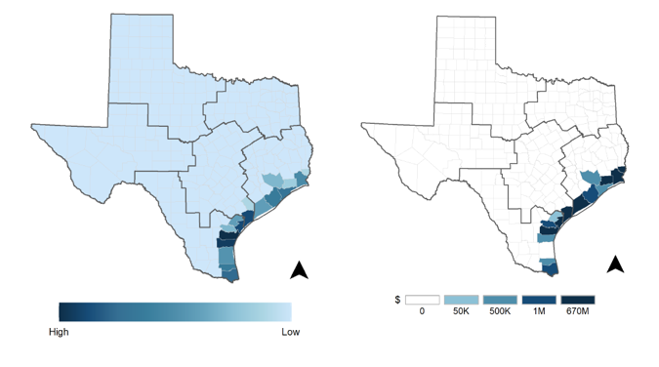

Figure 2. This map was obtained from the Texas Hazard Mitigation plan (2023) and features the historical severe coastal flooding (left) and losses (right) by county.

Table 3. Summary for severe coastal flooding events in the state of Texas, 2000-2021.
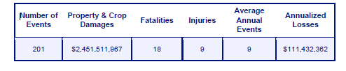

Coastal Storms
Coastal storms, including hurricanes and tropical storms, are one of the most devastating natural hazards in the Texas coastal zone; exposing large areas of the coast, people, and infrastructure to the effects of flooding and wind damage (see Figure 3). Coastal storms in Texas are classified as a high-risk factor because they may result in major injuries or deaths, complete shutdown of critical facilities for days or even weeks, and result in extensive or complete property destruction. As of 2019, approximately 1 million residents of Texas coastal counties live in floodplains which further increases their vulnerability to flood-related damage and property loss (NOAA, 2019). Historically, 60% of the federal disaster declarations in Texas coastal counties have been attributed to hurricanes or tropical storms (see Table 2) and the probability of occurrence is every 1.3 years (Texas Hazard Mitigation Plan 2023). Although storm warning systems have improved, allowing more than 12 hours of warning, the successful evacuation of all at-risk residents remains a significant challenge.

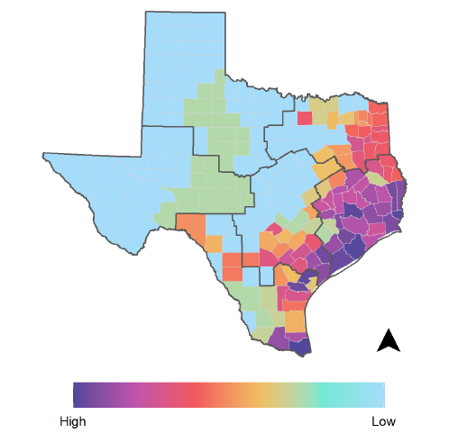

Figure 3. Hurricane Risk Areas for Texas Coastal Counties (Texas Hazard Mitigation Plan, 2000-2021).

Geologic Hazards
Overall, Texas is at low risk of geologic hazards such as earthquake or tsunamis. Texas coastal counties have minimal risk of earthquakes or tsunamis (see Figure 4), which can occur because of submarine landslides (Peterson et al. 2018).

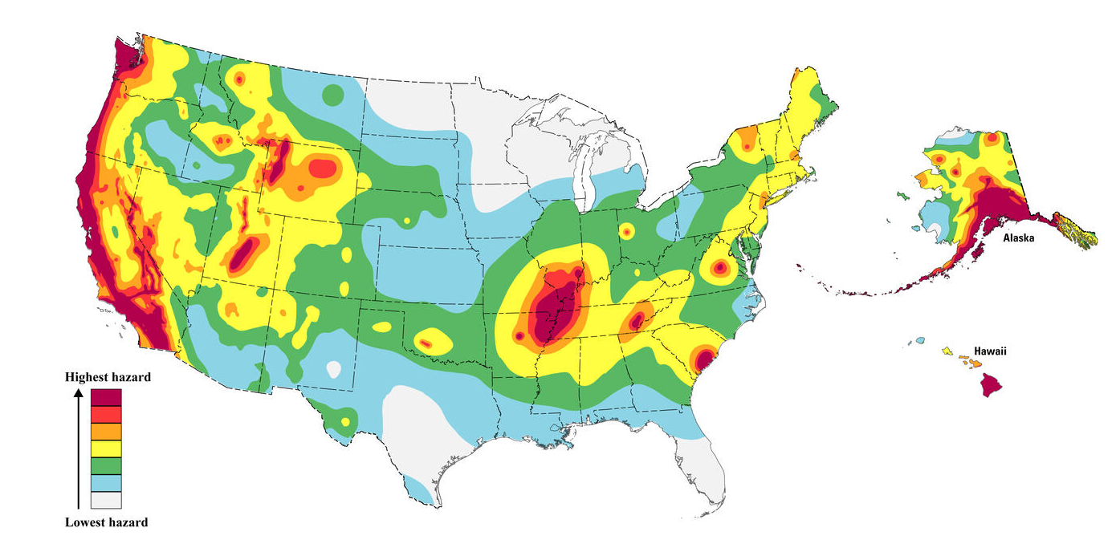
Figure 4. 2023 United States National Seismic Hazard Map (Image from USGS), This hazard map is a simplified 2% in 50-year probability of exceedance map for fixed VS30 760 m/s.
Shoreline Erosion
Coastal erosion is a hydrologic hazard defined as the wearing away of land and loss of beach, shoreline, or dune material because of natural coastal processes or manmade influences. Erosion can occur as a slow continuous process or as a response to waves and currents that accompany tropical storms and hurricanes, which in turn exposes property and infrastructure to storm surge. Texas has the sixth longest coastline in America coupled with some of the highest rates of coastal erosion. Texas has 367 miles of Gulf-facing shoreline, of which over 80% is considered critically eroding, with an average erosion rate of 4.17 ft yr⁻¹ (Paine et al. 2021). In addition, significant erosion also occurs across many sections of the 3,300+ miles of bay-facing shoreline. This erosion, resulting from hydrodynamic impacts by waves and current, is increasing due to processes including land subsidence, increased storm frequency and storm surge intensity, and natural and anthropogenic changes to sediment budgets that reduce sediment delivery to the coast.

Coastal erosion impedes public access and recreational activities on Texas beaches and other coastal lands, degrades critical coastal habitats, threatens coastal infrastructure, and threatens public and private property. Restoration and resiliency projects are direly needed to maintain both important coastal ecosystem services and the resiliency of the Texas coastal communities. The volume of sediment, both beach-quality sand and mixed-sediments, that will be needed for these projects over the coming decades is enormous. The 2023 Texas Coastal Resiliency Master Plan (TCRMP) estimates 6.87 million cubic yards of sand will be needed each year to keep pace with current rates of shoreline change. Sediment needs are expected to continue to increase as storms and storm surge intensities escalate. Additionally, as coastal resiliency projects begin to utilize the most accessible sediment resources, non-renewable sediment resources will be exhausted, and the cost of coastal resiliency projects will continue to grow. Therefore, it is essential that Texas has a plan to locate and use valuable sediment resources to achieve the best possible return on investment

Shoreline change analysis after Hurricane Ike in 2008 revealed that many areas of the Texas upper coast experienced over 20 meters of shoreline retreat, with a few areas such as the Sea Rim State Park experiencing retreat of 50 to 100 meters (Gibeaut et al, 2012). Storm surge induced erosion and inundation on Bolivar Peninsula and sections of Galveston Island destroyed many homes and caused large-scale destruction of roads and other infrastructure and facilities (Figure 5). Erosion is ranked as high hazard because of the potential damage to infrastructure and facilities along the Gulf and Bay shorelines resulting from highly probable and frequent tropical storm activity or storm occurrence.
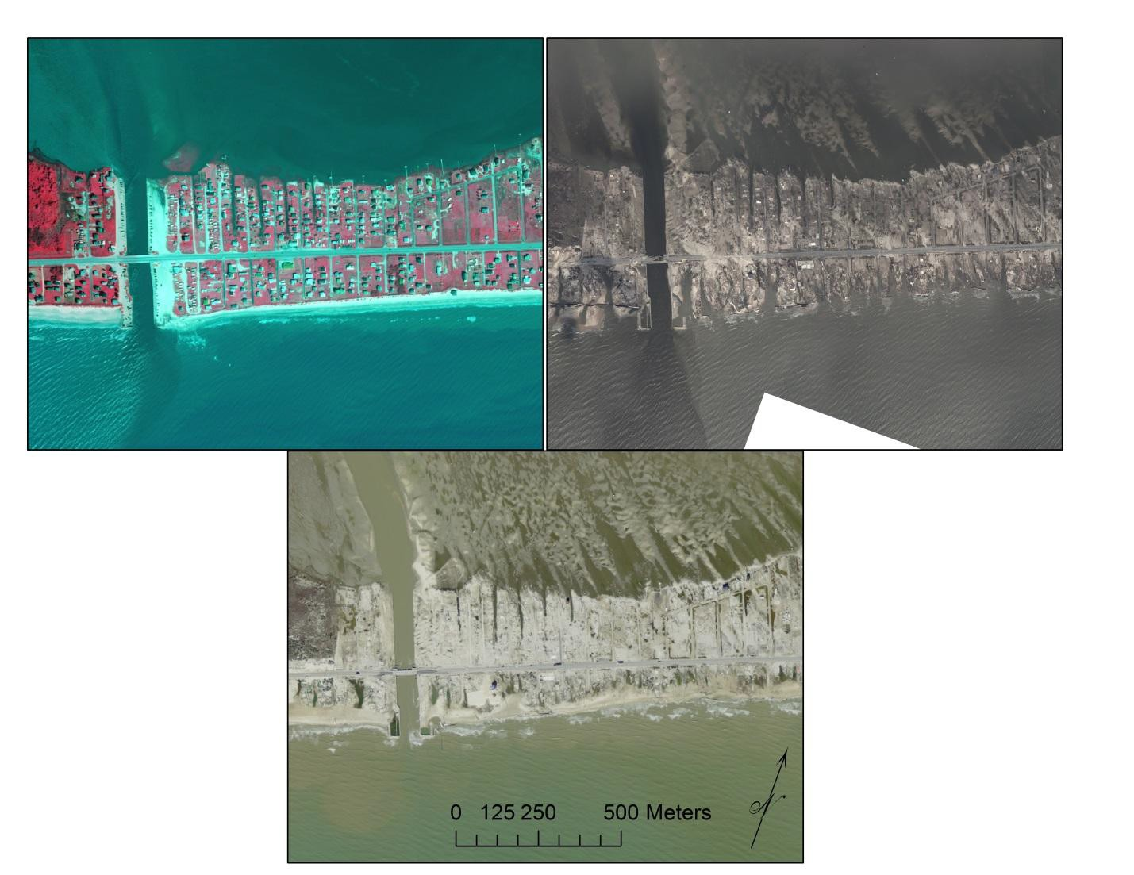
Figure 5. Imagery of Rollover Pass in Bolivar Peninsula Pre-Ike 2008 (top left), post Ike 2008 (top right), and the recovering shoreline in 2009. Images obtained from Texas Geographic Information System, formally Texas Natural Resource Information System.
Whether the erosion is caused by the lack of sediments to balance the long-term losses within the coastal compartments, or the episodic erosion brought on by storms or human activities, planning and implementation of erosion response and sediment management practices is essential to the sustainability of the shoreline and public beaches. The upper Texas coast from Sabine Pass to Rollover Pass, the Brazos-Colorado headland from Quintana to Sargent Beach, and sections of South Padre Island have the greatest erosion rates along the Texas Gulf shoreline ( Figure 6). In many of these locations, sufficient sand for dune restoration or beach nourishment is not available and other erosion mitigation methods may be needed. The TCRMP’s Initial Needs Assessment for the Texas Coast lists coastal erosion is as one of the top three issues of concern and priorities for all regions of the Texas coast (Gibeaut et al., 2014).

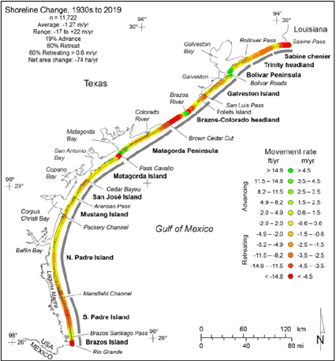

Figure 6. Long-term shoreline changes (1930s to 2019) of the Texas Gulf coast from research by the University of Texas Bureau of Economic Geology (Paine and Caudle, 2021). Eroding areas are shown in orange to red tones.

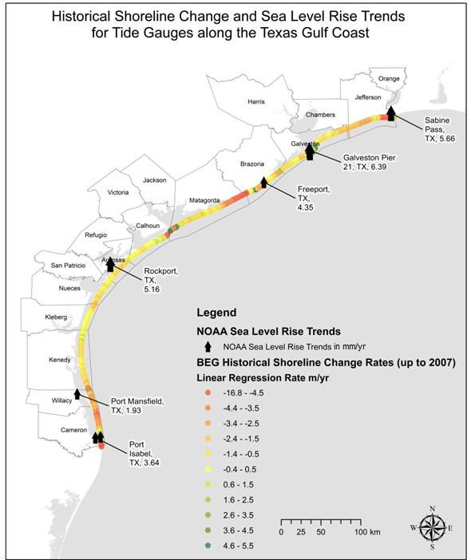

Figure 7. This map shows historical sea-level rise trends as published by NOAA (http://tidesandcurrents.noaa.gov/sltrends/) and historical shoreline change rates as calculated by the BEG (http://www.beg.utexas.edu/coastal/morphodynamics.php). Larger arrows signify negative or landward movement of the shoreline.
Land Subsidence
Land subsidence is defined as the loss of surface elevation due to the removal of subsurface support. The occurrence of land subsidence is particularly high in the coastal counties relative to the rest of the state due to compaction of the underlying sediments, comprised of alluvial, estuarine, coastal and deeper marine sediments. This stack of sediment may be 10-15 km thick and compacting at a rate of 0.05 mm/yr (Montagna et al., 2007). Review of regional hazard mitigation plans for the Texas Gulf coast reveal subsidence is of low hazard concern; three out of five hazard plans acknowledge the hazard but state the occurrence of significant subsidence in their plan-area is low. Because subsidence rates are minimal (0.05 mm/yr) and localized, the relative threat of land subsidence is classified as low, although it has the potential to augment the impacts of the sea level rise. Currently, subsidence alone has limited potential for injury or damage to critical facilities or infrastructure.

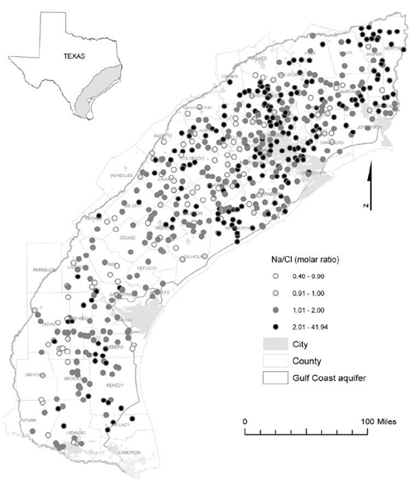

Figure 8. Distribution of Na/Cl molar ratio in the Gulf Coast aquifer of Texas (Chrowdhury et al., 2006). Na/Cl ratios of saltwater intrusion are usually lower than the marine values (~0.86 molar ratio) and high molar ratios (>1) typically characterize anthropogenic sources (Baer, 1999). Saltwater intrusion is documented for the Texas coast but, its occurrence is not likely to cause significant injury or loss to facilities or infrastructure and is found to be a medium risk hazard
Saltwater Intrusion
Intrusion of saltwater into groundwater and other freshwater systems, particularly in estuaries, is a concern in coastal communities as it threatens municipal water supplies and affects freshwater environments, including plants and other living organisms. Saltwater intrusion into an aquifer can occur if water from the aquifer is extracted faster than it is replenished. Saltwater intrusion can also result from elevated storm surge from tropical storms and hurricanes (Steyer et al., 2007). Although its occurrence is not likely to cause significant injury or loss to facilities or infrastructure, it may have significant impact on communities and natural ecosystems. Saltwater intrusion has been documented along parts of the Texas Gulf Coast and found to result from aquifer pumping and subsequent lowering of the water table, particularly in Kleberg, Matagorda and Brazoria counties (Chowdhury et al., 2006) (Figure 8). The threat of saltwater intrusion is currently at a medium risk.

Severe Storms and Tornados
Tornadoes occur most frequently in the northern part of Texas and are associated with cool frontal systems moving to the east (see Figure 9); however, tornadoes may also result from tropical storms in coastal counties. The severity of the impact of a large tornado is high because of the number of injuries and destruction that may take place with minimal warning time.

According to FEMA Disaster Declarations database, the Texas coastal zone had 38 emergency declarations due to severe storms tornadoes from 1953 to 2019, a much lower number when compared to coastal storms or floods. Thus, the relative risk of a tornado in Texas coastal counties is low. Since 2019, Texas coastal zones claimed no severe storms tornadoes, (Table 2).

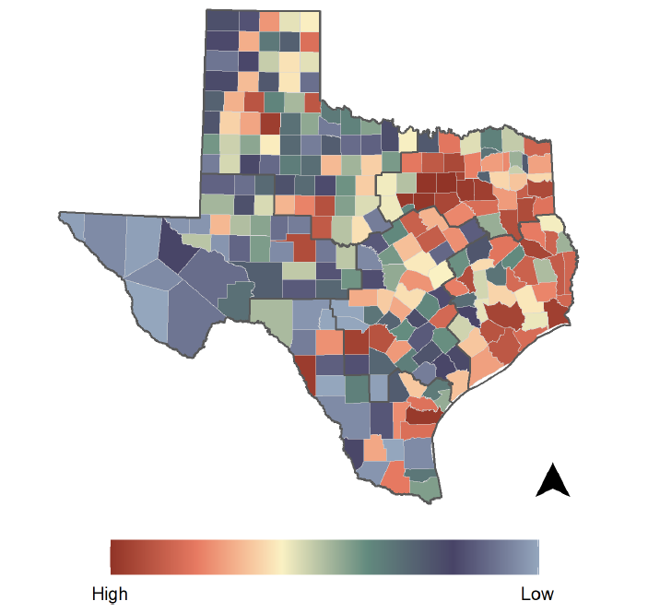

Figure 9. The map was obtained from the Texas Hazard Mitigation Plan (2023) and features counties at greatest tornado risk (2000-2021). Most of the Texas coastal counties lie within medium - high range of tornado activity.

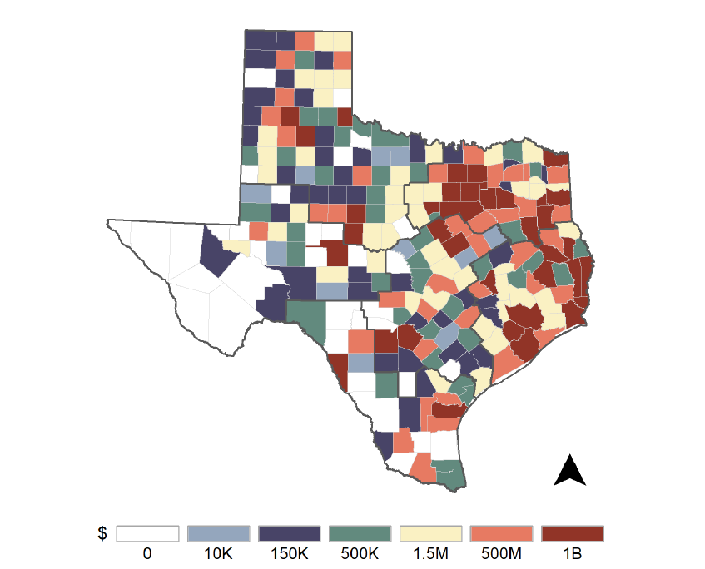

Figure 10. The map was obtained from the Texas Hazard Mitigation Plan (2023) and features historic losses (2000-2021 by counties from tornado and severe storms.
Drought
Due to the geographic location of the state, as many as two-thirds of the state’s counties, including coastal counties, lie within an arid or semi-arid climatic zone and are highly vulnerable to drought. During the past 20 years, Texas received more than 2,921 declarations for multi- county or regional drought; the Gulf Basin experiencing varying degrees of drought at least once every five-years.

According to the FEMA Disaster Declarations database, coastal counties do not have a federal declaration of drought, but many of the coastal counties had Secretarial Drought Designation (see Figure 11) in the last decade. The U.S. Secretary of Agriculture is authorized to designate counties as disaster areas to make emergency loans to agricultural producers suffering losses in those counties.

Drought is prevalent in the coastal region and a cause of agricultural losses; yet, it has a low probability of causing death or injuries and has more minor impacts in the coastal region relative to other threats. Perhaps the biggest impact of drought to the coastal region, in addition to area economics, is its impact to freshwater inflows into the bay systems. Drought within counties in or adjacent to a coastal watershed may lead to decreased input of freshwater to estuarine systems, causing increased salinities stressing environments and coastal resources like wetlands, oysters, and marine fauna.

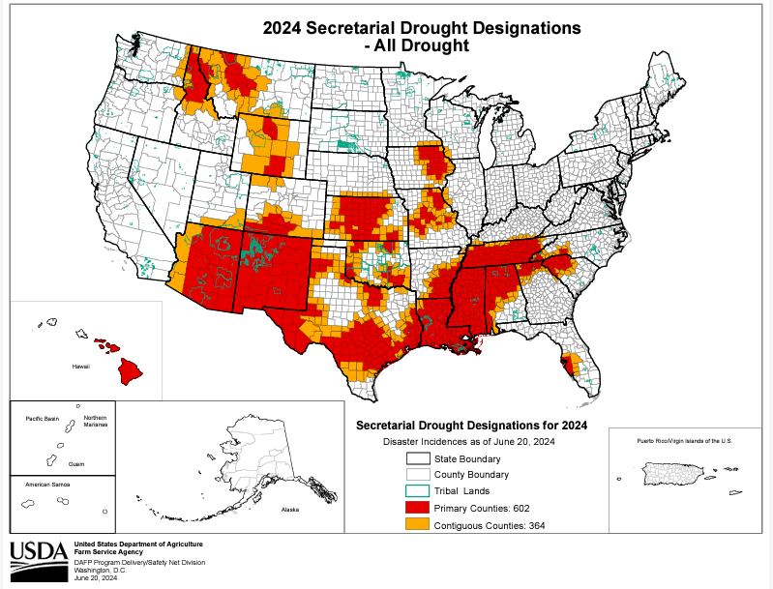
Figure 11. Secretarial Drought Designation Map.

Management Characterization
- In the tables below, indicate if the approach is employed by the state or territory and if significant state- or territory-level changes (positive or negative) have occurred that could impact the CMP’s ability to prevent or significantly reduce coastal hazards risk since the last assessment.

Significant Changes in Hazards Statutes, Regulations, Policies, or Case Law
Topic Addressed | Employed by State or Territory  (Y or N) | CMP Provides Assistance to Locals that Employ  (Y or N) | Significant Changes Since Last Assessment  (Y or N)
Elimination of development/redevelopment  in high-hazard areas | N | Y | N
Management of development/redevelopment  in other hazard areas | N | Y | N
Sea level rise or Great Lakes level change | N | Y | N

Significant Changes in Hazards Planning Programs or Initiatives
Topic Addressed | Employed by State or Territory  (Y or N) | CMP Provides Assistance to Locals that Employ  (Y or N) | Significant Changes Since Last Assessment  (Y or N)
Hazard mitigation | Y | Y | Y
Sea level rise or Great Lakes level change | N | Y | N

Significant Changes in Hazards Mapping or Modeling Programs or Initiatives
Topic Addressed | Employed by State or Territory  (Y or N) | CMP Provides Assistance to Locals that Employ  (Y or N) | Significant Changes Since Last Assessment  (Y or N)
Sea level rise or Great Lakes level change | Y | Y | N
Other hazards | Y | N | Y

- Briefly state how “high-hazard areas” are defined in your coastal zone.

Special Hazard Areas
The Texas Natural Resources Code, §33.203, Management of Public Land, describes a special hazard area as a coastal natural resource area “[…] designated under 42 U.S.C. Section 4001 et seq. as having special flood, mudslide or mudflow, or flood-related erosion hazards and shown on a flood hazard boundary map or flood insurance rate map as Zone A, AO, A1-30, AE, A99, AH, VO, V1-30, VE, V, M, or E.”

- For any management categories with significant changes, briefly provide the information below. If this information is provided under another enhancement area or section of the document, please provide a reference to the other section rather than duplicate the information:
  - Describe the significance of the changes;
  - Specify if they were 309 or other CZM-driven changes; and
  - Characterize the outcomes or likely future outcomes of the changes.

Texas Coastal Resiliency Master Plan (TCRMP)
A recent CMP success was the GLO’s production and release of the TCRMP in 2023. The TCRMP was originally funded and developed under the 2011-2015 309 Assessment and Strategy Report and was, at that time, called the Coastal and Marine Spatial Planning effort. The TCRMP provides a framework for community, socio-economic, ecologic, and infrastructure protection from coastal hazards, including short-term direct impacts (e.g., flooding, storm surge) and long-term gradual impacts (e.g., erosion, habitat loss). The 2023 TCRMP lays out 10 Actions at the state and regional level to increase long-term resilience. To bring about these 10 actions along the entire Texas coast, the 2023 TCRMP lists 121 “Tier 1” high priority projects. The GLO and its various project partners work together to fund and implement Tier 1 projects and develop new, effective, and long-term processes and relationships to make the collective vision of the TCRMP a reality.

The first iteration of the TCRMP was released in March 2017, the next version in March 2019, and the most recent version in March 2023. Each iteration highlights the value of the Texas coast, its resources, and the most pressing vulnerabilities that endanger coastal communities. Vulnerability categories include Degraded or Lost Habitat; Gulf and Bay Shoreline Change; Inland, Tidal and Storm Surge Flooding; and Degraded Water Quality and Quantity. The TCRMP then presents a host of actions, strategies, and projects that feature nature-based and infrastructure improvement project concepts to mitigate the vulnerabilities that threaten the vitality and productivity of the coastal area.

The TCRMP advocates for a “multiple lines of defense” approach, that can be performed at the state, regional, and local level to increase long-term resiliency. The Tier 1 projects present opportunities to implement the broader vision and actions that support this approach with a project evaluation process that leverages expert review by the Technical Advisory Committee to prioritize the most advantageous and feasible projects to advance the Texas coast toward greater ecological and societal resilience.

With a ready list of vetted Tier 1 projects identified through the planning process, the GLO uses the TCRMP as a platform to advocate for the overall mission to safeguard the state’s coastal resources and take action to protect communities, ecosystems, and economic growth within the Texas coastal area.

The Plan has three primary goals and associated objectives:

Goal 1: The GLO will use the TCRMP to direct its authority to identify, select and fund projects that address the Issues of Concern and restore, enhance and protect the Texas coast.

The development of the TCRMP has directed programs within the GLO, such as the CMP and the Coastal Erosion Planning and Resource Act (CEPRA), to work together to align their goals and objectives to congeal around a common mission of funding projects to improve management of the state’s coastal resources and ensure the long-term ecologic and economic resiliency of the Texas Coast. The TCRMP is also being used to inform priorities within the GLO’s Community Development and Revitalization Department’s coastal portion of the allocation of federal Community Development Block Grant funds and will continue to do so in the coming years.

Goal 2: Develop an adaptable TCRMP that accommodates changing coastal conditions. The Resiliency Plan will provide long-term, multiple lines of defense solutions to restore, enhance and protect coastal habitats, infrastructure and communities.

The TCRMP is an ever-evolving document as the conditions along the Texas coast and hazards faced by those communities also change. The TCRMP’s goal is to secure steady funding streams to implement projects and update the Tier-1 project list in four-year intervals.

Goal 3: Communicate the environmental and economic value of the Texas coast to state and national audiences.

The GLO continues to improve its outreach efforts to bring the TCRMP to a local and national audience to assist coastal communities in their efforts to become more resilient to future coastal hazards.

Data Management 309 Strategy
In the 2016 – 2020309 Assessment and Strategy, the CMP developed a coastal mobile data collection platform and applications to streamline and improve the efficiency of data collection, management, and distribution for coastal-related activities and decision-making.

This strategy created a Data Collector App User Guide for Storm Debris and Derelict Structure Assessments. Coastal Field Operations and Oil Spill staff continue to use ESRI Arc Geographic Information System (GIS) field maps for integrated photo and data collection when completing all coastal inspections in the field. This includes inspections for proposed and existing structures on state-owned submerged land, inspections to document public beach access points, and post storm inspections to evaluate damage, debris, and sunken vessel on state and public land. Photos and data are available in GIS Viewers and SharePoint for interconnected data-sharing across different divisions. For example, the Post Storm Damage Assessment Viewer provides a platform for key staff to view collected photos and data in real time following a Hurricane, for improved coordination and decision making.

The strategy also created a new method of storing and categorizing data collected via the Data Collector App. that changed how photos and data for the GLO’s Coastal Resources Division are housed.

The State Flood Planning Effort
The TWDB adopted Texas’ inaugural 2024 State Flood Plan, which was delivered to the Legislature September 1, 2024. This plan sets forth thousands of specific, actionable evaluations, projects and strategies that demonstrate a path forward to reduce the risk and impact of existing flood risk (TWDB, 2024). Additionally, the TWDB has completed a statewide flood mapping effort using a Base Level Engineering approach. This is important for communities that were never mapped for floodplains by FEMA or have outdated flood hazard data.

Enhancement Area Prioritization
- What level of priority is the enhancement area for the coastal management program?
High __x__
Medium _____
Low _____

- Briefly explain the reason for this level of priority. Include input from stakeholder engagement, including the types of stakeholders engaged.

This enhancement area was considered a high priority because it can address critical issues such as coastal storm surge and compound flooding, which cause immediate risks to coastal communities and ecosystems. In addition, coastal erosion and habitat degradation are ongoing risks to coastal regions. During stakeholder engagement efforts with coastal residents, local fisheries and tourists, state and federal agencies, energy sectors, as well as military/Navy, concerns about shoreline changes, wildlife habitat protection, military/Navy operations, and economic resilience were frequently raised. Thus, there is an urgent need to prioritize and advance this enhancement area to ensure the short-/long-term sustainability of the coast.

Public Access

Section 309 Enhancement Objective: Attain increased opportunities for public access, considering current and future public access needs, to coastal areas of recreational, historical, aesthetic, ecological, or cultural value. §309(a)(3)

Phase 1 (High-level) Assessment: (Must be completed by all states.)
Purpose: To quickly determine whether the enhancement area is a high-priority enhancement objective for the CMP that warrants a more in-depth assessment. The more in-depth assessments of Phase II will help the CMP understand key problems and opportunities that exist for program enhancement and determine the effectiveness of existing management efforts to address those problems.

Resource Characterization
- Use the table below to provide data on public access availability within the coastal zone.

Public Access Status and Trends
Type of Access | Current number | Changes or Trends Since Last Assessment  (↑, ↓, −, unknown) | Cite data source
Beach access sites | 208 | ↑ 23 Public Access Sites | GLO, 2025
Shoreline (other than beach) access sites | 281 bays  45 bayous  68 rivers | ↓ 6 | Txcoasts.com
Recreational boat (power or non-motorized) access sites | 201 | No change | Txcoasts.com
Designated scenic vistas or overlook points | 556 | − | Txcoasts.com
Fishing access points (i.e. piers, jetties) | 538 | No change | Txcoasts.com
Coastal trails/ boardwalks  (Please indicate number of trails/boardwalks and mileage) | # Of trails = 104 | ↓ 3 | Txcoasts.com
Acres of parkland/open space | 65 | - | -
Access sites that are Americans with Disabilities Act (ADA) compliant | 80 (ADA compliant) | ↑ 8 Access Sites | Txcoasts.com
Other  Access sites that are disabled friendly ⁹ | 210 | ↑ 210 Access Sites | Txcoasts.com
Other  Beach Watch | 172 stations, 61 beaches | No change | https://cgis.glo.texas.gov/Beachwatch/

- Briefly characterize the demand for coastal public access and the process for periodically assessing demand. Include a statement on the projected population increase for your coastal counties. There are several additional sources of statewide information that may help inform this response, such as the Statewide Comprehensive Outdoor Recreation Plan, the National Survey on Fishing, Hunting, and Wildlife Associated Recreation, and your state’s tourism office.

The COVID-19 pandemic highlighted the value of open and accessible natural spaces, and, since that time, Texas beaches have experienced a significant and persistent increase in visitors to coastal public beaches and bays. Public vehicular accessible beaches in Texas were a particular draw, and local governments who have the responsibility to clean and maintain beaches have been under pressure to manage increased demand. Beach user fee revenues for nine cities and counties with Gulf-facing beaches increased by 54% between 2020 and 2021, from about $10 million in 2020 to almost $16 million in 2021. After 2021, sales slowly decreased to approximately $14.5 million in 2024
In 2022, the 18 Texas coastal counties had an estimated total population of more than 7 million, or nearly 25 percent of the state’s total population. This was a 16% increase since the 2010 census (Texas Comptroller 2024). As the population along the coast increases, there will be increased pressure on coastal resources including access to and use of beaches and other public coastal recreational areas. In addition to increased demand for use, there is also an increasing need to enhance Americans with Disabilities Act and mobility impairment access to these recreational sites.

In 2024, GLO Beach and Dune staff did an inventory of the Gulf access points and updated the GLO’s public, interactive website, Txcoasts.com, with information on any new access points where data had changed and added additional access points that were not included. Txcoasts.com and its online inventory is frequently and regularly updated as changes to coastal access sites occur and GLO staff are considering undertaking a full Txcoasts.com update in 2025.

- If available, briefly list and summarize the results of any additional data or reports on the status or trends for coastal public access since the last assessment.

Recently, the GLO staff completed updates to two programmatic guidance documents: the Dune Protection and Improvement Manual and the Texas Beach Accessibility Guide (2023, 2024). See discussion below.
Management Characterization
- Indicate if the approach is employed by the state or territory and if there have been any significant state- or territory-level management changes (positive or negative) that could impact the future provision of public access to coastal areas of recreational, historical, aesthetic, ecological, or cultural value.

Significant Changes in Public Access Management
Management Category | Employed by State or Territory  (Y or N) | CMP Provides Assistance to Locals that Employ  (Y or N) | Significant Changes Since Last Assessment  (Y or N)
Statutes, regulations, policies, or case law interpreting these | Y | Y | Y
Operation/maintenance of existing facilities | Y | Y | Y
Acquisition/enhancement programs | Y | Y | Y

- For any management categories with significant changes, briefly provide the information below. If this information is provided under another enhancement area or section of the document, please provide a reference to the other section rather than duplicate the information:
  - Describe the significance of the changes;
  - Specify if they were 309 or other CZM-driven changes; and
  - Characterize the outcomes or likely future outcomes of the changes.

In Texas, public access to Gulf Coast beaches is not just the law, it is a constitutional right. The Texas Land Commissioner, by law, protects this public right for all Texans by enforcing the Texas Open Beaches Act (OBA). Under the Texas OBA, the public has the free and unrestricted right to access and use the State's beaches, which are located on what is commonly referred to as the "wet beach," from the water to the line of mean high tide; the dry sandy area that extends from the "wet beach” to the natural line of vegetation can be privately owned and may be subject to a public beach easement.

Under the OBA, the Texas Land Commissioner was given the authority to promulgate rules related to beachfront construction and the management of the public beach. These rules are located in 31 Texas Administrative Code Chapter 15 and are known as the Beach Dune Rules. As part of the 2021 – 2025 309 Assessment and Strategy Report, a new, full time staff position was funded and, after multiple years of coordination with local governments, state and federal resource agencies, and other stakeholders to research and draft an initial rulemaking package, the GLO adopted amendments to the Beach Dune Rules in May of 2023. The amendments were comprehensive, and notable changes to the regulations governing beach access, beachfront construction and dune protection included modifications to the mitigation and compensation deadlines for adverse effects to dunes and dune vegetation, new width limitations and height requirements for dune walkovers, an allowance for a limited use of impervious cover for accessibility enhancements at commercial or public beach access facilities, and a requirement for enhanced access to the water for persons with disabilities in areas where vehicles are prohibited from the beach. The amendments were posted for adoption in the May 5, 2023, issue of the Texas Register and became effective statewide on May 9, 2023.

Cities and counties along the coast are required to adopt laws to protect the public’s beach access rights. Usually, these local laws are adopted as a dune protection and beach access plan. The GLO reviews local beach access plans and certifies that they meet the minimum state standards set forth in the GLO Beach Dune Rules. The GLO certifies amendments to local beach access and dune protection plans as consistent with state law through formal rulemaking. Below is a list of the jurisdictions with plan amendments certified by the GLO since 2021:
- Brazoria County – December 2022
- Cameron County –September 2022
- Village of Surfside Beach – February 2024
- City of Galveston – March 2021 & November 2024

To enhance ADA access, the Beach and Dune Program worked with CMP to purchase mobility mats and/or beach wheelchairs for 15 coastal communities to allow persons with disabilities easier access to public beaches. The purchase of this equipment also helped local governments comply with the enhanced access requirements for persons with disabilities added to the GLO Beach Dune Rules in 2023.

In 2021, Texas House Bill 3807 required municipalities and counties responsible for cleaning and maintaining public Gulf-facing beaches to provide occupied lifeguard towers or mobile lifeguard units at each pier, jetty, or other structure that protrudes into the Gulf of America within their boundaries during reasonable daylight hours from Memorial Day to Labor Day. In 2023, Texas House Bill 630 updated this requirement to not apply to a municipality with a population that is less than 1,000 that is located in a county adjacent to a county with a population of more than 3.3 million or to a county adjacent to a county with a population of more than 3.3 million that contains a municipality with a population of less than 1,000. The primary effect this bill will have been requiring additional lifeguarding on public beaches to ensure safety. This will require additional local government funds to support the extra labor, during a time when beach access and use in Texas is surging.

Recently, the GLO staff completed updates to two programmatic guidance documents: the Dune Protection and Improvement Manual for the Texas Gulf Coast and the Texas Beach Accessibility Guide (2023, 2024). Updates included incorporating recent amendments to the Beach Dune Rules, best practices for dune restoration and mitigation with guidance on mitigation procedures, guidelines for the construction of dune walkovers and placement of sand fencing, and ADA requirements and best practices to enhance beach access for the mobility impaired. GLO staff translated the Dune Protection Manual and Beach Accessibility Guide into Spanish. The GLO website was updated to reflect the new versions of both (2023, 2024).

While not a significant change, the Texas CMP continues to emphasize and prioritize funding grant projects that will create and enhance public access to Texas beaches. Since the 2021 – 2025 309 Assessment and Strategy Report, CMP either funded or worked on 53 projects that created or enhanced public access.

- Indicate if your state or territory has a publicly available public access guide. How current is the publication and how frequently it is updated?
Publicly Available Access Guide
Public Access Guide | Printed | Online | Mobile App
State or territory has?  (Y or N) | N | Y | N
Web address  (if applicable) | N | Txcoasts.com | N
Date of last update | N | 2024 | N
Frequency of update | N | Plans for update TBD | N

Enhancement Area Prioritization
- What level of priority is the enhancement area for the coastal management program?
High _____
Medium _ X__
Low _____

- Briefly explain the reason for this level of priority. Include input from stakeholder engagement, including the types of stakeholders engaged.

Coastal access is important both economically and ecologically as access points contribute to both ecosystem health and coastal tourism and recreation. As public access is required by statute and state rules, it has been a high priority for the Texas CMP in the past. One of the crucial strategies from the 2016-2020 309 Assessment and Strategy Report was to update the Texas Administrative Code related to Beach and Dune Protection (see above). Because of the GLO’s continued work and successes to provide and maintain coastal public access to everyone, Public Access has been identified as a medium priority for the 2026-2030 period.

Marine Debris

Section 309 Enhancement Objective: Reducing marine debris entering the nation’s coastal and ocean environment by managing uses and activities that contribute to the entry of such debris. §309(a)(4)

Phase 1 (High-level) Assessment: (Must be completed by all states.)
Purpose: To quickly determine whether the enhancement area is a high-priority enhancement objective for the CMP that warrants a more in-depth assessment. The more in-depth assessments of Phase II will help the CMP understand key problems and opportunities that exist for program enhancement and determine the effectiveness of existing management efforts to address those problems.

Resource Characterization
- In the table below, characterize the existing status and trends of marine debris in the state’s coastal zone based on the best-available data.

Existing Status and Trends of Marine Debris in Coastal Zone
Source of Marine Debris | Significance of Source  (H, M, L, unknown) | Type of Impact  (aesthetic, resource damage, user conflicts, other) | Change Since Last Assessment  (↑, ↓, −, unknown)
Beach/shore litter | H | aesthetic, resource damage, tourism, economic conditions, human health | -
Land-based dumping | unknown | unknown | -
Storm drains and runoff | H | aesthetic, resource damage, | ↑
Land-based fishing (e.g., fishing line, gear) | H  (data not specific to land- based/ocean-based) | aesthetic, resource damage | ↑
Ocean/Great Lakes-based fishing (e.g., derelict fishing gear) | H  (data not specific to land- based/ocean-based) | aesthetic, resource damage | ↑
Derelict vessels | H | aesthetic, resource damage | unknown
Vessel-based (e.g., cruise ship, cargo ship, general vessel) | unknown | aesthetic, resource damage | unknown
Hurricane/Storm | H | all impacts | -
Tsunami | unknown | unknown | -

(Note: information for questions 1 and 2 of Resource Characterization was obtained through personal communication with the Texas General Land Office Adopt-A-Beach Program; the Beach Access and Dune Protection Program, Coastal Resources Division; Marine Debris Reimbursement Program; and Oil Spill Prevention and Response Division and Professional Services throughout July 2024.)

- If available, briefly list and summarize the results of any additional state- or territory-specific data or reports on the status and trends or potential impacts from marine debris in the coastal zone since the last assessment.
Source of Marine Debris | Summary of results since last assessment:
Land-based
Beach/shore litter | NOAA created a marine debris blog: (http://marinedebrisblog.wordpress.com/) to highlight marine debris cleanup efforts, programs and partnerships across the country. The GLO’s Adopt-A-Beach Program provided information on the number of miles cleaned, volunteers and tons collected. Debris details such as cigarette butts and bottle caps are also provided (see Table 3 and Table 4).
Dumping | Dumping data is not available.
Storm drains and runoff | Determined by local jurisdiction (local initiatives). General trend is upwards (personal communication, GLO, 2019) and must be mitigated through local jurisdictions. The implementation of the coastal NPS program will affect future storm drain and runoff policy (See Cumulative and Secondary Impacts)
Fishing (e.g., fishing line, gear) | TPWD administers the Crab Trap Removal Program. Since 2002, 42,726 derelict crab traps have been hauled from Texas bays (TPWD) (see Table 5).
Other (please specify) | The Texas Sea Grant Program coordinates the Clean Texas Marina Program, which has a marine debris component. There are 132 marinas now certified, up 40, since last assessment.  The GLO administers the Beach Maintenance Reimbursement Program, which provides state reimbursement to qualified city and county governments for certain expenses incurred while maintaining clean and safe public beaches.

Source of Marine Debris | Summary of results since last assessment:
Ocean-based
Fishing (e.g., derelict fishing gear) | See Fishing (e.g. fishing line, gear) section above.
Derelict vessels | Since 2005, a total of 956 derelict vessels have been documented coastwide. With funding from a Coastal Impact Assessment Program grant, a total of 739 vessels have been removed, with approximately 217 remaining. Funding for this project ends December 2016. There is not a dedicated funding stream for this effort. (Personal communication, GLO, Oil Spill Prevention and Response Division, April 2015, see Figure 12
Vessel-based (e.g., cruise ship, cargo ship, general vessel) | See discussion in “Derelict Vessels” section above and Figure 12 below.
Hurricane/storm | In 2020, Hurricane Hanna devastated the Texas coast with strong winds and rainfall. Debris identified for removal includes:  - Roughly 120 square feet of the parking lot at Padre Balli County Park.  - Estimated 3 inches of asphalt on top of 10 inches of base materials which calculates into approximately 5,555 cubic yards of materials to be removed.  - Up to 50 picnic table/cabanas to remove that consist of all treated wood materials.  - Possible old petroleum pipelines that got uncovered with the erosion, includes surf zone.  - Found this pipeline when we were doing to new construction of the RV park a few years back.  - It is about 4 inches in diameter and is made of cast-iron. It runs due East and West through destroyed parking lot into Gulf.  - Removing all the large chunks of debris scattered along the beach South to the PINS property line.  - This debris is made up of large tree trunks, sections of wood constructed items, probably the ends of dune walk overs that wash up down their items of that nature.  - This debris is scattered over roughly 6.5 miles of beach.  - Debris is categorized as moderate in nature.
Tsunami | No data available.

Table 4. GLO Debris Removal Results 2020 - 2025
Location of Debris Removal | Year | GLO Cost to Remove | Comments
Brazoria | 2020 | $ 664,000 | 1,443 cu yds concrete, 420 cu yd construction material, 817 cu yd vegetated material removed.
Nueces | 2020 | $ 671,000 | 479 cu yds debris, 11,748 cu yd of asphalt, 48 linear ft of pipeline removed.
Laguna Madre | 2020 | $ 390,000 | 74 tons of debris (Dumpsters)
Laguna Madre | 2022 | $ 195,000 | 30 tons of debris (Dumpsters)
Radio Tower | 2022 | $ 250,000 | 676 cu yds of concrete (Galveston)
Rollover Pass | 2022 | $ 325,000 | 400 cu yds of debris
Brazoria | 2024 | $ 68,000 | 676 cu yds (Cabin debris)
Quintana | 2024 | $ 325,000 | 160 cu yds of beach debris
Aransas | 2024 | $ 14,000 | 80 cu yds (sunken floating platform & 16’ vessel)
Rollover Pass | 2025 | $ 1,600,000 | 377 tons of concrete, 8 cu yds of sheet metal (Gilchrist debris)
Nueces | 2025 | $ 25,000 | 50 cu yds of concrete (North beach)

Table 5. Texas Adopt-A-Beach Program beach clean-up results, 2020 –2024.
Season Clean-up | Miles Cleaned | Volunteers | Tons Collected | Comments
Spring 2020 | 143 | 4,371 | 24 | Thunderstorms
Fall 2020 | 116 | 7,427 | 105 | Red Tide Conditions, many sites cancelled
Winter 2020 | 26 | 735 | 5
Spring 2021 | 151 | 6,757 | 57 | Flooding Conditions
Fall 2021 | 169 | 8,236 | 86 | Thunderstorms and Red Tide Conditions, many sites cancelled
Winter 2021 | 32 | 798 | 14
Spring 2022 | 146 | 6,772 | 78 | Sandfest competition in Port Aransas, forced site to close
Fall 2022 | 69 | 5,046 | 40 | One month after Hurricane Harvey, many sites cancelled
Winter 2022 | 35.5 | 1,451 | 36
Spring 2023 | 134 | 4,924 | 40 | Post Harvey, sites still recovering, cold weather, rain and flooding
Fall 2023 | 123 | 6,655 | 110.4 | Two sites cancelled due to red tide.
Spring 2024 | 129 | 5,502 | 29.6
Fall 2024 | 140 | 7,166 | 32.7
Totals: | 1413.5 | 65,840 | 657.7

Table 6. Texas Adopt-A-Beach Program trash data, 2020 – 2023.
Year: | Item: | Total Items: | Percentage:
2020 | Bottle Caps (Plastic) | 35417 | 27.43%
 | Cigarette Butts | 22788 | 17.65%
 | Food Wrappers (candy, chips, etc.) | 7955 | 6.16%
 | Beverage Bottles (Plastic) | 6654 | 5.15%
 | Straws, Stirrers | 6606 | 5.12%
 | Bottle Caps (Metal) | 4147 | 3.21%
 | Beverage Cans | 4111 | 3.18%
 | Other Plastic Bags | 4070 | 3.15%
 | Grocery Bags (Plastic) | 3239 | 2.51%
 | Lids (Plastic) | 3214 | 2.49%
 | Top Ten Total | 98,201 | 76.05%
2021 | Cigarette Butts | 195,846 | 20.15%
 | Bottle Caps (Plastic) | 181,068 | 18.63%
 | Beverage Bottles (Plastic) | 66,552 | 6.85%
 | Food Wrappers (candy, chips, etc.) | 59,451 | 6.12%
 | Straws, Stirrers | 45,900 | 4.72%
 | Bottle Caps (Metal) | 34,434 | 3.54%
 | Beverage Cans | 34,099 | 3.51%
 | Lids (Plastic) | 28,982 | 2.98%
 | Other Trash (Clean Swell) | 28,654 | 2.95%
 | Grocery Bags (Plastic) | 25,517 | 2.63%
 | Top Ten Total | 700,503 | 72.08%
2022 | Bottle Caps (plastic) | 16,580 | 19.37%
 | Cigarette butts | 12,434 | 14.52%
 | Beverage bottles (plastic) | 8,246 | 9.63%
 | Food wrappers (candy, chips, etc.) | 7,470 | 8.72%
 | Beverage cans | 5,103 | 5.96%
 | Grocery bags (plastic) | 3,927 | 4.59%
 | Straws/stirrers (plastic) | 3,925 | 4.58%
 | Bottle caps (metal) | 3,494 | 4.08%
 | Beverage bottles (glass) | 2,547 | 2.97%
 | Food containers (plastic) | 2,425 | 2.83%
 | Top Ten Total | 66,151 | 77.25%
2023 | Plastic/foam pieces | 19550 | 23.37%
 | Bottle caps (plastic) | 12257 | 14.65%
 | Cigarette butts | 7593 | 9.08%
 | Bottle caps (metal) | 4376 | 5.23%
 | Other waste (metal, paper, etc.) | 3459 | 4.14%
 | Beverage bottles (plastic) | 3358 | 4.01%
 | Food wrappers (candy, chips, etc.) | 3029 | 3.62%
 | Grocery bags (plastic) | 2976 | 3.56%
 | Other plastic waste | 2791 | 3.34%
 | Lines, nets, traps, ropes, etc. | 2523 | 3.02%
 | Top Ten Total | 61,912 | 74.02%

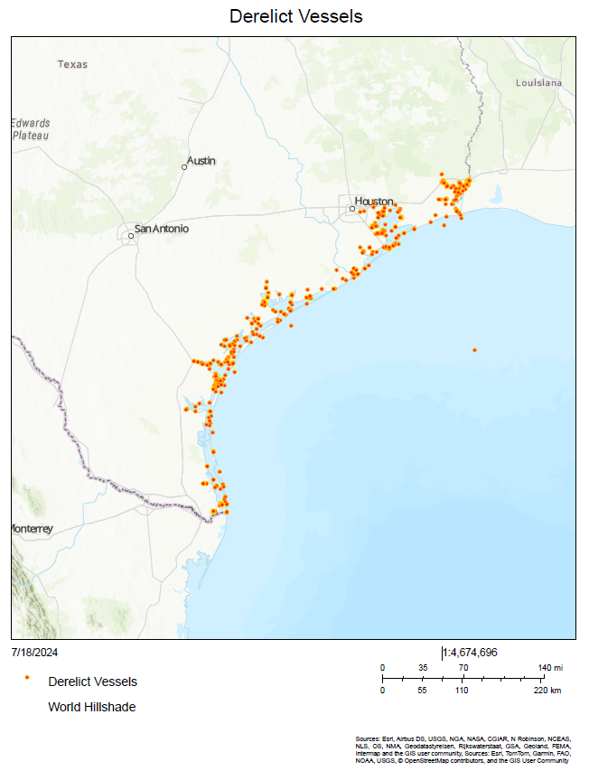

Figure 12. This map shows the locations of the remaining 188 derelict vessels in the coastal environment that the GLO, Oil Spill Prevention and Response Division has documented.

Table 7. Annual Crab Trap Removal Program results: 2015 – 2023.
Crab Traps Removed: | 2015 | 2016 | 2017 | 2018 | 2019 | 2020 | 2021 | 2022 | 2023
Sabine Lake | 73 | 121 | 75 | 150 | 7 | 5 | 37 | 1 | 134
Galveston Bay | 342 | 363 | 386 | 337 | 211 | 366 | 291 | 110 | 159
Matagorda Bay | 8 | 88 | 5 | 54 | 17 | 140 | 151 | 298 | 97
San Antonio Bay | 277 | 258 | 570 | 997 | 710 | 1249 | 874 | 608 | 797
Aransas Bay | 30 | 72 | 71 | 52 | 74 | 243 | 164 | 198 | 102
Corpus Christi Bay | 18 | 2 | 8 | 71 | 28 | 21 | 37 | 43 | 17
Up Laguna Madre | 0 | 0 | 0 | 0 | 0 | 2 | 0 | 0 | 2
Low Laguna Madre | 40 | 8 | 0 | 0 | 42 | 3 | 7 | 0 | 0
Totals: | 788 | 912 | 1115 | 1661 | 1089 | 2029 | 1561 | 1285 | 1308

Management Characterization
- Indicate if the approach is employed by the state or territory and if there have been any significant state- or territory-level management changes (positive or negative) for how marine debris is managed in the coastal zone.

Significant Changes in Marine Debris Management
Management Category | Employed by State/Territory  (Y or N) | CMP Provides Assistance to Locals that Employ  (Y or N) | Significant Changes Since Last Assessment  (Y or N)
Marine debris statutes, regulations, policies, or case law interpreting these | Y | Y | N
Marine debris removal programs | Y | Y | N

- For any management categories with significant changes, briefly provide the information below. If this information is provided under another enhancement area or section of the document, please provide a reference to the other section rather than duplicate the information:
  - Describe the significance of the changes;

The GLO will start an internal Marine Debris Removal Program in Spring 2025. The objective of the program is to support impactful marine debris removal projects that clean up and improve the accessibility and resiliency of the Texas coastal and marine environment. This program will primarily focus on the removal of small-scale debris located on state-owned submerged land and public beaches. For the purposes of this program, small-scale debris is defined as a projected removal cost of less than $500,000 and large-scale is defined as anything greater than $500,000. The GLO will allocate $3 million in Gulf of Mexico Energy Security Act (GOMESA) funding to the program each April.

The GLO has also pledged $18 million to remove abandoned, derelict well stubs from Trinity Bay with the intention of continuing well stub removal throughout other Texas bay systems. To date, eight wells have been successfully plugged and a ninth is underway, contractors have flushed and removed flowlines from the eight wells and cribbing has been removed from around three wells and a fourth is underway.

  - Specify if they were 309 or other CZM-driven changes; and
  - Characterize the outcomes and likely future outcomes of the changes.

Enhancement Area Prioritization
- What level of priority is the enhancement area for the coastal management program?
High __ _
Medium __x__
Low _____

- Briefly explain the reason for this level of priority. Include input from stakeholder engagement, including the types of stakeholders engaged.

Marine debris is not only a worldwide issue; it is also a significant concern in Texas. Storms and their aftermath, such as Harvey, have helped garner interest in removing marine debris. The GLO served as the primary FEMA contact for marine debris and coordinated environmental requirements, addressed contractor issues, worked with city, county, and federal governments, and worked with the public on issues associated with marine debris removal.

Incentives should be considered for coastal communities who actively participate in regulation and enforcement of anti-littering laws in an effort to reduce marine debris on Texas shores. Texas Adopt-a-Beach tracks data collection at beach cleanup sites which is reported in an online system that is used by various entities. This data can be used to produce educational materials for region specific areas that can be distributed throughout the Texas coastal zone for Texans of all ages. Because of the GLO’s continued work and successes to address Marine Debris, this enhancement area was identified as a medium priority for the 2026-2030 period.

Cumulative and Secondary Impacts

Section 309 Enhancement Objective: Development and adoption of procedures to assess, consider, and control cumulative and secondary impacts of coastal growth and development, including the collective effect on various individual uses or activities on coastal resources, such as coastal wetlands and fishery resources. §309(a)(5)

Phase 1 (High-level) Assessment: (Must be completed by all states.)
Purpose: To quickly determine whether the enhancement area is a high-priority enhancement objective for the CMP that warrants a more in-depth assessment. The more in-depth assessments of Phase II will help the CMP understand key problems and opportunities that exist for program enhancement and determine the effectiveness of existing management efforts to address those problems.

Resource Characterization
- Using National Ocean Economics Program Data on population and housing, please indicate the change in population and housing units in the state’s coastal counties between 2018 and 2023. You may wish to add additional trend comparisons to look at longer time horizons as well (data available back to 1970), but at a minimum, please show change over the most recent five-year period data is available (2018-2023) to approximate current assessment period.

Trends in Coastal Population and Housing Units
 | 2018 | 2023 | Percent Change  (2018-2023)
Number of people | 6,864,398 | 7,081,989 | 3.17%
Number of housing units | 2,685,574 | 2,907,611 | 8.26%

The chart above shows an increase in the state’s coastal population by over 200,00 over a six-year span (2018-2023), with an increase of 222,000 in total number of housing units over the same six-year period, resulting in a 3.17 and 8.26% increase change from the 2021 - 2025 309 Assessment and Strategy Report. This information is highlighted in the housing density maps, from 1970 and projected to 2030. Many vital natural resources and natural resource areas will likely be impacted by projected continued population and housing development growth. Overlay of the Texas Priority Conservation Areas, Environmentally Sensitive Shoreline, and Ecologically Unique Rivers maps (see below), on the Housing Density maps projected through 2030 emphasizes this point.

In addition to the potential threat to ecologically sensitive areas, the increase in population and housing units will increase the need for infrastructure and energy. The Texas coastal zone lies in a floodplain which will be susceptible to sea level rise in the future (see 309 Assessment Coastal Hazards Section). Finally, as discussed in the Wetlands section, wetland habitat is a vital component of the Texas coastal region. USACE has jurisdiction over wetland delineation permits.

Wetlands along this region are critical to storm buffering, in addition to serving as flora and fauna habitat, supporting biodiversity, providing ecosystem services, functioning as recreational areas and adding cultural value to the coastal-living experience (citing 309 Phase I Assessment Wetlands Section, Resource Characterization 2). Coastal Hazards, including flooding, coastal storms and shoreline erosion, have been identified as a high priority by the Texas CMP, and these are all directly affected by the survival of the regional wetlands and their environmental support as a buffer zone.

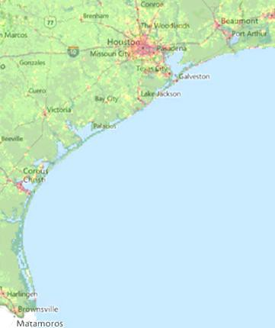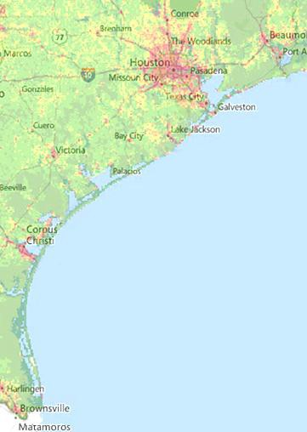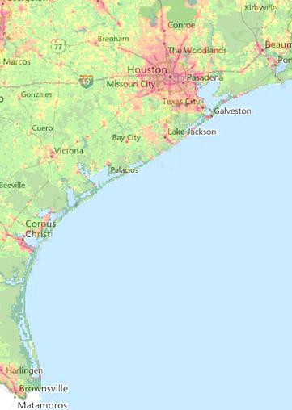
Housing Density 2030
Housing Density 1970
Housing Density 2000
Figure 13. Housing density maps, showing a visual increase in population density from the years 1970, 2000, and 2030. Source: Landscape America Atlas, 2014 (NatureServe).
The maps present a clear picture of how coastal development threatens the coastal system. Specifically, the maps show hot spots of high housing density in red, with low density in green. From 1970 to 2000, housing density increased dramatically in the three-core coastal urban areas (Houston-Galveston, Corpus Christi and Brownsville-South Padre). The projections for 2030 show an even more significant increase in housing density in these core areas. These areas, while home to core coastal urban centers, are also home to many essential habitats in which coastal species thrive. In addition, these increases in housing density also describe the increased population that will appear along the coast in the future. This dynamic has direct impacts on coastal hazards because of the number of people and built infrastructure that are put in harm’s way.

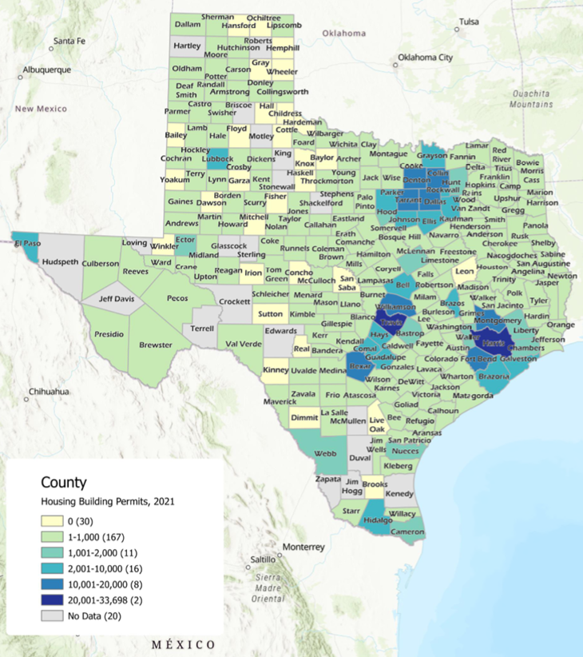

Figure 14. New Residential Housing Units in Texas Counties, 2021. Texas Demographic Center.

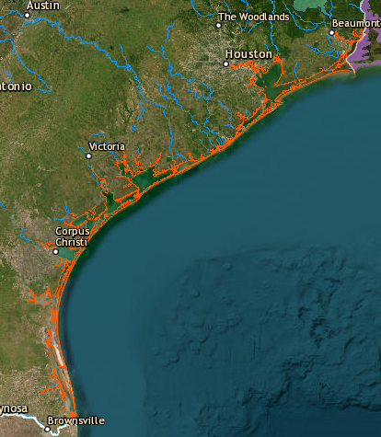

Figure 15. Texas Priority Conservation Areas, Environmentally Sensitive Shoreline, and Ecologically Unique Rivers. Source: Landscape America Atlas, 2014 (NatureServe), defined by The Nature Conservancy.

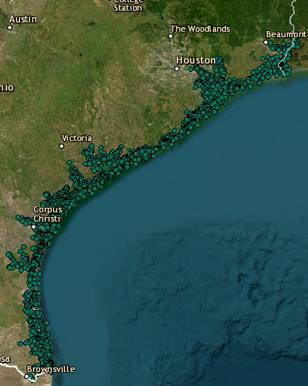

Figure 16. Texas Species Critical Habitat along the Texas coastal shore. Source: Landscape America Atlas, 2014 (NatureServe). Texas General Land Office created the Texas Gulf Coast Species / Habitat layer in 1995.
This map describes an inventory of specific places of coastal habitat and the species that use them. When comparing this map to housing density projections, there is concern as to the consequences in these special habitats.

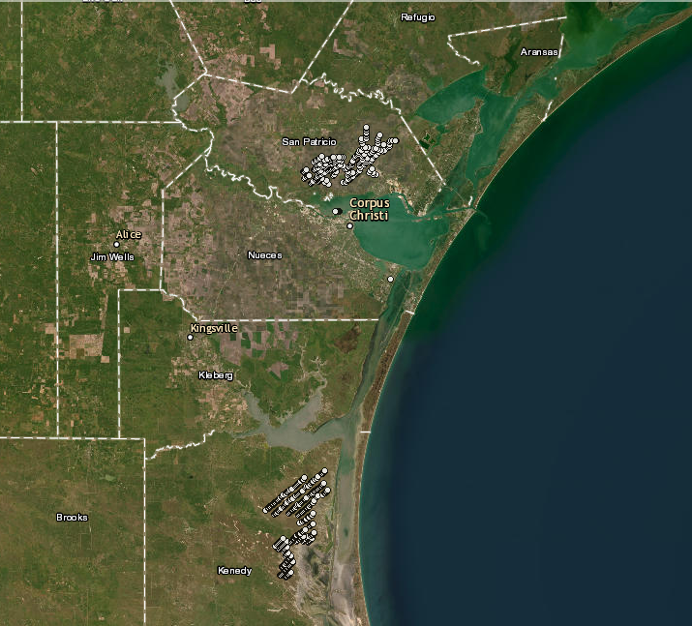

Figure 17. Texas Wind Turbines (FAA). Source: Landscape America Atlas, 2014 (NatureServe). The Federal Aviation Administration (FAA) created the Texas Windmills layer, Updated March 2012.

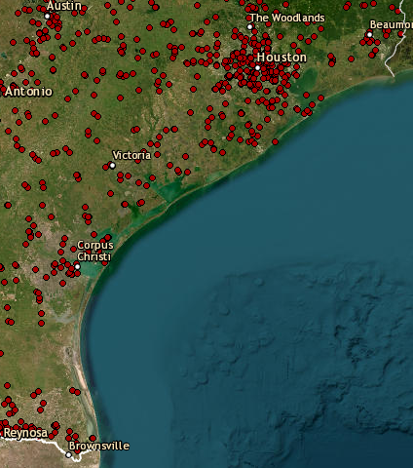

Figure 18. Texas Municipal Solid Waste Sites and Landfills. Landscape America Atlas, 2014 (NatureServe). The Texas Commission on Environmental Quality (TCEQ) created the Municipal Solid Waste Sites and Landfills Layer in April 2007.
Waste and landfills are located throughout the entire state but are also concentrated in core coastal urban areas. In addition, some are located very close to species habitats as seen in the species habitat map. As housing density and population continue to rise, more waste will increase landfill needs, further threatening the coastal environment by taking up valuable space better suited to other activities and causing potential pollution through landfill gas, leachate, or runoff.

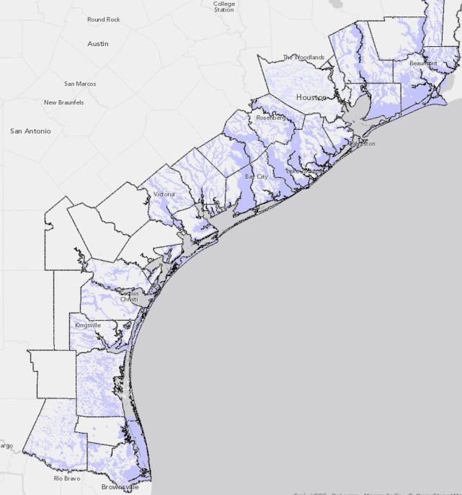
Figure 19. 100-year floodplain. Source: Texas Coastal Community Planning Atlas, 2014.

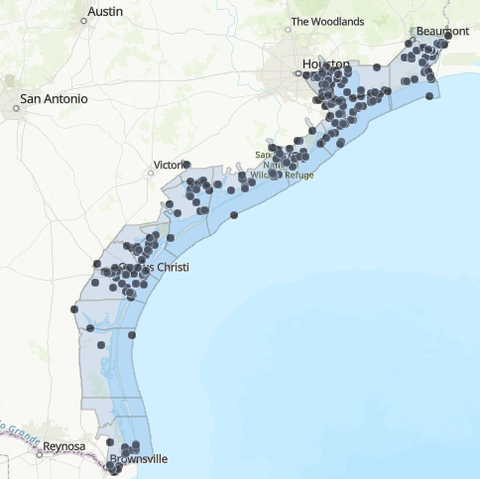

Figure 20. Location of Section 404 wetland permits, designated by the U.S. Army Corps of Engineers jurisdiction, indicating permits for development in the Coastal Boundary Zone, 2021-2023.

- Using the tables below as a guide, provide information on land cover changes and development trends. Be as quantitative as possible using state or national land cover data. The tables are a suggestion of how you could present the information. Feel free to adjust column and row headings to align with data and time frames available in your state or territory. If quantitative data on land cover changes and development trends are not available, provide a brief qualitative narrative describing changes in land cover, especially development trends, including significant changes since the last assessment.

Distribution of Land Cover Types in Coastal Counties
Land Cover Type | Land Area Coverage in 2021  (Acres) | Gain/Loss Since 1996  (Acres)
Developed, High Intensity | 675840 | 176595.2
Developed, Low Intensity | 486707.2 | 75308.8
Developed, Open Space | 276595.2 | 30835.2
Grassland | 768224 | -54278.4
Scrub/Shrub | 945369.6 | 14764.8
Barren Land | 400051.2 | 22630.4
Open Water | 2339545.6 | -9523.2
Agriculture | 3799750.4 | -162765
Forested | 679500.8 | -56678.4
Woody Wetland | 620608 | -37260.8
Emergent Wetland | 1014899.2 | 339.2

Development Status and Trends for Coastal Counties
 | 1996 | 2021 | Percent Net Change
Percent land area developed | 145.84 | 178.11 | 22.12
Percent impervious surface area | 55.08 | 73.23 | 32.95

How Land Use Is Changing in Coastal Counties
Land Cover Type | Areas Lost to Development Between 1996-2021 (Acres)
Barren Land | 4864
Emergent Wetland | 9497.6
Woody Wetland | 26662.4
Open Water | 1504
Agriculture | 108960
Scrub/Shrub | 19321.6
Grassland | 34188.8
Forested | 77728

- Briefly characterize how the coastal shoreline has changed in the past five years due to development, including potential changes to shoreline structures such as groins, bulkheads and other shoreline stabilization structures, and docks and piers. If available, include quantitative data that may be available from permitting databases or other resources about changes in shoreline structures.

The CMP and its partner program, Clean Coast Texas (CCT), emphasizes the use of green infrastructure including retrofit planning, constructed wetlands planning, and permeable pavement to mitigate the impacts of population growth and land use change.

- Briefly summarize the results of any additional state- or territory-specific data or reports on the cumulative and secondary impacts of coastal growth and development, such as water quality, shoreline hardening, and habitat fragmentation, since the last assessment.

Cities and counties Beach Access and Dune Management Plans and Erosion Response Plans address development and access in coastal areas. (See the Wetlands Enhancement section for more information). The state reviews local beach access plans and certifies that they meet the minimum state standards set forth in the General Land Office Beach/Dune Rules. These plans can address land use, development, and impervious surfaces, but are under the authority of local municipalities and counties. Changes taking place at the local level do not constitute state-level changes.

Management Characterization
- Indicate if the approach is employed by the state or territory and if there have been any significant state-level changes (positive or negative) in the development and adoption of procedures to assess, consider, and control cumulative and secondary impacts of coastal growth and development, including the collective effect on various individual uses or activities on coastal resources, such as coastal wetlands and fishery resources, since the last assessment.

Significant Changes in Management of Cumulative and Secondary Impacts of Development
Management Category | Employed by State or Territory  (Y or N) | CMP Provides Assistance to Locals that Employ  (Y or N) | Significant Changes Since Last Assessment  (Y or N)
Statutes, regulations, policies, or case law interpreting these | Y | Y | N
Guidance documents | Y | Y | Y
Management plans (including SAMPs) | N | Y | Y

Cities and counties Beach Access and Dune Management Plans and Erosion Response Plans address development and access in coastal areas. (See the Wetlands Enhancement section for more information). The state reviews local beach access plans and certifies that they meet the minimum state standards set forth in the General Land Office Beach/Dune Rules. These plans can address land use, development, and impervious surfaces, but are under the authority of local municipalities and counties. Changes taking place at the local level do not constitute state-level changes.

- For any management categories with significant changes, briefly provide the information below. If this information is provided under another enhancement area or section of the document, please provide a reference to the other section rather than duplicate the information:
  - Describe the significance of the changes;
  - Specify if they were 309 or other CZM-driven changes; and
  - Characterize the outcomes or likely future outcomes of the changes.

Coastal Nonpoint Source Pollution (NPS)/Clean Coast Texas (CCT)
On May 19, 2022, NOAA and EPA notified GLO and TCEQ that the State of Texas fully satisfied all conditions established in the 2003 ruling requiring additional efforts to gain compliance with the Coastal Zone Act Reauthorization Amendment.
During the final federal review period in 2021, GLO initiated efforts to develop program resources necessary to implement unmet Management Measure requirements. Accordingly, Texas focused on urban management measures related to New and Existing Site Development, Watershed Protection, Septic System Regulatory Inspections Roads, Highways and Bridges, and associated administration.

In 2021, the State of Texas Coastal NPS Pollution Management program rebranded its community engagement efforts and launched the CCT program in January of that year. GLO led efforts to build and recruit a multi-disciplinary team who have proven success at working with communities to enhance their management of NPS and stormwater pollution. This team consisted of universities and non-government organizations from Texas State University – San Marcos Meadows Center for Water and Environment, Texas AgriLife Extension Texas Community Watershed Partners, Texas Sea Grant, and an engineering firm.

Building on efforts from 2020, initial work in 2021 focused on developing implementation resources for CCT. While assisting coastal communities in developing or revising local policies/ordinances that enhance the management of NPS pollution is priority, other supporting resources were also necessary to meet a wide array of local needs and challenges. Some of these tools and resources include: building the CCT website at www.cleancoast.texas.gov, updating the Guidance for Sustainable Stormwater Drainage manual, developing a menu of services, developing story maps that engage and communicate with local decision makers, developing green infrastructure and low impact development workshops, developing local planning workshops, conducting surveys and one-on-one or small group interviews to understand needs, hosting stakeholder numerous meetings, developing online and hard copy infographics, creating and hosting numerous monthly online workshops that teach stakeholders how to management NPS pollution, conducting in-depth coastal zone boundary water quality and land use analysis, implementing strategies to revise ordinances, and other related resources.

By 2022, CCT was interacting with 1000s of target stakeholders, who include elected officials, staff, influencers, decision makers, and developers. Some highlights include over 120 community interactions by CCT Collaborative team members:

- 17 CCT community workshops and events that include efforts spanned from training new citizens scientists to supporting coastal communities in hazard mitigation and resiliency planning with green stormwater infrastructure. One highlight was the successful pilot of a GIS-based Flow Assessment and Stormwater Technology workshop in Kingsville, TX on August 10, 2022. This workshop integrated water quality and local stormwater planning.
- 1,967 event attendees including 763 participants for the CCT Lunch and Learn series.
- Four Comprehensive Plans supported including the City of Hitchcock, City of Rockport, Willacy County, and Ingleside on the Bay.
- Four Memorandums of Agreement formalizing CCT partnerships with Aransas County, City of Rockport, Town of Fulton, and the Aransas County Navigation District.
- A technical committee has been established to consider updates to local drainage criteria, ordinances, and adoption of Guidance for Sustainable Stormwater Drainage on the Texas Coast.

After much community engagement, CCT was still seeking success in implementing local ordinance revision in 2023. CCT expanded its services to also include retrofit planning, constructed wetlands planning, grant development and application resources, community funding guide, and availability of technical engineering services to be responsive to unique local stormwater challenges. Partner communities slowly began to build momentum, and agreements were established with Nueces County, Ingleside on the Bay, Port Lavaca, La Marque, Port Aransas, Rockport, Fulton, Aransas County, Aransas County Navigation District, and Galveston.

In 2024, CCT hosted 22 events, engaged with 15 communities, had 868 attendees, conducted ordinance planning and provided engineering support, brought more than 40 organizations together to support the program, and have 4 active green stormwater infrastructure projects under design or being constructed.

In hopes of enhancing the program’s progress, GLO reorganized the CCT team and brought on new partnering organizations in late 2024. Texas A&M – Corpus Christi Harte Research Institute of Gulf of America Studies was installed to lead coastal engagement and coordinate the collaboration. The Coastal Bend Council of Government, who has a core mission of assisting Coastal Bend communities with water quality planning, has also joined the team. CCT has strategically divided the Coastal Zone into two main regions, with HRI leading efforts in the middle and lower coast and Texas Community Watershed Partners leading engagement efforts in the upper coastal region. All engagement assets are now located on the waterfront, and we aim to significantly improve opportunities for ordinance adoption, coastal planning, and related project objectives.

Enhancement Area Prioritization
- What level of priority is the enhancement area for the coastal management program?
High ____
Medium __x__
Low _____

- Briefly explain the reason for this level of priority. Include input from stakeholder engagement, including the types of stakeholders engaged.

The coastal population in Texas is increasing and this trend is predicted to continue in the future leading to increased demand for and use of coastal resources. This leads to expanded cumulative and secondary impacts to coastal communities and the local environments on which they depend. The cumulative and secondary impacts to this enhancement area is deemed medium priority because significant changes to the coastal environment pose threats to ecosystem health and function, the services they provide to human populations, and the overall resilience of coastal and marine systems. Impacts to natural resources are projected to remain high due to increasing development in the coastal zone, coupled with projected regional relative sea level rise effects.

However, the Texas CMP made large strides towards tackling this issue in the last Assessment with the success of its coastal NPS pollution strategy (see above). Future Implementation of the Coastal NPS pollution program through various other funding streams will help tackle many of the current cumulative and secondary impacts affecting coastal resources today.

Special Area Management Planning

Section 309 Enhancement Objective: Preparing and implementing special area management plans for important coastal areas. §309(a)(6)

The Coastal Zone Management Act defines a special area management plan (SAMP) as “a comprehensive plan providing for natural resource protection and reasonable coastal-dependent economic growth containing a detailed and comprehensive statement of policies; standards and criteria to guide public and private uses of lands and waters; and mechanisms for timely implementation in specific geographic areas within the coastal zone. In addition, SAMPs provide for increased specificity in protecting natural resources, reasonable coastal-dependent economic growth, improved protection of life and property in hazardous areas, including those areas likely to be affected by land subsidence, sea level rise, or fluctuating water levels of the Great Lakes, and improved predictability in governmental decision making.”

Phase 1 (High-level) Assessment: (Must be completed by all states and territories.)
Purpose: To quickly determine whether the enhancement area is a high-priority enhancement objective for the CMP that warrants a more in-depth assessment. The more in-depth assessments of Phase II will help the CMP understand key problems and opportunities that exist for program enhancement and determine the effectiveness of existing management efforts to address those problems.

Resource Characterization
- In the table below, identify geographic areas in the coastal zone subject to use conflicts that may be able to be addressed through a SAMP. This can include areas that are already covered by a SAMP but where new issues or conflicts have emerged that are not addressed through the current SAMP.

Geographic Area | Opportunities for New or Updated Special Area Management Plans  Major conflicts/issues
Coastal Zone | Opportunities exist for development of SAMPs, but SAMPs are not currently authorized in Texas*

- If available, briefly list and summarize the results of any additional state- or territory-specific data or reports on the status and trends of SAMPs since the last assessment.

This is not applicable in Texas.

Management Characterization
- Indicate if the approach is employed by the state or territory and if there have been any significant state- or territory-level management changes (positive or negative) that could help prepare and implement SAMPs in the coastal zone.

Significant Changes in Special Area Management Planning
Management Category | Employed by State or Territory  (Y or N) | CMP Provides Assistance to Locals that Employ  (Y or N) | Significant Changes Since Last Assessment  (Y or N)
SAMP policies, or case law interpreting these | N | N | N
SAMP plans | N | N | N

- For any management categories with significant changes, briefly provide the information below. If this information is provided under another enhancement area or section of the document, please provide a reference to the other section rather than duplicate the information:
  - Describe the significance of the changes;
  - Specify if they were 309 or other CZM-driven changes; and
  - Characterize the outcomes or likely future outcomes of the changes.

None.

Enhancement Area Prioritization
- What level of priority is the enhancement area for the coastal management program?

No priority given, as SAMPs are prohibited by the Texas Legislature.

High _____
Medium _____
Low _____

- Briefly explain the reason for this level of priority. Include input from stakeholder engagement, including the types of stakeholders engaged.

This section is not applicable, as development and approval of SAMPs by the CMP is prohibited.

Ocean Resources
Section 309 Enhancement Objective: Planning for the use of ocean [and Great Lakes] resources. §309(a)(7)

Phase 1 (High-level) Assessment: (Must be completed by all states and territories.)
Purpose: To quickly determine whether the enhancement area is a high-priority enhancement objective for the CMP that warrants a more in-depth assessment. The more in-depth assessments of Phase II will help the CMP understand key problems and opportunities that exist for program enhancement and determine the effectiveness of existing management efforts to address those problems.

Resource Characterization
- Understanding the ocean and Great Lakes economy can help improve management of the resources it depends on. Using Economics: National Ocean Watch (ENOW), indicate the status of the ocean and Great Lakes economy as of 2021 (the most recent data) in the tables below. Include graphs and figures, as appropriate, to help illustrate the information. Note ENOW data are not available for the territories. The territories can provide alternative data, if available, or a general narrative, to capture the value of their ocean economy.

Status of Ocean and Great Lakes Economy for Coastal Counties (2021)
 | All Ocean Sectors | Living Resources | Marine Construction | Ship & Boat Building | Marine Transportation | Offshore Mineral Extraction | Tourism & Recreation
Employment  (# of Jobs) | 164,145 | 3,652 | 7,397 | 1152 | 34,280 | 58,138 | 47,995
Establishments  (# of Establishments) | 5856 | 248 | 169 | 33 | 677 | 1854 | 2,471
Wages | $14,486B | $165.6M | $53M | $95.3M | $1.7B | $10.3B | $1.05B
GDP | $94.400B | $482.3 | $951.8M | $290.6M | $2.2B | $84.2B | $2.13B

Change in Ocean and Great Lakes Economy for Coastal Counties (2005-2021)
 | All Ocean Sectors | Living Resources | Marine Construction | Ship & Boat Building | Marine Transportation | Offshore Mineral Extraction | Tourism & Recreation
Employment  (# of Jobs) | 192,067 | 6,902 | 7,021 | 3,779 | 31,910 | 92,272 | 50,182
Establishments  (# of Establishments) | 6,197 | 426 | 148 | 99 | 752 | 2,482 | 2,290
Wages  (Millions of Dollars) | $19,000 | $146.3 | $462.2 | $232.1 | $1,900 | $15,400 | $884.4
GDP  (Millions of Dollars) | $71,800 | $482.3 | $946.3 | $493.7 | $4,200 | $63,800 | $1,900

- Understanding existing uses within ocean and Great Lakes waters can help reduce use conflicts and minimize threats when planning for ocean and Great Lakes resources. Using Ocean Reports, indicate the number of uses within the ocean or Great Lakes waters off of your state. To avoid duplication, energy uses (including pipelines and cables) are reported under “Energy and Government Facility Siting” in the following template. However, feel free to include energy uses in this table as well if listing all uses within ocean and Great Lakes waters in one place is preferred. Add additional lines, as needed, to include additional uses that are important to your state. Note: The Ocean Reports tool does not include data for the Great Lakes states. Great Lakes states should fill in the table as best they can using other data sources.

Uses within Ocean or Great Lakes Waters
Type of Use | Number of Sites
Federal sand and gravel leases (Completed) | N/A
Federal sand and gravel leases (Active) | N/A
Federal sand and gravel leases (Expired) | N/A
Federal sand and gravel leases (Proposed) | N/A
Beach Nourishment Projects | 42
Ocean Disposal Sites | 555
Principle Ports (Number and Total Tonnage) | 9 / 267,396,216
Coastal Maintained Channels | 43
Designated Anchorage Areas | 11
Danger Zones and Restricted Areas | 1
Other (please specify)

- In the table below, characterize how the threats to and use conflicts over ocean and Great Lakes resources in the state’s or territory’s coastal zone have changed since the last assessment.

Significant Changes to Ocean and Great Lakes Resources and Uses
Resource/Use  Change in the Threat to the Resource or Use Conflict | Since Last Assessment  (↑, ↓, −, unknown)
Benthic habitat (including coral reefs) | ↑
Living marine resources (fish, shellfish, marine mammals, birds, etc.) | ↑
Sand/gravel | ↑
Cultural/historic | ↑
Other (please specify) | −
Transportation/navigation | ↑
Offshore development | ↑
Energy production | ↑
Fishing (commercial and recreational) | ↑
Recreation/tourism | ↑
Sand/gravel extraction | ↑
Dredge disposal | −
Aquaculture | ↑
Other (please specify) | −

- For those ocean and Great Lakes resources and uses in the table above that had an increase in threat to the resource or increased use conflict in the state’s or territory’s coastal zone since the last assessment, characterize the major contributors to that increase. Place an “X” in the column if the use or phenomenon is a major contributor to the increase.

Major Contributors to an Increase in Threat or Use Conflict to Ocean
and Great Lakes Resources
 | Land-based development | Offshore development | Polluted runoff | Invasive species | Fishing (Commercial and Recreational) | Aquaculture | Recreation | Marine Transportation | Dredging | Sand/Mineral Extraction | Ocean Acidification | Other (Specify)
Benthic Habitat |  | X | X |  |  |  |  | X | X
Living marine resources | X | X | X | X | X |  | X | X |  |  | X
Cultural/historic | X |  | X |  |  |  |  |  | X
Offshore Development31 |  | X | X
Energy Production |  | X | X
Fishing (Commercial and  Recreational) |  |  | X | X | X |  |  |  |  |  | X
Recreation and Tourism |  |  | X |  |  |  |  |  |  |  | X

- If available, briefly list and summarize the results of any additional state- or territory-specific data or reports on the status and trends of ocean and Great Lakes resources or threats to those resources since the last assessment to augment the national data sets.
Continuous threats to maintaining viable populations of all oceanic species include erosion, severe storm surge, marine habitat loss, bycatch, invasive species, NPS pollution, hypoxia, decreased freshwater inflows, and ocean acidification, as described below.

Erosion and severe storm surge are stressors to ocean resources as they change environmental conditions and lead to habitat loss. Ocean resources provide a suite of ecosystem services including the provision of habitat, protection against storms and flooding, erosion control, food, recreational opportunities, and water purification (waste and nutrient regulation). Erosion and storm surge are direct threats to these services, along with other factors such as decreased river discharges, alteration of water flows, development and damage from commercial and recreational use, NPS source pollution, and invasive species.

Habitat loss can have significant impacts on marine species populations and may result from erosion and storm surge, decrease in river discharges, alteration of water flows, and damage from commercial and recreational use among other things. The removal of oil platforms can also contribute to loss of marine habitat. An alternative to their complete removal is to convert these platforms into artificial reefs. The Department of Interior’s Bureau of Safety and Environmental Enforcement developed a “Rigs-to-Reefs” national policy that allows non-producing oil platforms to be converted into artificial reefs, creating marine habitat. The program has been popular among fishermen, the oil industry, and regulators around the Gulf of America. Texas has an Artificial Reef Plan and Program that allows the TPWD to enhance, promote, maintain and monitor the artificial reefs off the Texas coast. There are currently 66 artificial reef sites in Texas a total of 5.37 sq. mi. of important habitat supporting activities such as commercial and recreational fishing and diving

Bycatch from commercial trawl and other fisheries threaten non-target species in all life history stages as well as endangered and threatened species. In response to this threat, in 1998 the National Marine Fisheries Service (NMFS) implemented the use of bycatch reduction devices (BRD) by Gulf shrimp trawlers. This implementation is estimated to save millions of juvenile red snapper and other finfish from being caught in shrimp trawls (Fletcher, 2014). To reduce regulatory conflict between state and federal mandates and to ensure shrimp vessels can fish in both state and federal waters, TPWD mandates shrimp trawlers be equipped with BRDs and only approves BRD devices previously approved by NMFS (Riechers, 2010).

Invasive species are known to pose a threat to indigenous habitats, food webs, and marine species. Although some invasive species arrive because of warming temperatures, most invasive species are transported by commercial vessels ballast water, ship hulls, or by accidental or intentional release from marine aquaria and aquaculture facilities. The Texas Invasive Species Coordinating Committee was established in 2009 to coordinate state agencies efforts and prevent and manage invasive species in Texas (Texas Parks and Wildlife Department, 2019b; Texas Invasives, 2024).

Water quality and quantity, which are crucial for healthy ocean resources and coastal populations, are continuously affected by development, NPS pollution and decreased freshwater inflows. As human population increases and land use changes, so do the impacts of NPS. The infamous “dead zone” in the Gulf of America (off the coast of Louisiana and part of Texas) illustrates the environmental impact NPS can have. Dead zones occur when fertilizer runoff congests waterways with nutrients, such as nitrogen and phosphorous, leading to an explosion of microbes that consume oxygen and deplete the water of oxygen, killing fish and other marine life. The CWA requires states to develop a program to protect water resources from NPS pollution. In Texas, the NPS Management Program is cooperatively administered by the Texas State Soil and Water Conservation Board and the TCEQ, works to prevent and reduce NPS pollution.

The TPWD’s Kills and Spills Team (KAST) investigate fish and wildlife kills consequent of pollution and natural events. KAST assesses the impacts to fish and wildlife, and investigates the causes of the incidents, which are divided in two broad categories: natural causes and human activities. In Texas, the most common natural cause of fish kills is low dissolved oxygen, i.e. hypoxia. The most common cause of fish kills due to human activities include toxic releases of chemicals, fertilizers, crude oil, used oil, sewage, and pesticides.

Freshwater inflows determine water quality by transporting nutrients and diluting salinities in estuaries, and balancing erosion rates by delivering sediments. Freshwater, nutrients, and sediments are all necessary to sustain estuarine and marine life (TWDB, 2019). However, decades of diverting water from rivers and streams have reduced freshwater inflows to the coast. Decreased freshwater inflows can cause loss of habitat, productivity, and biodiversity. Thus, as the upstream demand for freshwater continues, the ability to effectively manage freshwater inflows becomes increasingly critical (Harte Research Institute, 2019).

Ocean acidification occurs due to changes in the ocean’s chemistry as seawater absorbs much of the carbon dioxide that is in the atmosphere and as carbon enters the water from land-based sources. As a result, there is an increase in CO₂ concentration, a decrease in pH, and a change in the inorganic carbon chemistry of seawater. This increase in acidity alters conditions required for oysters, clams, corals, and other animals that build shells and skeletons and is thought to promote shifts in community structure, specifically in marine phytoplankton (Bercel T. & Kranz S, 2019). In 2009, Congress approved the Federal Ocean Acidification Research and Monitoring Act to oversee and gain a better understanding of how acidification affects important national fisheries. Without relevant information, industries that depend on fish and shellfish populations won’t know how to protect their businesses. If acidification harms fisheries that are important to the Gulf of America’s food web, this could have significant impacts in the state of Texas’ seafood industry, which is important not only locally, but nationally.

Looking at future threats, the increase in offshore oil development planned for the Western Gulf of America, such as the Texas Gulf Link Deepwater Port, will increase threats to marine resources (Oil and Gas Watch, 2022). See the Energy and Government Facility Siting section below.

Management Characterization
- Indicate if the approach is employed by the state or territory and if any significant state- or territory-level changes (positive or negative) in the management of ocean and Great Lakes resources have occurred since the last assessment?

Significant Changes to Management of Ocean and Great Lakes Resources
Management Category | Employed by State or Territory  (Y or N) | CMP Provides Assistance to Locals that Employ  (Y or N) | Significant Changes Since Last Assessment  (Y or N)
Statutes, regulations, policies, or case law interpreting these | Y | N | N
Regional comprehensive ocean/Great Lakes management plans | Y | Y | N
State comprehensive ocean/Great Lakes management plans | N | N | Y
Single-sector management plans | Y | Y | Y

- For any management categories with significant changes, briefly provide the information below. If this information is provided under another enhancement area or section of the document, please provide a reference to the other section rather than duplicate the information:
  - Describe the significance of the changes;
  - Specify if they were 309 or other CZM-driven changes; and
  - Characterize the outcomes or likely future outcomes of the changes.

Single-Sector Management Plan
TPWD enacted a new saltwater fishing regulation in 2022 that reduced the bag limit on speckled trout from five to three fish per day.

- Indicate if your state or territory has a comprehensive ocean or Great Lakes management plan.

Comprehensive Ocean/Great Lakes Management Plan | State Plan | Regional Plan
Completed plan (Y/N) (If yes, specify year completed) | Y (2017, 2019) | N
Under development (Y/N) | Y (2028 release) | N
Web address (if available) | http://www.glo.texas.gov/coast/coastal-management/coastal-resiliency/index.html | N/A
Area covered by plan | Texas | Gulf of America Region

Enhancement Area Prioritization
- What level of priority is the enhancement area for the coastal management program?
High _ ___
Medium __x__
Low _____

- Briefly explain the reason for this level of priority. Include input from stakeholder engagement, including the types of stakeholders engaged.

Ocean resources, including fish and wildlife, commercial and recreational fishing, oil and gas exploration, shipping, and tourism have a high economic value and human demand; the livelihood of coastal populations depends on these resources. Ocean resources are designated as a medium priority enhancement area for the Texas CMP because of the variety of factors that could potentially negatively impact them, explained above. However, the CMP feels each of these factors is being addressed in its own unique way by the appropriate Texas resource agency with the hope that research and development in each stressor category will, over time, result in positive overall impacts to Ocean resources.

Energy and Government Facility Siting
Section 309 Enhancement Objective: Adoption of procedures and enforceable policies to help facilitate the siting of energy facilities and Government facilities and energy-related activities and Government activities which may be of greater than local significance. §309(a)(8)

Phase 1 (High-level) Assessment: (Must be completed by all states and territories.)
Purpose: To quickly determine whether the enhancement area is a high-priority enhancement objective for the CMP that warrants a more in-depth assessment. The more in-depth assessments of Phase II will help the CMP understand key problems and opportunities that exist for program enhancement and determine the effectiveness of existing management efforts to address those problems.

Resource Characterization
- In the table below, characterize the status and trends of different types of energy facilities and activities in the state’s or territory’s coastal zone based on best-available data. If available, identify the approximate number of facilities by type. For ocean-facing states and territories (not Great Lakes states), Ocean Reports includes existing data for many energy facilities and activities.

Status and Trends in Energy Facilities and Activities in the Coastal Zone
Type of Energy Facility/Activity | Exists in Coastal Zone  (# or Y/N) | Change in Existing Facilities/Activities Since Last Assessment (↑, ↓, −, unknown) | Proposed in Coastal Zone  (# or Y/N) | Change in Proposed Facilities/Activities Since Last Assessment (↑, ↓, −, unknown)
Pipelines | Y | ↑ | Y | ↓
Electrical grid (transmission cables) | Y | ↑ | Y | ↓
Ports | Y | − | N | unknown
Liquid natural gas (LNG) | Y (2-E, 2-I) | ↑ | Y (10-E, 1-I) | ↑
Electric Power Facilities (Oil) | Y | − | unknown | unknown
Electric Power Facilities (Gas) | Y | − | unknown | unknown
Electric Power Facilities (Coal) | N | − | N | −
Electric Power Facilities (Nuclear) | Y | − | N | −
Electric Power Facilities (Wave) | N | − | N | −
Electric Power Facilities (Tidal) | N | − | N | −
Electric Power Facilities (Current. Ocean, lake, river) | N | − | N | −
Electric Power Facilities (Hydropower) | N | − | N | −
Electric Power Facilities (Ocean thermal energy conversion) | N | − | N | −
Electric Power Facilities (Solar) | Y | ↑ | N | −
Electric Power Facilities (Biomass) | Y | ↓ | N | −

- If available, briefly list and summarize the results of any additional state- or territory-specific information, data, or reports on the status and trends for energy facilities and activities of greater than local significance in the coastal zone since the last assessment.

Pipelines
Major pipelines (>50 miles) constructed or under construction between 2015-2019 include: (Company – Length - Coastal Counties) (Texas Railroad Commission 2024)
- Kinder Morgan Tejas Pipeline LLC – 62 miles – Brazoria
- Plains Pipeline LP – 502 miles – Lavaca, Refugio, San Patricio
- Plains Pipeline LP – 109 miles – Chambers, Harris, Jefferson
- Enterprise Products Operating LLC – 131 miles – Harris, Galveston, Brazoria, Matagorda, Jackson, Calhoun
- Enterprise Products Operating LLC – 91 miles – Harris, Galveston, Brazoria, Matagorda
- City of Port Aransas Gas Dept. – 60 miles - Nueces
- DCP Operating Company – 485 miles – Victoria, Jackson, Brazoria
- Pecan Pipeline Company – 54 miles – Nueces
- Marathon – 235 miles – Brazoria, Victoria, Matagorda
- Enterprise Products Operating LLC – 554 – Chambers
- Epic Consolidated OPS LLC – 95 miles – San Patricio, Nueces
- Epic Consolidated OPS LLC – 118 miles - San Patricio, Refugio, Calhoun, Victoria, Matagorda, Jackson
- Energy Transfer Company – 62 miles – Chambers, Jefferson
- AMP NGL Pipeline LLC – 98 miles – Brazoria
- Epic Consolidated OPS LLC – 138 miles - San Patricio, Refugio, Calhoun, Victoria, Matagorda, Jackson

Electric Grid Major Changes/Improvements Since Last Report
The Electric Reliability Council of Texas (ERCOT) acts as the independent organization under the Public Utility Regulatory Act and is responsible for coordinating market transactions, system-wide transmission planning and network reliability, and ensuring the reliability and suitability of the regional electric network. Every year, ERCOT assesses the transmission system by addressing issues of reliability of transmission lines, economic transmission needs, and recommendations for future improvements.

The congestion costs ($2.4 billion) and ERCOT’s real-time market were down 15% from 2022, largely attributed to the lower natural gas prices in 2023. Houston experiences much lower congestion due to 2022 needing to accommodate transmission upgrades which were completed prior to 2023 (ERCOT, 2023).

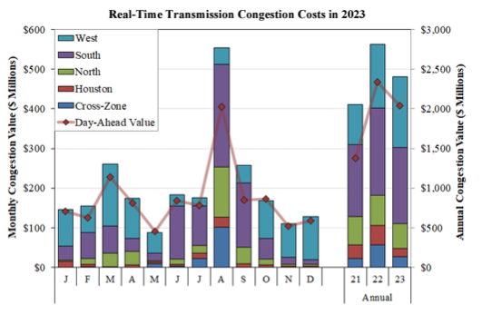
Figure 21. Real-Time Transmission Congestion Costs. From ERCOT 2023.

Ports
Texas ports (marine terminals where marine cargo and cruise activity occurs) play a crucial role in the State’s transportation system and are a critical part of the State’s economy. According to Texas Ports Association, Texas ports generate $450 billion in economic activity and $7.8 billion in state and local taxes (up from $6.89 billion) (Texas Department of Transportation, 2024). They handle over 629 million tons of foreign and domestic cargo annually. Six of the state’s ports are ranked in the top 20 U.S. ports by total tonnage: Beaumont, Corpus Christi, Houston, Port Arthur, and Texas City (Texas Department of Transportation, 2024).

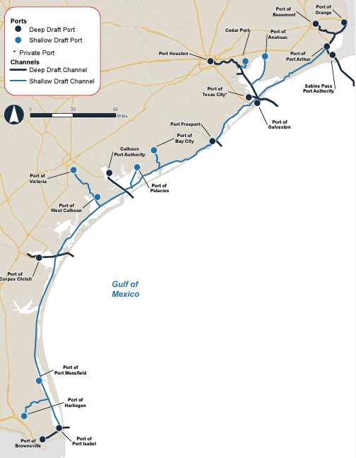
Figure 22. Texas Sea Ports. Source: txdot.gov.

Deep Water Ports (DWP)
Between 2015 and 2019, the Department of Interior’s Bureau of Ocean Energy Management (BOEM) held two lease sales for the Western Gulf of America covering a total of 328,000 acres for oil and gas development in the U.S. Outer Continental Shelf (OCS) offshore Texas. Today, Texas has three pending (and one issued) DWP license applications. All DWP applications are required to be consistent with the Texas CMP and the Texas Governor must approve or deny each Texas DWP application. The status for each DWP application is listed below.

SPOT (Sea Port Oil Terminal, LLC):
SPOT has applied to own, construct, and operate a DWP to export domestically produced crude oil approximately 27.2 to 30.8 nautical miles off the coast of Freeport. The GLO issued a conditional concurrence June 21, 2021. The Final Environmental Impact Statement (FEIS) was published August 23, 2022. On August 31, 2022, Governor Abbott issued his approval for the issuance of the DWP license. On November 21, 2022, the Maritime Administrator issued the SPOT Record of Decision, with conditions. The Maritime Administrator signed the SPOT Terminal Services LLC DWP license April 08, 2024.
GulfLink (Texas GulfLink, LLC):
Gulflink has applied to own, construct, and operate a DWP to export domestically produced crude oil approximately 28.3 nautical miles off the coast of Brazoria County. The GLO’s conditional concurrence was issued April 13, 2023. The FEIS was published July 4, 2024, and Governor Abbott’s approval letter dated October 2, 2024, was issued.

Bluewater (Bluewater Texas Terminals, LLC):
Bluewater has applied to own, construct, and operate a DWP to export domestically produced crude oil approximately 15 nautical miles off the coast of San Patricio County. The Draft Environmental Impact Statement (DEIS) was published for public notice and comment October 28, 2021, and the USACE public notice was published November 18, 2021. A supplemental DEIS is in progress.

Blue Marlin Onshore Port, LLC:
Blue Marlin Onshore Port has applied to develop a DWP site in the Gulf of America to provide crude oil transportation and loading services for crude oil produced in the continental United States. The project extends from Nederland, Texas to Cameron Parish, Louisiana. The application was deemed administratively complete on October 22, 2020, and two public scoping meetings were held on December 2, 2020, and December 3, 2020, for the communities of Cameron Parish, Louisiana and Jefferson County and Orange County, Texas. The DEIS was published in early 2025.

Liquefied Natural Gas (LNG)
The Federal Energy Regulatory Commission (FERC) is the authorizing agency for the siting and construction of onshore and near-shore Liquid Natural Gas (LNG) import and export facilities under Section 3 of the Natural Gas Act. As part of the requirements set by the National Environmental Policy Act, FERC prepares environmental assessments or impact statements for proposed LNG facilities under its jurisdiction. Once the projects are approved and built, they are overseen by FERC for as long as they are in operation. Currently, FERC regulates twenty-six LNG facilities in Texas (FERC, 2024).

The Coastal Zone has the following LNG terminals (FERC, 2024):
- Existing
  - Export Terminal
    - Corpus Christi, TX: 0.71 Bcfd (Cheniere – Corpus Christi LNG Train 1)
    - Freeport, TX: 2.13 Bcfd (Freeport LNG Dev/Freeport LNG Expansion
  - Import Terminals
    - Freeport, TX: 1.5 Bcfd (Cheniere/Freeport LNG Dev.)
    - Sabine Pass, TX: 2.0 Bcfd (ExxonMobil – Golden Pass) (Phase I & II)
- Approved, Not Yet Built
  - Export Terminals
    - Under Construction
      - Sabine Pass, TX: 2.1 Bcfd (ExxonMobil – Golden Pass) (CP14-517)
      - Brownsville, TX: 3.73 Bcfd (Rio Grande LNG – NextDecade) (CP16-454)
      - Corpus Christi, TX: 1.58 Bcfd (Cheniere – Corpus Christi LNG Stage 3) (CP18-512)
      - Port Arthur, TX: 1.86 Bcfd (Port Arthur LNG Trains 1 & 2) (CP17-20)
    - Not Under Construction
      - Freeport, TX: 0.72 Bcfd (Freeport LNG Dev) (CP17-470)
      - Brownsville, TX: 0.55 Bcfd (Texas LNG Brownville) (CP16-116)
      - Port Arthur, TX: 1.86 (Sempra – Port Arthur LNG Trains 3 & 4) (CP20-55)
- Proposed Terminals
  - Export terminals
    - Corpus Christi, TX: 0.45 Bcfd (Cheniere Corpus Christi Midscale Trains 8-9) (CP23-129)

Propane and Crude Export Facilities
In 2018, Moda Midstream, LLC acquired the Ingleside, TX propane and crude export facility from Occidental Petroleum at Ingleside Energy Center, LLC (NS Energy, 2021). The facility began operation in 2015 and has crude storage capacity of 15.3 million barrels and an export capacity of 1.6 million barrels a day. This facility is one of the biggest crude export terminals by volume in the US.

In April 2024, the U.S. Maritime Administration approved construction for an offshore oil export terminal in the Gulf of America, 30 miles off Freeport, TX. The project includes two pipelines to shore and one onshore line to an inland terminal. The project must be completed by Dec 31, 2028, and would allow access to up to 7 million barrels per day of oil supply from nearby basins (S&P Global, 2023).

Oil and Gas
At the beginning of 2019, Texas’ oil production surpassed the production of every Organization of Petroleum Exporting Countries country, except for Saudi Arabia and Iraq. Texas’ production, mainly driven by Eagle Ford Shale in South Texas, the Permian Basin in West Texas, and Barnett Shale in North Texas, is approximately 4.6 million barrels a day. Texas oil production is expected to exceed 5.6 million barrels per day in 2024 (US Energy Information Administration, 2024).

As of July 2024, Texas leads the nation in crude oil refining capacity with 34 petroleum refineries (30 in the previous assessment) with 22 on the Texas coast. With a capacity of over 6.3 million barrels of crude oil per day (5.7 million in the previous assessment), this accounts for approximately 31 percent of the total U.S. refining capacity (29 percent in the previous assessment). Texas also leads the nation in natural gas production - accounting for approximately 27% of the U.S. marketed natural gas production in 2024. In the Texas coastal zone, there are currently 64 oil and gas energy facilities and 9 natural gas processing plants along the coast, including: 3 petroleum power plants, 34 petroleum refineries, 9 natural gas processing plants, and 18 ethylene cracker plants.

Natural Gas Power Plants
Since the last assessment, approximately 12 additional natural gas power plants were built along the Texas coast. Thus, in addition to processing plants and refineries, the coastal zone has 66 natural gas power plants.

Coal
Texas is the seventh largest coal producer in the country and number two lignite producer. Currently, Texas only produces lignite, the lowest grade of coal, with most lignite reserves found in the Texas Gulf Coast region. Texas is also the leading State in coal consumption with its emissions of carbon dioxide and sulfur dioxide the highest among the nation (U.S. Energy Information Administration, 2024).

There are no coal power plants in the coastal zone, but two are very close to the region: WA Parish Power Plant located outside Houston in Fort Bend County and Coleto Creek Power Plant located in Fannin, Goliad County (U.S. Energy Information Administration, 2024). In Texas, there are a total of 15 coal power plants, but the development of new ones may prove challenging given the availability and lower price of natural gas, coal emissions of atmospheric pollutants and greenhouse gases, and the federal regulatory requirements for lower emissions. One-third of coal fired power plants in Texas are scheduled for retirement by 2023 (Texas Comptroller, 2024). Coal provided 10.8% of Texas’s electric-generating capacity in 2023 (Texas Comptroller, 2024).

Nuclear
Texas has two nuclear power plants, one of which is in the coastal zone, the South Texas Project Plant located in Matagorda County. The South Texas Project Plant has two reactors, and two more were proposed, and, despite receiving approval in 2016, were later cancelled (U.S. Energy Information Administration, 2024; U.S. Nuclear Regulatory Commission, 2024). At the time of the previous assessment there was one other proposed plant, the Victoria County Station with two reactors, but that license application has been suspended (U.S. Nuclear Regulatory Commission, 2024).

In 2024, nuclear energy provided about 7.5% of the state’s electricity, behind natural gas, crude oil, coal, and wind (Nuclear Energy Institute, 2024).

Wind
Texas is the leading state in wind energy generation, with more installed capacity, more jobs, and wind turbines than any other State (American Wind Energy Association, 2019). The state provided almost one-fifth of the total U.S. utility-scale electricity generation from all nonhydroelectric renewable sources in 2018, more than any other state (U.S. Energy Information Administration, 2019a). The percentage of Texas’ electricity provided by wind has been increasing reaching 15.9% in 2018 (9.9 percent in 2013); the equivalent of powering 7.3 million average American homes (American Wind Energy Association, 2019).

Currently in the coastal zone there are:
- 25 wind farms (15 in last assessment) with a total net summer capacity of 8337 megawatts (2806 in last assessment) (U.S. Energy Information Administration, 2024).

Compared to onshore wind, offshore wind has the advantage that it peaks during the day, when demand for power is highest. Texas does not plan to pursue offshore wind energy at this time.

Wave
According to the Texas Comptroller of Public Accounts, although lengthy, the Texas coastline and Gulf of America offshore conditions are neither suitable nor cost-effective to ocean and wave power technologies due to shallow waters and the semi-enclosed nature of the Gulf of America basin (Window on State Government, 2014a).

Tidal, Current, Hydropower, and Ocean Thermal Energy Conversion
Hydropower is generated from the force of moving water spinning turbines that subsequently generate usable electricity. Texas has 26 hydropower plants that contribute less than 1% to the state’s electricity generation. While accounting for a small art of Texas’ energy portfolio hydropower is a low-cost, clean source of energy (Texas Comptroller, 2024).

Solar
In 2023, Texas was the county’s second-largest producer of solar power. Solar energy accounted for 6% of the states total electricity generating in 2023. Future solar development continues to be a priority. Between 2024-2025, power plants developer is anticipating adding almost 24,000 megawatts of utility-scale solar generating capacity (U.S. Energy Information Administration, 2024).

Between 2020 – 2022, five solar farms were commissioned in two coastal counties (Brazoria and Cameron), resulting in additional 1420 megawatts of generating capacity (U.S. Energy Information Administration, 2024).

Biomass
Biomass is any animal or plant matter used to produce energy. The most common resource is wood, but other sources include grasses, food crops, agriculture residues, manure, and methane from landfills. Biomass fueled 0.2% of Texas’s total in-state electricity generation in 2023. There are currently two biomass power plants in the coastal zone (no increase since last assessment) (U.S. Energy Information Administration, 2024).

Geothermal
Geothermal energy is obtained by using high temperatures underground to produce electricity from heated water or other direct uses (e.g. hot springs spas or aquaculture) (Window on State Government, 2014b). Drilling for geothermal resources (drilling for water) is like drilling for oil and gas, which means Texas can use its decades of experience with oil and gas extraction. The state also has an advantage in access to detailed heat data resources, reservoirs, and deep water due to oil and gas drilling practices (Geothermal Energy Association, 2014).

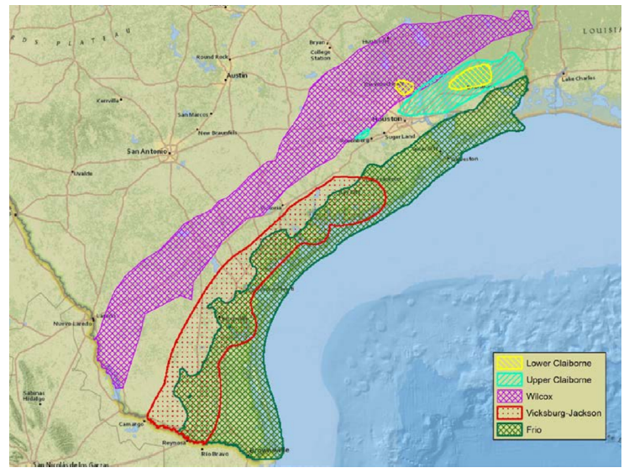
Figure 23. The geologic trends of potential geothermal reservoirs in the Gulf Coast, Texas (Esposito and Augustin, 2012).

Currently there are no geothermal power plants in the coastal zone; however, the gulf coast region has the highest overpressure and geothermal temperature gradient in sedimentary basins.

- Briefly characterize the existing status and trends for federal government facilities and activities of greater than local significance in the state’s coastal zone since the last assessment.

Nothing to report.

Management Characterization
- Indicate if the approach is employed by the state or territory and if significant state- or territory-level changes (positive or negative) that could facilitate or impede energy and government facility siting and activities have occurred since the last assessment.

Significant Changes in Energy and Government Facility Management
Management Category | Employed by State or Territory  (Y or N) | CMP Provides Assistance to Locals that Employ  (Y or N) | Significant Changes Since Last Assessment  (Y or N)
Statutes, regulations, policies, or case law interpretations | Y | Y | N
State comprehensive siting plans or procedures | N | N | N
*In regard to siting of energy facilities, different agencies can address siting through public hearings (Public Utilities Commission, TCEQ, Texas RRC. ERCOT), but the ability of the Coastal Coordination Council (CCC) or any agency to deny a project based on siting is in question. In Texas, specifically for renewable energy projects, the issue of siting is of concern for onshore and offshore projects, the latter being of lesser concern. Clear siting authority for both onshore and offshore facilities would be beneficial.

- For any management categories with significant changes, briefly provide the information below. If this information is provided under another enhancement area or section of the document, please provide a reference to the other section rather than duplicate the information:
  - Describe the significance of the changes;

Offshore Oil Exploration Leases
From 2015 to 2019, BOEM held two lease sales for the Western Gulf of America, covering a total of 328,000 acres for oil and gas development in the OCS offshore Texas. In addition, three more Gulf of America area sales are scheduled before 2029 (BOEM, 2024). No lease sales have been conducted since 2019 in the Western Gulf of America.

Federal Consistency
In an effort to refine coordination with BOEM and the Bureau of Safety and Environmental Enforcement (BSEE), the GLO conducts federal consistency for activities located in significant sediment resource area (SSRA) blocks in the OCS including oil and gas exploration and development which includes the installation and decommissioning in-place of existing and proposed infrastructure such as platforms, pipelines, and wells; renewable energy activities which include the installation and decommissioning in-place of infrastructure including turbines and transmission cables; subsurface mineral extraction; carbon sequestration; communication infrastructure and submarine cable systems; aquaculture; and any other exploration or infrastructure that may potentially impede access to sediment resources for a period exceeding one month when falling within the identified SSRA blocks.

GLO also works with BOEM to identify and expand SSRA blocks within the OCS using geophysical surveys conducted since 2020. This effort has resulted in isolating additional potential SSRAs. BOEM is currently reviewing GLO suggested additional SSRA blocks in the middle and upper OCS.

The GLO, along with the Water Institute and BOEM, are planning to develop a multi-use conflict tool, which will continue to protect potential sediment resources and help better coordinate offshore planning efforts.

  - Specify if they were 309 or other CZM-driven changes;

These efforts are not driven by CZM.

  - Characterize the outcomes or likely future outcomes of the changes.

Concerning the sale of Western Gulf of America Offshore Oil Exploration Leases, the likely outcome will be an increase in offshore drilling and oil and gas production in the Texas coastal zone.

Enhancement Area Prioritization
- What level of priority is the enhancement area for the coastal management program?
High _____
Medium __X__
Low _____

- Briefly explain the reason for this level of priority. Include input from stakeholder engagement, including the types of stakeholders engaged.

Energy production is vitally important in the coastal zone, the state, the nation, and world-wide. By the end of 2024, Texas’ oil production reached approximately 5.9 million barrels a day, seeing Texas surpass Iraq and Iran in production. In total, Texas accounts for 11.5% of all U.S. energy jobs. As of 2023, Texas leads the nation in crude oil refining capacity with 32 petroleum refineries accounting for approximately 32% percent of total U.S. refining capacity. Given the trends in oil production in Texas, these numbers are likely to increase, bringing more money and jobs to the economy.

This enhancement area was a medium priority as the energy industry is currently addressing issues in the area. One area of concern though is the recent interest in developing offshore, deepwater oil export terminals off the coast of Texas. All DWP applications are required to be consistent with the Texas CMP and the Texas Governor must approve or deny each Texas DWP application.

Aquaculture
Section 309 Enhancement Objective: Adoption of procedures and policies to evaluate and facilitate the siting of public and private aquaculture facilities in the coastal zone, which will enable states to formulate, administer, and implement strategic plans for marine aquaculture. §309(a)(9)

Phase 1 (High-level) Assessment: (Must be completed by all states and territories.)
Purpose: To quickly determine whether the enhancement area is a high-priority enhancement objective for the CMP that warrants a more in-depth assessment. The more in-depth assessments of Phase II will help the CMP understand key problems and opportunities that exist for program enhancement and determine the effectiveness of existing management efforts to address those problems.

Resource Characterization
- In the table below, characterize the existing status and trends of aquaculture facilities in the state’s coastal zone based on the best-available data. Your state Sea Grant Program may have information to help with this assessment.

Status and Trends of Aquaculture Facilities and Activities
Type of Facility/Activity | Number of Facilities | Approximate Economic Value | Change Since Last Assessment  (↑, ↓, −, unknown)
Catfish | 46 farms | $27,529,000 (USDA 2023) | ↑
Red Drum (food fish) | 7 farms | N/A (USDA, 2023) | ↓
Hybrid Striped Bass | 5 farms | N/A (USDA, 2023) | ↑
Sport fish (not red drum) | 13 farms | $2,469,000 (USDA 2023) | ↓ , ↑
Trout | 2 farms | N/A (USDA,2023) | ↑
Crawfish | 6 farms | 321,000 (USDA, 2023) | ↓
Tilapia (food fish) | 8 farms | 1,441,000 (USDA, 2023) | ↑
Tilapia (recreational stocking) | 13 operators | $ value unknown. | Unknown (same number of operators)
Ornamentals | 10 farms | $978,000 (USDA, 2023) | ↓ , ↑
Baitfish | 14 farms | $ value unknown. | −
Alligators | 3 farms | $190,000 (USDA, 2023) | ↑
Carp (food fish) | 8 farms | $121,000 (USDA, 2023) | ↑
Other food fish | 28 farms | $13,130,000 (USDA, 2023) | −

- If available, briefly list and summarize the results of any additional state- or territory-specific data or reports on the status and trends or potential impacts from aquaculture activities in the coastal zone since the last assessment.

Texas Aquaculture - A Regulatory Guide, produced by the Texas GLO
Summary: A trifold brochure including a summary of the Texas Department of Agriculture, TCEQ, TPWD, and the GLO.

List of Texas aquaculture facilities (Texas Aquaculture Association)
Summary: Client legal name, DBA, Physical Address, City, State, Zip

The Census of Aquaculture (USDA) has extensive detailed information about aquaculture in Texas via tables.
Summary: Values of Aquaculture products by type with details on water sources, aquaculture methods, product sales, distribution, and employment and payroll.

Management Characterization
- Indicate if the approach is employed by the state or territory and if there have been any state- or territory-level changes (positive or negative) that could facilitate or impede the siting of public or private aquaculture facilities in the coastal zone.

Significant Changes in Aquaculture Management
Management Category | Employed by State or Territory  (Y or N) | CMP Provides Assistance to Locals that Employ  (Y or N) | Significant Changes Since Last Assessment  (Y or N)
Aquaculture comprehensive siting plans or procedures | Y  (The Texas Department of Agriculture coordinates the licensing of aquaculture facilities and vehicles transporting (live) cultured species, in partnership with Texas Parks & Wildlife Department and the Texas Commission on Environmental Quality.) (Texas Agriculture Code § 12 et seq.) | Y | N
Other aquaculture statutes, regulations, policies, or case law interpreting these | Y | Y | Y

- For any management categories with significant changes, briefly provide the information below. If this information is provided under another enhancement area or section of the document, please provide a reference to the other section rather than duplicate the information:
  - Describe the significance of the changes;
  - Specify if they were 309 or other CZM-driven changes; and
  - Characterize the outcomes or likely future outcomes of the changes.

New Oyster Aquaculture Law
The 86th Texas Legislature enacted House Bill 1300, which added Chapter 75 “Cultivated Oyster Mariculture” to the TPWD Code and delegated to TPWD the authority to regulate the process of growing oysters in captivity. In turn, in 2020 adopted regulations governing cultivated oyster mariculture (COM) (Texas Administrative Code Chapter 58 Subchapter E Cultivated Oyster Mariculture). The TPWD oversees the COM Program and permits the activity of oyster mariculture. The TPWD COM Program regulates oyster farming in Texas by overseeing permits, conducting inspections, verifying compliance with biosecurity and genetic integrity protocols, receiving and reviewing monthly harvest reports and annual reports, and providing educational resources to promote mariculture best practices. A person must obtain a COM permit from TPWD to legally conduct oyster mariculture. In addition, authorizations must also be obtained for other state and federal agencies such as the GLO, TCEQ, USACE, U.S. Coast Guard, and in cases of holding, processing, or shipping oysters, the Texas Department of State Health Services. There are two types of COM permits: Grow-Out (farms) and Nursery-Hatchery. Grow-Out locations raise oysters to market size and sell for consumption. Nursery-Hatchery locations breed and/or raise larval-juvenile oysters before they are transferred to Grow-Out locations. Nursery-Hatchery permit holders may not sell oysters for consumption. There are siting constraints around certain natural resources such as sea grass, oyster habitat, and bird rookeries. Additionally, the GLO has siting constraints around oil and gas structures. TPWD strongly encourages potential applicants to schedule a consult with the COM Program official, where locations are evaluated for siting conflicts using a multilayer GIS map. As of the end of 2024 there are 13 fully permitted Grow-Out sites and six fully permitted Nursery-Hatchery sites. There are 29 Grow-Out sites that have conditional permits, awaiting their other agency authorizations before they can be fully permitted.

Enhancement Area Prioritization
- What level of priority is the enhancement area for the coastal management program?
High ____
Medium _ X_
Low ____

- Briefly explain the reason for this level of priority. Include input from stakeholder engagement, including the types of stakeholders engaged.

COM provides numerous benefits to local communities, ecosystems, and economies, including sustainable local seafood, enhanced habitat structure for recreational fishing in Texas bays, improved water quality and nutrient reduction, and reduced pressure on wild oyster populations. Efforts to support and enhance the COM industry in Texas will lead to healthier coastal ecosystems on multiple fronts. Potential benefits associated with a thriving COM sector in Texas justify a higher priority level since last assessment, ranking Medium, with stakeholder agreement.

Phase II Assessment

Wetlands

In-Depth Resource Characterization
Purpose: To determine key problems and opportunities to improve the CMP’s ability to protect, restore, and enhance wetlands.

- What are the three most significant existing or emerging physical stressors or threats to wetlands within your coastal zone? Indicate the geographic scope of the stressor, i.e., is it prevalent throughout your coastal zone, or are there specific areas that are most threatened? Stressors can be development/fill; hydrological alteration/channelization; erosion; pollution; invasive species; freshwater input; sea level rise/Great Lakes level change; or other (please specify).
 | Stressor/Threat | Geographic Scope  (throughout coastal zone or specific areas most threatened)
Stressor 1 | Development | Near current urban areas throughout the state (Galveston, Brazoria, Aransas, Nueces and Cameron counties)
Stressor 2 | Sea level rise | Coastwide
Stressor 3 | Erosion | Coastwide, but exacerbated in ship channels

- Briefly explain why these are currently the most significant stressors or threats to wetlands within your coastal zone. Cite stakeholder input and/or existing reports or studies to support this assessment.

Texas has the fifth largest wetland acreage in the United States with 3.9 million acres of wetlands, 2.3% of its total land area. According to “The State of Texas Wetlands: A Review of Current and Future Challenges” Texas Water Journal article as, of 1990, there was an estimated 52% reduction in the state’s original wetland acreage. However, there has not been a recent assessment of statewide wetland loss or gain since then. Wetlands provide some of the most critical ecosystem services to the state of Texas including wildlife habitat, flood storage and control, aquifer recharge, water quality improvement, pollutant breakdown, and storage of greenhouse gases, as well as human recreational opportunities (Texas Water Journal, 2023). However, Texas wetlands face many challenges in the coming decades with the anticipate effects of relative sea level rise, population growth and urban development in Texas expected to continue to increase.

Development and Increasing Population
Texas’ coastal population increased by over 200,00 people in a six-year span (2018-2023), with an increase of 222,000 in total number of housing units over the same six-year period, resulting in a 3.17 and 8.26% increase change from the 2021 - 2025 309 Assessment and Strategy Report. Many vital natural resources and natural resource areas will likely be impacted by projected continued population and housing development growth. Overlay of the Texas Priority Conservation Areas, Environmentally Sensitive Shoreline, and Ecologically Unique Rivers maps (see below), on the Housing Density maps projected through 2030 emphasizes this point.

In addition to the potential threat to ecologically sensitive areas, the increase in population and housing units will increase the need for infrastructure and energy. The Texas coastal zone lies in a floodplain which will be susceptible to relative sea level rise in the future (see 309 Assessment Coastal Hazards Section). Finally, as discussed in the Wetlands section, wetland habitat is a vital component of the Texas coastal region. USACE has jurisdiction over wetland delineation permits.

Wetlands along this region are critical to storm buffering, in addition to serving as flora and fauna habitat, supporting biodiversity, providing ecosystem services, functioning as recreational areas and adding cultural value to the coastal-living experience (citing 309 Phase I Assessment Wetlands Section, Resource Characterization 2). Coastal Hazards, including flooding, coastal storms and shoreline erosion, have been identified as a high priority by the Texas CMP, and these are all directly affected by the survival of the regional wetlands and their environmental support as a buffer zone.
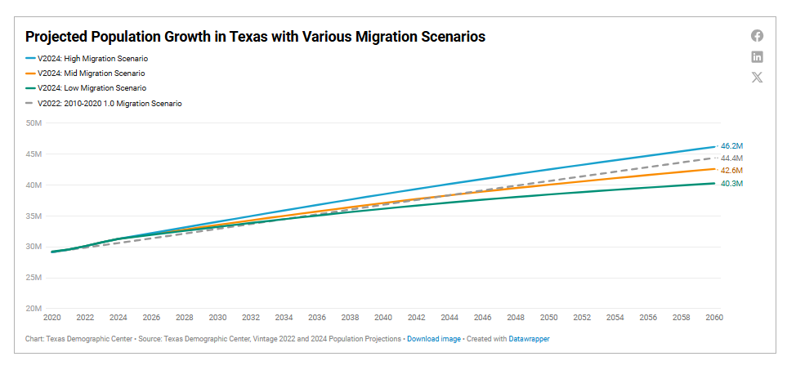
Figure 24.Texas Demographic Center (2022). Projections of the Total Population of Texas and Counties in Texas, 2020-2060 (0.5 Migration Scenario).
Development also leads to a loss of wetland habitat. In Harris County, 30% of freshwater marshes and swamps have been lost since 1992, primarily to development, and many of these freshwater habitats lay outside the 100-year floodplain and are unprotected by the federal regulatory system (Geotechnology Research Institute, 2014). Rising population density is also associated with an increase in impervious surfaces; the alteration of natural wetlands leads to loss of habitat and natural water retention within the watershed unit. Increased development leads to other issues such as changes in hydrology, habitat fragmentation, and spread of invasive species. While population growth and development may not be curtailed, planning and conservation of priority wetlands may help improve community resilience.

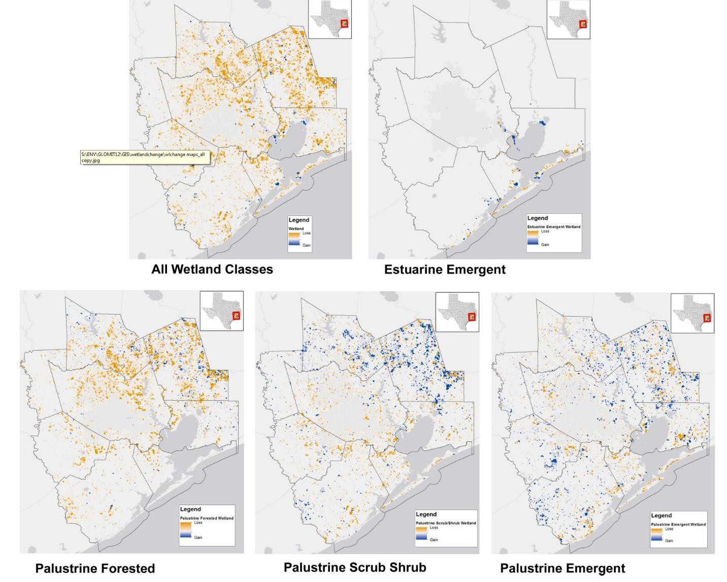
Figure 25. Heat map showing net loss (orange) and gain (blue) of various wetland classes between 1996-2010 in the upper Texas coast including coastal counties of Brazoria, Harris, Galveston, and Chambers. Image from (Geotechnology Research Institute, 2014).

With increased development there is an accompanying increase in water demand. This may lead to decreased flow into estuarine environments, having profound effects on these ecosystems. The projected increase of water demand is associated with increasing consumption as well as growing sectors like mining (including the exploration, development and extraction of oil, gas coal and other materials) steam-electric power generators, agricultural irrigation, and livestock water needs (State Water Plan 2021).

Increased urban development along the coast also poses a threat to wetlands in the face of relative sea level rise (Enwright et al. 2016). Historically, wetlands have moved landward and seaward as sea levels changed. However, with increasing development, hard infrastructure prevents wetlands from migrating inland. This creates a “coastal squeeze” where wetlands transform into open water without inland migration, exacerbating wetland loss compared to what would occur naturally (Borchert et al. 2018).

Relative Sea Level Rise
Relative sea level rise, including subsidence, is one of the highest reported causes of wetland loss (White and Tremblay. 1995; Ravens et al. 2009; Cline et al. 2011) in Texas and, wetland loss to subsidence is expected to continue. Wetlands provide a suite of ecosystem services, including the provision of habitat, water purification, recreational opportunities, and protection against storms and flooding. All these important benefits are at risk with the threat posed by relative sea level rise. In addition, climatic change may exacerbate the magnitude of rise rates which in turn may cause wetland loss through erosion or inundation (Brunn 1962; Leatherman et al. 2000).

For wetlands to remain in their current extent or expand, marsh sedimentation rates must be equal to or surpass those of relative sea level rise (Brinson et al. 1995). It is unlikely that sedimentation rates along Texas estuarine wetlands can keep up with relative sea level rise rates as the construction of upstream dams and reservoirs has reduced the quantity of sediments reaching the coast (White et al. 2002). Table 6 shows current relative sea level rise rates from NOAA. In the case that wetlands do not accrete at a rate to compete with relative sea level rise, migration inland and upslope may occur. Landward migration of wetlands is possible in areas that are undeveloped and have gentle slopes. However, many barriers to upland migration exist (see previous section).

Table 8. RSLR rates reported from NOAA Sea Level Rise Trends for Galveston Bay, Freeport, and Rockport Tide gauges.
Tide Gauge | Relative sea level rise Rate (mm/yr)**
Galveston Bay | 6.6
Freeport | 4.2
Rockport | 6.0

* Source NOAA Sea Level Trends http://tidesandcurrents.noaa.gov/sltrends/sltrends.html. Accessed 11/21/2019.
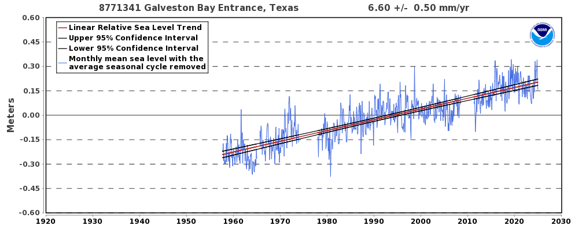
Figure 26.The relative sea level trend is 6.6 millimeters/year with a 95% confidence

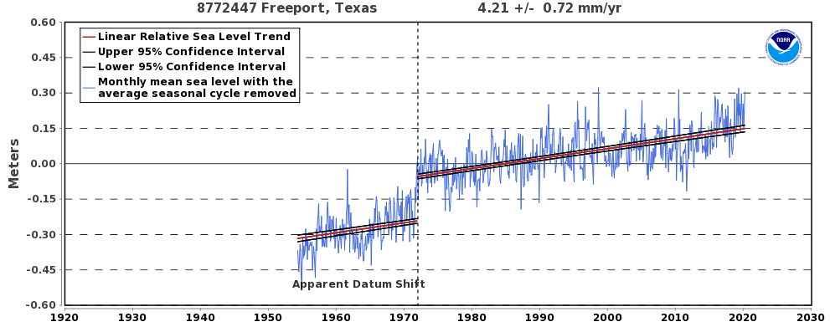
Figure 27. The relative sea level trend is 4.21 millimeters/year with a 95% confidence

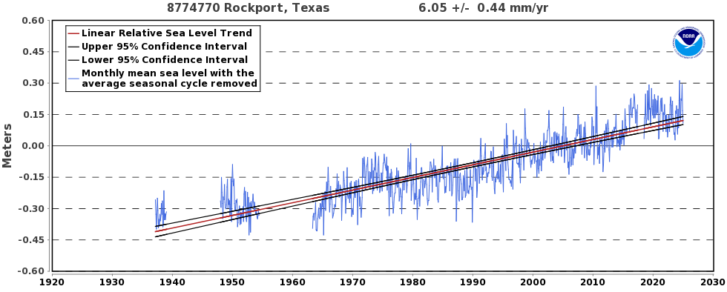
Figure 28. The relative sea level trend is 6.05 millimeters/year with a 95% confidence

Drought
Drought has historically affected the distribution of wetlands as it impacts soil moisture and estuarine water levels. Although drought may be a temporary and periodic event for many areas, it is an ongoing issue in South Texas where more frequent drought spells prevent the necessary amount of fresh water from reaching freshwater wetlands in the coastal area. This is a challenging situation for land and local wildlife refuge managers who may not have the ability to acquire, move, or store fresh water for wetlands in time of drought. The availability of fresh water is important for wildlife, wading birds, and waterfowl; as well as to maintain healthy estuarine water quality. Additionally, the drying of wetlands promotes encroachment of invasive plant species, presenting additional management challenges.

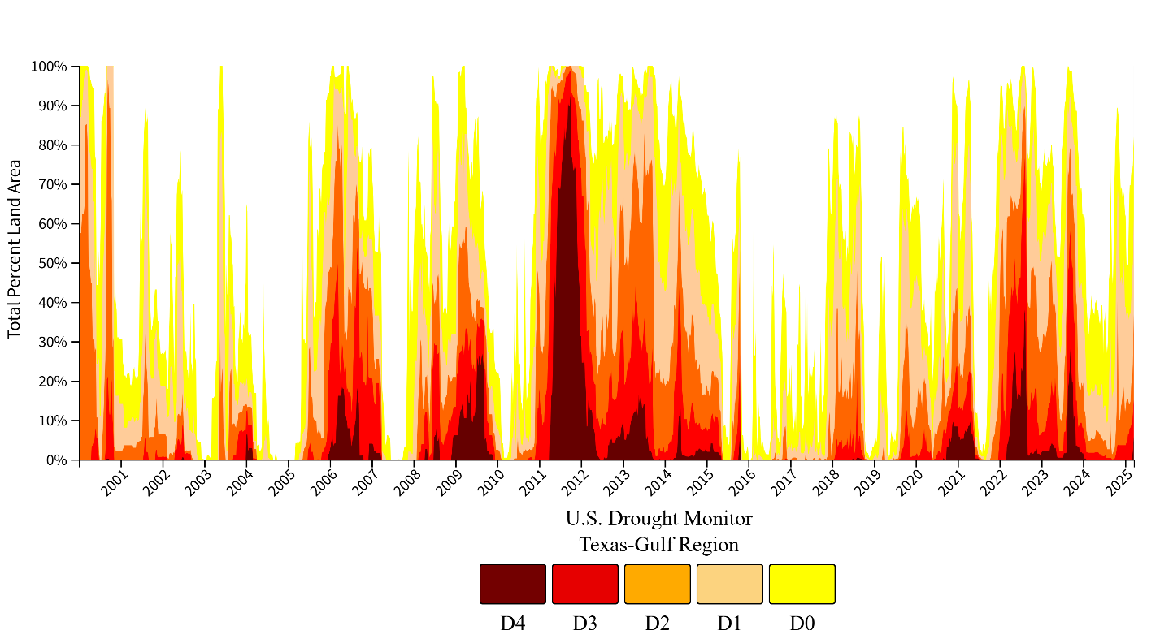

Figure 29. The U.S. Drought Monitor (2000–present) depicts the location and intensity of drought across the country. Authors from NOAA, USDA, and the National Drought Mitigation Center produce a new map based on their assessments of the best available data and input from local observers.

- Are there emerging issues of concern but which lack sufficient information to evaluate the level of the potential threat? If so, please list. Include additional lines if needed.
Emerging Issue | Information Needed
Energy Development | Information is needed on potential impacts to wetlands and other critical habitats that result from mining, processing, and transportation of energy products including injection wells, pipeline and facility construction, and plan operations.
Freshwater Inflows | Evaluate the potential impacts and benefits of established flow standards on freshwater inflows to estuarine habitats and organisms.

Fresh Water Inflow Standards
In a previous assessment, a short introduction of Senate Bill 3 was presented. Senate Bill 3 (80th Texas Legislature, 2007) implemented a stakeholder led process to determine environmental flow standards for river basins and bay systems that are adequate to support a sound ecological environment, to the maximum extent reasonable considering other public interests (TCEQ 2014). Through this process, stakeholder committees, and scientific teams, with support from resource agencies were tasked with developing a set of recommendations which were submitted to TCEQ for consideration for consideration during rulemaking to adopt environmental flow standards for each of the 11 basin and bay areas (seven of which encompass major estuaries on the Texas Coast). To date, TCEQ has adopted instream flow standards at 96 measurement points in 11 river basins and freshwater inflow standards for five of the seven major estuaries. Environmental flow standards adopted by TCEQ consist of a seasonal schedule of flow quantities that address subsistence flow, base flow, and one level of high flow pulses. One issue that has emerged from this process is the need for increased monitoring and data collection in coastal areas. Recommendations have been impacted especially by lack of data, or out-of-date data on water circulation, important estuarine species, and hydrogeologic change. This includes transdisciplinary research that integrates biological, hydrological, land use, and policy analysis.

In-Depth Management Characterization

Purpose: To determine the effectiveness of management efforts to address identified problems related to the wetland’s enhancement objective.

- For each additional wetland management category below that was not already discussed as part of the Phase I assessment, indicate if the approach is employed by the state or territory and if significant state- or territory-level changes (positive or negative) have occurred since the last assessment.

Significant Changes in Wetland Management
Management Category | Employed By State or Territory  (Y or N) | CMP Provides Assistance to Locals that Employ  (Y or N) | Significant Changes Since Last Assessment  (Y or N)
Wetland assessment methodologies | Y | Y | Y
Wetland mapping and GIS | Y | Y | N
Watershed or special area management plans addressing wetlands | Y | Y | Y
Wetland technical assistance, education, and outreach | Y | Y | N

- For management categories with significant changes since the last assessment, briefly provide the information below. If this information is provided under another enhancement area or section of the document, please provide a reference to the other section rather than duplicate the information.
- Describe significant changes since the last assessment;
- Specify if they were 309 or other CZM-driven changes; and
- Characterize the outcomes or likely future outcomes of the changes.

Wetland Assessment and Mapping
A 309-driven initiative to develop a RAM tool for projects on state owed submerged lands was talked about in detail in Phase 1 (see Data Management 309 Strategy in Coastal Hazards). This is one method that will change how wetlands are assessed by the GLO’s Field Operations team in the future.

In the past, the CMP has relied on NOAA’s OCM and the C-CAP tool for mapping wetland change in Texas. As such, Texas has no updated data on wetland mapping since 2010. Therefore, there is a need for more detailed wetland mapping data along the Texas coast. This information would help the TCRMP and the effort to quantify ecosystem services gained by implementing projects. The CMP is currently funding a project titled “Texas Wetlands Status and Trends Online GIS Viewer” which will develop a user-friendly, interactive, web-based display of GIS-based maps of historical and current Texas wetland types, boundaries, and distribution. The new interface and website will allow users to view, analyze, and download the data.

Watershed or Special Area Management
Some changes have occurred regarding freshwater inflow standards (please see Question 3 in this section). These are not CZM-driven changes but may have an impact on wetland health and other estuarine environments.

The TCEQ and the Texas State Soil and Water Conservation Board (TSSWCB) support the development and implementation of watershed protection plans that have the potential to prevent or manage NPS pollution. Several such plans were developed with local stakeholder groups, usually with funding and technical assistance from the TCEQ and/or the TSSWCB, along with the EPA. These plans are highly localized and could be expanded and coordinated for comprehensive coastal protection and targeted watershed areas under the coastal NPS pollution program. Watershed Protection Plans in the Coastal Zone include:
- Arenosa and Garcitas
- Arroyo Colorado
- Baffin Bay, Petronila/San Fernando Creeks
- Bastrop Bayou
- Carancahua Bay
- Cedar Bayou
- Clear Creek Tidal
- Double Bayou
- Hidalgo Main
- Highland and Marchand Bayous
- Lavaca River
- Lower Laguna Madre
- Lower Nueces River
- Mission and Aransas
- North Floodway
- Raymondville Drain
- San Bernard
- Tres Palacios

In 2021, the TWDB adopted a new State Water Plan to provide a roadmap for addressing water needs that accompany huge population growth by identifying water management strategies and their associated costs for communities across the state. It provides a regional approach to water management planning around the state. This is a non-CZM driven change.

Wetland Technical Assistance, Education, and Outreach
TPWD aids landowners who are interested in developing and managing wetland habitats on their property through programs like the Texas Prairie Wetlands Project, the Coastal Program, and the Landowner Incentive Program. Depending on eligibility, some programs offer cost-share assistance to build and manage wetlands, technical guidance from local biologists and other guidance information. This is not a CZM-driven effort.

CMP is funding many education and outreach programs such as Boater Waste Education Campaign, Green Infrastructure for Texas, and The Texas Coastal Monitoring program, all of which provide a hands-on learning experience to participating members of the community. These programs educate individuals on coastal environments, monitoring techniques and practices and help foster appreciation and understanding of the services provided by wetlands and other coastal habitats. These are CZM-driven efforts.

Wetland Protection and Restoration
As of 2019, 48 wetland enhancement and protection projects were funded through the Gulf Environmental Benefit Fund from NFWF (See Wetlands, Phase I). The projects address high priority conservation needs (some identified in the Texas Coastal and Estuarine Land Conservation Program Plan) and represent important efforts to protect and enhance natural and living resource along the Texas coast. Funded projects include a combination of land/marsh acquisition and estuarine and shoreline restoration and enhancement. This is not a CZM-driven effort.

The GLO’s CEPRA program also funds efforts to protect, restore, and study wetlands. CEPRA funds studies to reduce the effects of coastal erosion as well as infrastructure and shoreline development to mitigate erosion impacts. Through this non-CZM program, the state of Texas funds projects which aid in management and enhancement of wetlands.

Some CMP funded Wetland Enhancement Projects since 2021 include:
- Boggy Bayou Nature Park Improvements: Phase II
- Bayou Riparian Corridor Restoration: Clear Creek
- Clear Creek Riparian Restoration Project
- The effects of Rollover Pass closure on tidal wetland plant assemblages and associated fauna
- Texas Regional Stormwater Wetland Manual: Empowering communities to develop wetlands for resiliency
- Redhead Pond Invasive Species Management
- Redhead Pond - Adjacent Tract(s) Acquisition
- Exploration Green Stormwater Wetland Water Quality Baseline Study
- Freshwater Inflow Standards for East Matagorda Bay Wetlands: Lake Austin
- Hitchcock City Parks: Mitigating NPS Pollution with Green Infrastructure
- Assessment of beneficial uses restoration as wetland bird habitat
- Prediction of Texas wetland erosion through remote sensing, field surveys, and numerical modeling
- The Clean Coast Texas Collaborative Years 3 and 4
- The Clean Coast Texas Collaborative Years 5 & 6
- Updating the National Wetland Inventory in Coastal Texas
- Hydrologic monitoring and modeling to aid restoration of the Welder Flats Marsh for Whooping Cranes
- Preserve and Enhance the Resilience of Bayside Wetlands on Mustang Island
- Petronilla Wetlands
- Packery Channel Nature Park Habitat Creation and Public Access

- Identify and describe the conclusions of any studies that have been done that illustrate the effectiveness of the state’s or territory’s management efforts in protecting, restoring, and enhancing coastal wetlands since the last assessment. If none, is there any information that you are lacking to assess the effectiveness of the state’s or territory’s management efforts?

The State has established successful programs for the protection, restoration, and enhancement of coastal environments including wetlands. State programs previously mention, CEPRA and CMP, work in tangent to fund various research and wetland enhancement efforts. The state also invests GOMESA funds, via these two programs, into projects that work to protect and preserve wetlands.

Identification of Priorities:

- Considering changes in wetlands and wetland management since the last assessment and stakeholder input, identify and briefly describe the top one to three management priorities where there is the greatest opportunity for the CMP to improve its ability to more effectively respond to significant wetlands stressors. (Approximately 1-3 sentences per management priority.)

Management Priority 1: Develop a comprehensive monitoring program

Description: Wetland restoration is a huge priority in Texas, with tens of millions of dollars available through CMP, CEPRA, GOMESA, NRDA, RESTORE, and NFWF. The development of wetland monitoring protocols will help ensure best practices are engaged during wetland monitoring, wetland restoration and marsh restoration projects. To enhance the programmatic goals of the CMP, including both the SMP and the TCRMP, the GLO proposes a comprehensive evaluation of environmental monitoring activities and needs in coastal Texas to support current and future wetland restoration and protection projects.

Management Priority 2: Enhance management processes to provide for wetland resilience through policies, restoration, and outreach

Description: Faced with various coastal issues such as relative sea level rise, erosion, and population growth, there is a need to mitigate impacts as well as prevent future wetland degradation. Often engineering solutions are sought to mitigate some of these issues. More recently, resilient coastal solutions have been employed to address wetland and shoreline erosion. Texas has a special opportunity in that a large percentage of its shoreline is undeveloped, so future construction can adopt coastal resiliency principles, like living shorelines, that not only mitigate for hazards, but maintain their ecological function and ecosystem-services provided by coastal wetlands. Outreach is essential in building a support for healthy and resilient communities.

Management Priority 3: Develop multiple spatial scales to delineate comparisons of changing conditions and mitigate land loss through restoration
Description: With CMP, CEPRA, and other programs receiving dozens of ecosystem restoration project proposals every year, there is need for a robust monitoring protocol to monitor effectiveness of restoration actions taken with CMP and CEPRA funds.

- Identify and briefly explain priority needs and information gaps the CMP has to help it address the management priorities identified above. The needs and gaps identified here do not need to be limited to those items that will be addressed through a Section 309 strategy but should include any items that will be part of a strategy.

Priority Needs | Need?  (Y or N) | Brief Explanation of Need/Gap
Research | Y | More research in wetland processes such as sedimentation, ecology, ecosystem services, and hydrodynamic processes
Mapping/GIS | Y | Maintain and update bathymetry and topography
Data and information management | Y | Improved database on coastal related activities including restoration and mitigation monitoring and tracking
Training/capacity building | Y | Training professionals in living shorelines. Staff training on mitigation and restoration tracking and evaluation.
Decision-support tools | Y | Comprehensive management – consolidate multiple plans; increase policy acceptance through greater stakeholder coordination and involvement.
Communication and outreach | Y | Education and outreach wetland functions and ecosystem services and living shorelines.

Enhancement Area Strategy Development
- Will the CMP develop one or more strategies for this enhancement area?
Yes ___X_
No ______

- Briefly explain why a strategy will or will not be developed for this enhancement area.

The Texas coast is dynamic and requires advanced monitoring to support evaluation of the impact and efficacy of restoration actions. Establishing a wetland monitoring protocol provide this information and will support adaptive management, future scenario modeling and give valuable data to advancing scientific research for the Texas coast. Due to these reasons, the CMP proposes developing a coastwide wetland monitoring protocol and guidance document during this 309-funding cycle.

Coastal Hazards

In-Depth Resource Characterization
Purpose: To determine key problems and opportunities to improve the CMP’s ability to prevent or significantly reduce coastal hazard risks by eliminating development and redevelopment in high-hazard areas and managing the effects of potential sea level rise and Great Lakes level change.

- Based on the characterization of coastal hazard risk, what are the three most significant coastal hazards within your coastal zone? Also indicate the geographic scope of the hazard, i.e., is it prevalent throughout the coastal zone, or are there specific areas most at risk?

 | Type of Hazard | Geographic Scope  (throughout coastal zone or specific areas most threatened)
Hazard 1 | Coastal Storms | Coast-wide
Hazard 2 | Flooding/Storm Surge | Coast-wide
Hazard 3 | Erosion | Coast-wide – Gulf shoreline and bay front communities
Hazard 4 | Coastal NPS Pollution | Coast-wide

- Briefly explain why these are currently the most significant coastal hazards within the coastal zone. Cite stakeholder input and/or existing reports or studies to support this assessment.

Coastal Storms
FEMA Disaster Declarations from 1953-2024 have occurred in all 18 coastal counties. Coastal storms present an imminent threat to people and property living near the coast and many of the impacts to communities, natural environments, and the economy are long lasting (see Phase 1 Coastal Hazards for summary of coastal storms). Hurricane return periods are shown in Figure 30 and return periods for major hurricanes in Figure 31. Counties of the Texas coast, on average, experience a hurricane once every 9-13 years and a major hurricane (≥Category 3) once every 25-40 years (Blake and Gibley 2011). Because hurricanes may occur any year, it is essential for communities to plan and mitigate for impacts yearly and prior to hurricane season. Tropical storms and hurricanes can lead to dramatic rain events that can cause large-scale devastation (see the section below on Flooding).

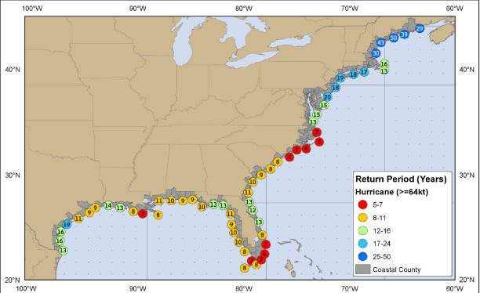
Figure 30. Estimated return period in years for hurricanes passing within 30 nautical miles of various locations on the U.S. Coast. Image from Blake and Gibley (2011).
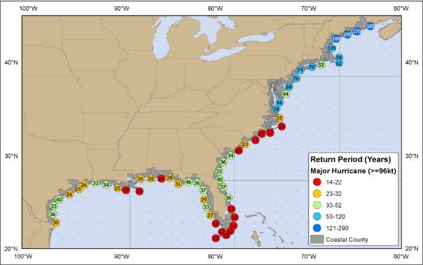
Figure 31. Estimated return period in years for major hurricanes passing within 50 nautical miles of various locations on the U.S. Coast. Image from Blake and Gibley (2011).

Flooding
Flooding has historically been a major hazard in Texas and is the most frequent and costliest hazard for the state of Texas (see Phase 1 Assessment). Most Texas coastal counties have experienced severe coastal flooding (see Figure 2 in Phase 1). According to the 2023 Texas Hazard Mitigation Plan, coastal flooding occurs at least once every three years, have a short warning time of 3-6 hours, and, when a flood does occur, there is great potential for loss of human life and destruction and damage to infrastructure, approximately $350 million in state annualized physical lost (Texas Hazard Mitigation Plan, 2023).

Hurricane Harvey introduced an unprecedented rain event in Texas that affected nearly six million people. In just under five days, rainfall counts surpassed fifty-one inches, making Harvey the most extreme rain-fall event recorded for the contiguous United States. Because Houston is situated on a low-lying coastal plain with clay-based soil that makes drainage of overflow waters a slow process, the built environment may play a role in the excessive flooding. The increased development of this rapidly growing city has altered natural drainage patterns, sending floodwaters into streets, homes, and businesses. Compounding the issue, Houston does not have a levee system in place, relying instead on its bayous to drain floodwater which increases the risk of damaging communities downstream.

Large amounts of resources from a variety of different sources are currently being used to address flooding and coastal hazard mitigation in the central and upper Texas coasts. For example, a recent $4 billion grant from the U.S. Department of Housing and Urban Development will be used to improve coastal infrastructure to reduce impacts from hazards in the future. The 2023 Texas Hazard Mitigation Plan provides an extremely detailed guide to coastal hazards affecting coastal Texas and contains resources for best practices.

Erosion
Long-term, continuous shoreline erosion and episodic shoreline change is a serious hazard on the Texas coast, threatening homes, infrastructure, commercial establishments, and coastal habitats (see Phase 1 assessments for maps and descriptions). Erosion is attributed to processes like wave and current removal of unconsolidated sediment along shorelines, as well as ship wakes, storms, and relative sea level rise. Erosion impacts are compounded due to the natural lack of sufficient sediment supply to the coast, coastal development activities along the edges of shorelines, and navigation structures. Erosion threatens beach use and access, habitat loss, roadways and infrastructure, like evacuation routes, and natural storm protection from dunes and barrier islands. It is estimated the state of Texas has lost almost 60,000 acres of saltwater wetlands since the 1950’s. The Texas coast is also estimated to have some of the highest coastal erosion rates in the country with some areas losing more than 55 feet per year and averaging four feet per year coastwide (CEPRA 86th Leg. Report).

The GLO monitors shoreline change rates via a project with the Bureau of Economic Geology at the University of Texas at Austin that continuously updates bay shoreline data erosion rates. Texas has recently released various restoration plans that focus on massive coastwide ecosystem restoration projects. These projects, totaling billions of dollars, will require enormous volumes of sediment. Currently, potentially available sediments in Texas, especially offshore, are partially mapped, and required further geo-tech to verify characterization of reported geo-investigation. Additionally, a lack of a CMP enforceable policy to govern how to prioritize for restoration projects, is needed to assist with the value and use of the SMP.

Coastal NPS Pollution
Severe storms and flooding, such as that seen during Hurricane Harvey, generate massive inputs of terrestrial runoff which can negatively impact marine ecosystems, and can potentially expose beachgoers to contaminated runoff which can include human waste pollution. A study published in Frontier in Marine Science reported finding human contamination from 2016 and Hurricane Harvey flooding events as far offshore as the Flower Garden Banks National Marine Sanctuary, about 100 miles off the Texas coast. The study found bacteria from human wastewater, including E. coli, in sponges at the Flower Garden Banks. Unmaintained and aging sewer systems are commons sources for fecal contaminations.

Coastal erosion intensifies nonpoint source pollution by disturbing soil and infrastructure, releasing contaminants into nearby water bodies. As erosion strips away vegetative buffers and topsoil, it increases runoff carrying nutrients, sediments, and pollutants from diffuse sources. Floodwaters further amplify this issue by transporting agricultural chemicals, roadway debris, and waste into coastal zones. Critically, erosion can expose or damage septic systems, allowing untreated wastewater to seep directly into the environment. This creates a significant public health concern, especially in low-lying areas prone to flooding. Over time, these processes degrade water quality, threaten marine ecosystems, and complicate coastal management strategies. Within the next few decades, relative sea level rise is expected to exceed the ground elevation of some infrastructure, potentially negatively impacts onsite sewage facilities (OSSF). There are an estimated 63,000 OSSFs exist in the 18 counties of the Texas coastal zone. Failing OSSFs are a significant source of NPS pollution to coastal waterways, thus it is essential to evaluate the risk for failure given predicted intensification of weather-related effects.

- Are there emerging issues of concern, but which lack sufficient information to evaluate the level of the potential threat? If so, please list. Include additional lines if needed.
Emerging Issue | Information Needed
Increased coastal pollution events | Adoption rate of coastal nonpoint source pollution management measures in local communities, especially those in central Texas

In the previous assessment, one of the strategies developed by the CMP was to implement a coastal NPS pollution program. The aim of this program is to reduce coastal pollution through retrofit planning, education, new research, and new policies and initiatives. A detailed description of this can be found in Phase I, Cumulative and Secondary Impacts.

In-Depth Management Characterization
Purpose: To determine the effectiveness of management efforts to address identified problems related to the coastal hazards enhancement objective.

- For each coastal hazard management category below, indicate if the approach is employed by the state or territory and if there has been a significant change since the last assessment.

Significant Changes in Coastal Hazards Statutes, Regulations, and Policies
Management Category | Employed by State/Territory  (Y or N) | CMP Provides Assistance to Locals that Employ  (Y or N) | Significant Change Since the Last Assessment  (Y or N)
Shorefront setbacks/no build areas | Y | Y | Y
Rolling easements | Y | N | N
Repair/rebuilding restrictions | Y | Y | N
Hard shoreline protection structure restrictions | Y-beach/dune | Y | N
Promotion of alternative shoreline stabilization methodologies (i.e., living shorelines/green infrastructure) | N | Y | Y
Repair/replacement of shore protection structure restrictions | Y | N | N
Inlet management | Y | Y | N
Protection of important natural resources for hazard mitigation benefits (e.g., dunes, wetlands, barrier islands, coral reefs) (other than setbacks/no build areas) | Y | Y | N
Repetitive flood loss policies (e.g., relocation, buyouts) | Y | Y | N
Freeboard requirements | N | Y | N
Real estate sales disclosure requirements | Y | Y | N
Restrictions on publicly funded infrastructure | Y | Y | N
Infrastructure protection (e.g., considering hazards in siting and design) | Y | Y | Y
Other (please specify)

Significant Changes to Coastal Hazard Management Planning Programs or Initiatives
Management Category | Employed by State/Territory  (Y or N) | CMP Provides Assistance to Locals that Employ  (Y or N) | Significant Change Since the Last Assessment  (Y or N)
Hazard mitigation plans | Y | Y | Y
Sea level rise/Great Lake level change or climate change adaptation plans | N | Y | N
Statewide requirement for local post-disaster recovery planning | N | Y | N
Sediment management plans | Y | Y | N
Beach nourishment plans | Y | Y | Y
Special Area Management Plans (that address hazards issues) | Y | Y | N
Managed retreat plans | N | Y | N
Other (please specify)

Significant Changes to Coastal Hazard Research, Mapping, and
Education Programs or Initiatives
Management Category | Employed by State/Territory  (Y or N) | CMP Provides Assistance to Locals that Employ  (Y or N) | Significant Change Since the Last Assessment  (Y or N)
General hazards mapping or modeling | Y | Y | Y
Sea level rise mapping or modeling | Y | Y | Y
Hazards monitoring (e.g., erosion rate, shoreline change, high-water marks) | Y | Y | Y
Hazards education and outreach | Y | Y | Y
Other (please specify)

Statutes, Regulations, and Policies
Most hazard mitigation in Texas is the responsibility of city governments because the state and county levels of government have limited control over land use and building standards (Peacock et al. 2011). In the coast environment, however, Texas employs the Dune Protection Act and Open Beaches Act to authorize GLO to establish and enforce minimum standards for coastal protection and planning by city and county governments. Under these acts, GLO oversees and advises local governments on the planning and permitting of coastal development and overall erosion response planning in gulf facing areas. CEPRA and the CMP aid and fund many hazard management efforts throughout the coastal zone.

Shorefront setbacks:
Refer to Phase 1, Coastal Hazards, Management Characterization for more details.

Promotion of alternative shoreline stabilization methodologies (i.e., living shorelines/green infrastructure):
A strategy in the previous 309 assessment was related to living shorelines education (see Phase 1 Assessment, Wetlands). Although this has not led to a policy change, the CMP will continue to advocate for living shorelines over hardened structures.

Infrastructure Protection:
In the previous 309 assessment, the USACE Galveston District was in the reconnaissance phase of the Coastal Texas Storm Damage Risk Management and Ecosystem Restoration Study, now the Coastal Texas Protection & Restoration Feasibility Study (Coastal Texas Study). The Coastal Texas Study involves engineering, economic, and environmental analyses on large-scale projects, which may be considered by Congress for authorization and funding. Formal public meetings for the study were hosted in fall 2018, and – since this time – the USACE and the GLO worked together to refine and produce the study based on public comments received at these meetings. The Coastal Texas Study recommendations will enhance resiliency in coastal communities and improve our capabilities to prepare for, resist, recover and adapt to coastal hazards.

Management Planning Programs or Initiatives
Hazard mitigation plans
Updates to the State’s Hazard Mitigation Plan were completed by the Texas Division of Emergency Management in 2023 (Phase 1 Assessment, Coastal Hazards).

Texas Coastal Resiliency Master Plan
In 2023, the GLO released its updated version of the Texas Coastal Resiliency Master Plan, including a list of 123 coastal hazard projects (see Phase 1 Assessment, Coastal Hazards).

CEPRA Hot Tax
In 2019, during the 86th Legislative session, Texas passed House Bill 6, which set up a dedicated funding stream to CEPRA. Over the next ten years, CEPRA will receive 2% of all coastal counties’ hotel occupancy tax. This is the first such dedicated funding stream for CEPRA and will allow the program to better plan for future beach and dune nourishment projects.

Regional General Permit for Beach Nourishment
The current 309 strategy is developing a regional general permit application for beach nourishment. This permit will provide a larger opportunity for beach nourishment and reduce the nourishment permitting timelines from 2-3 years to just a few months.

Research, Mapping, and Education Programs or Initiatives
The CMP has funded several projects related to hazards mapping over the past five years, including “The Texas Coastal Collaborative – A dynamic approach to hazard mitigation, resiliency and NPS control”, “Historical Shoreline Movement in Galveston, Trinity, East, and West Bays on the Upper Texas Gulf Coast”, and “GLO Living Shorelines Program Website Maintenance (FY22-24)”.

Another mapping and web-mapping tool available is the Coastal Resilience Tool from The Nature Conservancy. This tool offers information and data for relative sea level rise, inundation scenarios for select location, sea level effects on marshes, and results of exposure and vulnerability indices.

Hazards Education and Outreach
Under recent cycles the CMP has / is funding “The Texas High School Coastal Monitoring Program”. This CMP funded program engages students and teachers who live along the coast in the study of their natural environment. Scientists from the University of Texas Bureau of Economic Geology work with middle and high school students and teachers to gain a better understanding of dune and beach dynamics on the Texas coast. The students are active participants in the research project, which has the dual benefit of enhancing their science education while providing valuable data on the dynamic coastline. The data collected by the students are analyzed by BEG scientists and the students themselves and compared to data collected by students and scientists in previous years. Time series of measurements are important in understanding the dynamics of the potential of coastal hazards, as well as the changing aspects of Texas’ coastal environment. Cycle 27 CMP funds were used to strengthen the Texas coastal database and further understanding of short-term (seasonal, yearly, and storm impacts) and long-term (decadal and storm recovery) changes to the coastal environment.

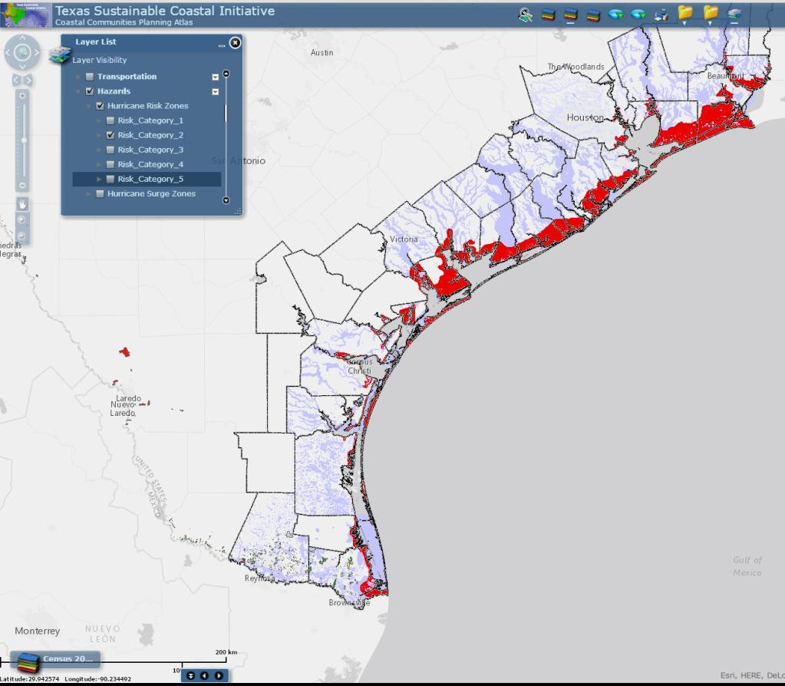

Figure 32. Screen view of the Coastal Communities Planning Atlas featuring FEMA 100 yr flood risk zones (purple) and hurricane risk zones (category 2).

Research and Restoration
The State funds projects which mitigate coastal hazards through programs such as the GOMESA, CMP, CEPRA, and the Community Development and Revitalization Program’s (CDR) Community Development Block Grant funds. Through these programs, coastal communities can mitigate hazard impacts by employing projects related to beach nourishment, wetland and shoreline protection and restoration, planning, and outreach activities.

The CEPRA program funds projects to reduce the effects of coastal erosion as well as infrastructure and shoreline development to mitigate erosion impacts. CEPRA projects during the last funding period include beach nourishment, studies/monitoring, and shoreline stabilization work mostly concentrated on the upper Texas coast that is still recovering from the erosion impacts from Hurricane Ike. The Coastal Bend and lower coast CEPRA projects focused on marsh/habitat restoration near Corpus Christi and beach nourishment along South Padre Island.

CMP funded projects during the last assessment period which aid in mitigation of hazards include (Cycle 24 - 29):

- A Comprehensive Assessment of Texas Coastal Ecosystems & Economies to Inform Ecological Restoration
- A Stakeholder Driven Plan for Long-Term Coastal Hydrologic Monitoring
- A study of the Laguna Salada ecosystem to support Baffin Bay restoration
- Addressing NPS pollution through the Galveston Bay Coalition of Watersheds
- An integrated assessment of nutrient loadings to Baffin Bay, Texas
- Assessing Coastal Change in Support of the 2023 Texas Coastal Resiliency Master Plan
- Assessing flow and sediment dynamics of Lower Brazos and San Bernard Basins
- Assessment of seagrass habitat and stability in Texas coastal waters
- Beach and Dune Protection
- Beneficial Dredge Use Master Plan - Phase 2 GLO Regions 3 and 4
- Beneficial Use Master Plan -- Texas GLO Regions 3 (Coastal Bend) and 4 (Lower Coast)
- Chester Island Bird Habitat Management and Protection
- Closing the loop: Recycling shells and restoring reefs for resilience and recovery
- Controls of Subsurface Geology on Barrier Islands Breaching
- Copano Cove Ranch Acquisition
- Critically Eroding Area Identification Tool
- Developing a Framework for Modeling Texas Coast Waves and Validation
- Developing a Refined Engagement Strategy for Coastal NPS Pollution Control Program Resources
- Dog Island Acquisition
- Dune Restoration Phase II South Padre Island
- Evaluating Health Risks of Fecal Pollution in Little Bay
- Evaluating the trophic value of beneficial uses restoration sites for coastal birds
- Expanding Riparian Buffers in Petronila Creek Watershed
- Flooding Frequency and After-Storm Dune Recovery in Cedar Lakes' Washover
- GLO - San Patricio County Interlocal Agreement for Coastal Boundary Survey
- GLO Living Shorelines Program Website Maintenance (FY22-24)
- Gulf Reef Rehabilitation
- High Frequency Radar for Texas Bays and Ports
- Historical Shoreline Movement in Galveston, Trinity, East, and West Bays on the Upper Texas Gulf Coast
- Hydroclimatic Modulations of Bacteria/Nutrient Input to Texas Coastal Water
- Identify potential BMP tools to reduce bacteria loading in Neches River
- Impacts of Major Storms on Coastal Erosion in the Texas Gulf Coast
- Improvements to the Wastewater Treatment in Western Nueces County
- Integrative Assessment of Bacterial Pollution
- Integrative Assessment of Bacterial Pollution- Phase II
- Living Shoreline Protection
- Lower Laguna Madre Hydrodynamic Characterization
- Marine Debris/ Vessel Removal
- Matagorda Bay shoreline resilience: Restoring seagrass pilots
- Modernizing Texas Beach Watch Technology System
- Monitoring and Analysis of Sediment and Nutrients and their Associated Pollutant Loads
- Multifaceted Approach to Addressing Nonpoint Source Pollution in Galveston County
- Old Queen Isabella Causeway Demolition and Engineered Reef Design
- OSSF identification using remote sensing and GIS
- Packery Channel Nature Park Shoreline Enhancement
- Quantifying erosion and pollution from rainfall runoff on urbanized beaches - Galveston Island study
- Queen Isabella Causeway Decommissioning and Artificial Reef Placement
- Recovering Access and Restoring Resilience at Stewart Beach Park on Galveston Island
- Resilient Coastal Dune Ecosystems for Erosion and Habitat Protection at South Padre Island
- Restoration of small shell island on Bill Day’s Reef to enhance nesting for American Oystercatchers
- Restoring TCOON by Reimagining Lighthouse, a Data Platform
- Shell Bank: Enhancing coastal resiliency via shell recycling, restoration and community partnerships
- Smart and Self-Sustaining Early Warning Systems for Coastal Flooding
- Study and Expansion of Oyster Shell Recycling & Reef Restoration
- Tern Rookery Island Protection and Restoration, Phase I: Feasibility Study & Alternatives Analysis
- Texas Citizen Planner: Local Community Planning for Resiliency and Mitigation
- Texas Coastal Nutrient Input Repository - Phase I Lavaca Bay
- Texas Coastal Resiliency Master Plan - Phase 4
- Texas Gulf Region Cooperative Weed Management Area: Dune Management & Restoration on Mustang Island
- Texas Gulf Region CWMA: Dune Management & Restoration on Mustang Island, Phase II
- Texas High School Coastal Monitoring (FY21-FY25)
- The Texas Coastal Collaborative - A dynamic approach to hazard mitigation, resiliency & NPS control
- Threat of Rising Sea Level & Water Tables to Texas Coastal Septic Systems: An Integrated Study
- Water Quality and Nutrient Dynamics Associated with Freshwater Delivery

- Identify and describe the conclusions of any studies that have been done that illustrate the effectiveness of the state’s management efforts in addressing coastal hazards since the last assessment. If none, is there any information that you are lacking to assess the effectiveness of the state’s management efforts?

Given the aftermath of Hurricane Harvey, the State’s ability to respond to coastal hazards is being tested. Currently, billions of dollars are being spent on disaster mitigation and coastal resiliency. A detailed analysis of how these funds were spent and the effectiveness that they will have at preventing future hazards should be identified.

Identification of Priorities
- Considering changes in coastal hazard risk and coastal hazard management since the last assessment and stakeholder input, identify and briefly describe the top one to three management priorities where there is the greatest opportunity for the CMP to improve its ability to more effectively address the most significant hazard risks. (Approximately 1-3 sentences per management priority.)

Management Priority 1: Identify resources for coastal restoration projects through creation of a comprehensive sediment management plan

Description: The 2023 Texas Coastal Resiliency Master Plan estimated that 6.87 million cubic yards of sand will be needed each year to keep pace with current rates of shoreline change. Sediment needs are expected to continue to increase into the future as sea level rise and storm intensities continue to escalate. Additionally, as coastal resiliency projects begin to utilize the most accessible sediment resources, non-renewable sediment resources will be exhausted, and the cost of coastal resiliency projects will continue to grow. The GLO is developing the SMP to combat coastal erosion, with the ultimate goals of maintaining the important ecosystem services of coastal environments and enhancing resiliency of Texas coastal communities. The first iteration of the SMP is underway and the GLO currently plans to release a new iteration of the SMP every four years to incorporate new data and new policy directions.

Management Priority 2: Continue to promote outreach to coastal communities on coastal resiliency and preparedness and provide hazard planning assistance & tools.

Description: Continue to educate and promote best management practices and programs to enhance the preservation of natural shorelines for coastal hazard mitigation planning, like building living shorelines. Incorporate ecosystem services and community resiliency into public outreach programs. Provide technical assistance and planning tools to communities for vulnerability assessments and pre-storm planning.

Management Priority 3: Track implementation of the Texas Coastal Nonpoint Source Pollution program
Description: NOAA and EPA approval of the Texas Coastal NPS Pollution program is a monumental step for the program and the CMP. The next phase is a 15-year implementation process to ensure management measures are voluntarily adopted by various municipalities. In order to gauge the success of these measures, a tracking system needs to be created. Reducing NPS pollution is tied to coastal hazards reduction because infrastructure improvements that address NPS pollution often also address coastal hazards issues.

Management Priority 4: Acquire a USACE general permit for coastal restoration projects

Description: With the potential for dozens of TCRMP projects to be funded over the next five years, a large hurdle and potential holdup in future project implementation is the time and resources it will take to acquire USACE permits for each project. While the GLO is still working to get an RGP for beach nourishment, acquisition of additional general permits from the USACE for other project types would allow projects to be completed more efficiently, and the coast could benefit from coastal hazards reduction projects sooner. With the establishment of a Programmatic Biological Opinion with USWFS, this could allow for adjustments to conservation measures with on-going iterations, possibly allowing for nourishment at quicker intervals.

- Identify and briefly explain priority needs and information gaps the CMP has for addressing the management priorities identified above. The needs and gaps identified here should not be limited to those items that will be addressed through a Section 309 strategy but should include any items that will be part of a strategy.

Priority Needs | Need?  (Y or N) | Brief Explanation of Need/Gap
Research | Y | Analyze resilience: social, economic, ecological and infrastructure; community barriers (i.e. colonias)
Mapping/GIS/modeling | Y | Improve topographic and bathymetry models. Develop and update infrastructure maps in GIS format for communities which still rely on paper records.
Data and information management | Y | Continue to populate GLO’s coastal database and enhance data management platforms for on-site hazards response and assessments.
Training/Capacity building | Y | Green building/infrastructure for improved hydrology
Decision-support tools | Y | Data driven priority modeling designating restoration areas.
Communication and outreach | Y | Continue efforts to bring necessary data, tools, and professional assistance to local communities.
Other (specify)

Enhancement Area Strategy Development:

- Will the CMP develop one or more strategies for this enhancement area?
Yes ______
No ___X__

- Briefly explain why a strategy will or will not be developed for this enhancement area.

Texas has taken a large step forward in tackling coastal hazards with the GLO’s adoption of the TCRMP. A suite of projects working in tandem provides great potential to mitigate from future hazards. However, more planning needs to be done to ensure that the correct resources are being allocated to the correct projects. The CMP continue the challenge of developing the SMP and acquiring an RGP for future coastal restoration projects.

Texas Coastwide Reference Monitoring System (T-CRMS)

- Issue Area(s)
- The proposed strategy or implementation activities will primarily support the following high-priority enhancement area(s) (check no more than two):
☐ Aquaculture ☐ Cumulative and Secondary Impacts
☐ Energy and Government Facility Siting ☒ Wetlands
☐ Coastal Hazards ☐ Marine Debris
☐ Ocean/Great Lakes Resources ☐ Public Access
☐ Special Area Management Planning

- The proposed strategy or implementation activities will also support the following enhancement areas (check all that apply):
☐ Aquaculture ☐ Cumulative and Secondary Impacts
☐ Energy and Government Facility Siting ☒ Wetlands
☐ Coastal Hazards ☐ Marine Debris
☐ Ocean/Great Lakes Resources ☐ Public Access
☐ Special Area Management Planning

- Strategy Description
- The proposed strategy will lead to, or implement, the following types of program changes (check all that apply):
☐ A change to coastal zone boundaries;
☐ New or revised authorities, including statutes, regulations, enforceable policies,
administrative decisions, executive orders, and memoranda of agreement/understanding;
☐ New or revised local coastal programs and implementing ordinances;
☐ New or revised coastal land acquisition, management, and restoration programs;
☐ New or revised special area management plans (SAMP) or plans for areas of
particular concern including enforceable policies and other necessary implementation mechanisms or criteria and procedures for designating and managing areas of particular concern; and,
☒ New or revised guidelines, procedures, and policy documents which are formally
adopted by a state or territory and provide specific interpretations of enforceable CZM program policies to applicants, local government, and other agencies that will result in meaningful improvements in coastal resource management.

- Strategy Goal

Development of a Texas Coastwide Reference Monitoring System protocol and guidance document.

- Description

The TCRMP is an ongoing, iterative, comprehensive coastwide planning process led by the GLO to protect and promote a vibrant and resilient Texas coast. The plan aims to support and sustain a strong economy and healthy environment for all who live, work, play, or otherwise benefit from the natural resources and infrastructure along the Texas coast. The Texas coast comprises more than 3,300 miles of bay shorelines and vast expanses of tallgrass prairie uplands, salt marsh wetlands, beaches and dunes, estuaries, and other ecosystems, which contain priceless natural, recreational, and aesthetic resources. The TCRMP involves collaboration between various stakeholders, including state and federal agencies, local communities, and private entities, to develop and implement coastal restoration and other related projects that restore coastal environment and habitat (including wetlands) and enhance coastal resilience. The TCRMP aligns well with NOAA Section 309 priorities, which focus on enhancing state and territory coastal management programs through nine key areas, including the protection and restoration of coastal wetlands and the assessment of the cumulative and secondary impacts of coastal growth and development. The TCRMP supports these priorities by addressing coastal hazards, promoting sustainable development, and enhancing the resilience of coastal ecosystems and communities.

- Needs and Gaps Addressed

The TCRMP’s focus on sediment management, erosion control, and habitat restoration aligns with NOAA's goals of protecting and restoring coastal wetlands, as well as reducing the impacts of coastal growth and development. Additionally, the TCRMP's emphasis on stakeholder engagement and collaboration with local communities and federal agencies supports NOAA's priority of preparing special area management plans and developing policies to facilitate the siting of energy-related facilities and activities. To enhance the programmatic goals of the CMP, including both the SMP and the TCRMP, the GLO proposes a comprehensive evaluation of environmental monitoring activities and needs in coastal Texas to support current and future restoration and protection projects. A comprehensive monitoring program, developed at the appropriate scale (spatial and temporal), is critical for establishing baseline conditions, assessing project impacts and effectiveness, and providing the data required for designing, engineering, permitting, and evaluating restoration projects. The GLO will use the existing Louisiana Coastwide Reference Monitoring System (CRMS; https://www.lacoast.gov/crms/Home.aspx) program as guidance and leverage lessons learned to develop a Texas Coastwide Reference Monitoring System (T-CRMS) guidance document tailored to the specific projects, stakeholders, and needs outlined in the TCRMP.

- Benefits to Coastal Management

The TCRMP identifies priority projects to address coastal hazards, including erosion, flooding, sea level rise, and storm surge. These projects include beach nourishment, dune restoration, and marsh restoration. The CMP is also developing an SMP to understand Texas' sediment needs and create guidance for effective sediment resource use for future coastal resiliency and restoration efforts. Additionally, the GLO’s CEPRA program has funded multiple survey efforts to collect regional geological data that support these plans and future projects.

- Likelihood of Success

Creating the T-CRMS will be an ambitious undertaking requiring extensive coordination and resources. Years 1 and 2 will be critical in the success of T-CRMS. Defining guidance as well as the planned stakeholder engagement that will occur in Year 1 and 2 will ensure success. The momentum behind the development of this plan is high and the CMP is confident about the creation and this plan within five years.

- Strategy Work Plan

Strategy Goal: Development of the Texas Coastwide Reference Monitoring System
Total Years: 5
Total Budget: 2.5 million

Year(s): 1 - 2

Description of Activities:
The first task will be to define the goals and objectives of the T-CRMS guidance document to best support and enhance the CMP through comprehensive data collection and monitoring. This task will define critical success factors and resource needs and develop a timeline and phased approach as needed for spatial coverage of sites. The keys to program success will include a commitment to long-term monitoring and a spatial design sufficient to inform planning and evaluation of project efforts. Only with a long-term data set are environmental trajectories and scientific assumptions used in modeling and design capable of being properly evaluated and tested.

The GLO will conduct a search to compile a list of ongoing monitoring activities across the Texas coast. For each monitoring location, the parameters collected, the organization responsible, the frequency and duration of monitoring, and the method used will be documented. Additionally, the location of the data, whether the data are publicly available, and how the data are served will be documented and recorded.

Monitoring networks from other coastal programs will be evaluated to gain insight and lessons learned. Meetings will be scheduled with relevant program leads to discuss goals, tools, and similarities, as well as mitigation strategies to avoid risks that could impact success.

Identifying and gathering appropriate stakeholders early in the process is crucial for developing a well-defined list of data requirements, objectives, concerns, issues, and complexities that need to be addressed in the guidance document. A list of organizations will be composed for TCRMP Regions 1 – 4 for engagement in the process and may include:
- Other state agencies: TPWD, TWDB, Texas Division of Emergency Management, etc.
- Gulf Coastal Protection District, including implementation of the Sabine Pass to Galveston Bay Coastal Storm Risk Management Program and the Coastal Texas Study.
- LA CMP (Louisiana Department of Energy and Natural Resources)
- Federal Agencies: USGS, USFWS, National Park Service, etc.
- USACE, including implementation of the Coastal Texas Study.
- Local Government, including county government, councils of government, etc.
- Non-profits.
- Research and academic institutions.
- Private landowners.
- Industry.
- Contractors engaged in restoration and protection programs.

A series of meetings will be held at suitable venues across TCRMP Regions 1–4, with remote attendance options available, to focus on a range of previously identified topics and objectives. When feasible, meetings will be scheduled to coincide with other scheduled meetings for efficiency and effectiveness (e.g., Gulf Coast Protection District meetings, etc.).

Topics to discuss will include:
Key parameters to monitor. Identifying a consistent set of parameters to be monitored at every selected station at the same frequency and using the identical methodology is critical to program success.
- Environmental issues and impacts to program success.
- Strategies to mitigate risk and delays with large complex construction and restoration programs.
- Land rights and access agreements.
- Policy guidance and suggested modifications.
- Timeline of data needs for project success.
- Synergies with other restoration and construction program needs.

In support of the above Stakeholder Engagement efforts, the GLO will leverage the existence and success of the existing Technical Advisory Committee (TAC) for the TCRMP. The TCRMP TAC plays a crucial role in the development and implementation of the TCRMP. The TAC comprises experts and stakeholders from diverse fields, including coastal management, environmental science, engineering, and community planning. Their primary responsibility is to provide guidance and recommendations to ensure that the TCRMP effectively addresses the challenges and needs of the Texas coast.

The TAC collaborates closely with GLO to identify and prioritize projects that enhance coastal resilience. The TAC's input is vital in ensuring that the TCRMP is comprehensive and considers the best available scientific research, local expertise, and monitoring data from completed projects. As such, the GLO will leverage the existing TAC to inform the T-CRMS tasks. The GLO aims to integrate future TAC meetings with other T-CRMS planned stakeholder engagement meetings and activities to enhance collaboration and improve stakeholder engagement efficiencies.

Based on previous tasks, a report will be prepared that documents all meetings held, and the organizations engaged in the process. Included will be a list of parameters that were identified and proposed for inclusion in a coastal monitoring program. A complete list of all evaluated parameters, along with a priority ranking, will also be included for documentation and to identify potential modifications required due to future program financial limitations.

Summaries of other topics discussed, and final recommendations made will be provided.

Major Milestone(s):
- Define Guidance Document Goals and Objectives
- Document Existing Resources
- Stakeholder Engagement
- Document Stakeholder Engagement Results

Budget: $1,055,000

Year(s): 3 – 5

Description of Activities:

Based on the priority monitoring parameters selected and the specific requirements for program goals, a proposed design ensuring statistical robustness for the overall program will be developed. This will include the quantity and spatial distribution of field site locations. Assumptions regarding future program funding levels will be made during the design analysis. The Louisiana CRMS program design methods will be reviewed for potential suitability and guidance.

The design must be sufficient to provide the quantity of sites to detect change at multiple scales (site, project, region, and coast), as defined by the program goals and the results of the stakeholder meeting. Land ownership layers will be created and evaluated for discussion, as each landowner will need to be contacted for future site deployment and program implementation.

For all aspects of the proposed monitoring program, a detailed standard operating procedure will be developed. Best practices and other monitoring program procedures will be reviewed and used as feasible. Each protocol will be tailored to the Texas coastal environments to provide the most accurate data possible. Examples of procedures for development may include:
- Field site selection criteria
- Field site construction
- Field method protocols for each parameter of interest (e.g., vegetation, hydrology, elevation, etc.)
- Quality Assurance/Quality Control protocols for data collection, processing, and validation
- Operations and Maintenance

As the program design and proposed methods are available, site visits will take place in each TCRMP Region. Where feasible, a subset of specific site locations will be visited to assess the complexity of access, the methods of access required (e.g., outboard boat, airboat), the types of habitats encountered, and any potential challenges and logistics that need to be addressed. The suitability of the potential site for collecting high-quality data on the selected parameters for monitoring will also be assessed and documented.

For the parameters collected, options will be evaluated for hosting and serving the resulting data. Existing monitoring databases at GLO and other agencies will be reviewed as potential options for modification and use. Third-party database development and data hosting will also be assessed. This exercise will involve defining a standard format for each parameter, specifying preferred units of measurement, and outlining other requirements.

Data analytics and visualization experts will be engaged to provide details on design, user interface, graphics capability, reporting, and data availability to stakeholders and the public.

Major Milestone(s):
- Monitoring Program Field Design
- Standard Operating Procedure Protocol Development
- Field Site Investigation
- Database Evaluation and Options

Budget: $1,520,000

- Fiscal and Technical Needs

A. Fiscal Needs:

Creating a T-CRMS program will be a complicated effort needing input and guidance from a variety of technical stakeholders and with contributions from multiple funding streams. The strategy work plan above only mentions tasks that will have designated CMP 309 funding. Other efforts related to implementing TCRMP, such as funding research and data collection, are expected to cost $10M+ and will be funded through alternative funding sources. All of these activities will be acknowledged in progress reports as they are also crucial to the creation and implementation of TCRMP.

B. Technical Needs:

The GLO is fortunate to have many shoreline ecologists, geological experts, and natural resources mangers on its staff and has the available knowledge to identify the components that will go into the TCRMP. However, the GLO’s capacity is limited. Therefore, the development of the plan that will be contracted outside of the agency.

- Projects of Special Merit (Optional)

The CMP will apply for projects of special merit to supplement the TCRMP, as its creation will be more expensive than allocated 309 funding. Projects will likely be to conduct implementation and possible pilot stations that have been identified after on the ground reconnaissance is completed. Other projects may also be explored as they arise.

5-Year Budget Summary by Strategy

Strategy Title | Anticipated Funding Source (309 or Other) | Year 1  Funding | Year 2 Funding | Year 3 Funding | Year 4 Funding | Year 5 Funding | Total Funding
Creation of Texas Coastal Monitoring Program Feasibility and Protocol | 309 | $515,000 | $515,000 | $515,000 | $515,000 | $515,000 | $2,575,000
Total Funding |  | $515,000 | $515,000 | $515,000 | $515,000 | $515,000 | $2,575,000

Summary of Stakeholder and Public Comment

Stakeholder Input
Input for Phase I was requested through phone calls and emails to selected stakeholders and coastal partners. These stakeholders and partners represented State agencies and local government including Texas Sea Grant, TCEQ, TPWD, TWDB, the GLO, Texas Railroad Commission, and Texas Department of Transportation. Pertinent information and data were added to various sections of Phase I based on input. For example, TPWD provided crab trap data, while the GLO’s Beach Cleanup team provided information on marine debris.

Input for Phase II was internally conducted by GLO coastal staff.

Based on stakeholder voting and input on the potential management priorities, it was clear that the best action the CMP could take over the next 5 years would be to focus on the Wetland enhancement area and develop a strategy focused on restoration project monitoring. This resulted in the selection of the T-CRMS strategy. The CMP convened a workgroup in April 2025 to begin to formulize the work plan for the T-CRMS program. This involved input from various stakeholders, including many divisions within the GLO (CEPRA, CMP, NRDA,). Many more stakeholders will be brought in to assist with the development of the T-CRMS program once the planning process begins. Stakeholders were sent a draft of Phase II and the T-CRMS strategy in April 2025.

On 08-01-2025, the final 309 document was made available for public comment through the Texas Register. The public comment period will close after 30 days.

References

4COffshore. (2014). GOWind - (Gulf Offshore Wind Demonstrator) Offshore Wind Farm. http://www.4coffshore.com/windfarms/gowind---(gulf-offshore-wind-demonstrator)-united-states-us95.html

Amadeo, K. (2019). Hurricane Harvey Facts, Damage, and Costs. The Balance. https://www.thebalance.com/hurricane-harvey-facts-damage-costs-4150087

American Wind Energy Association. (2019). Wind Energy in Texas. https://www.awea.org/Awea/media/Resources/StateFactSheets/Texas.pdf

Blake, E., and Gibley, E. (2011). The deadliest, costliest, and most intense United
States tropical cyclones from 1851 to 2010 (and other frequently requested hurricane facts). NOAA Technical Memo NWS NHC-6.

BOEM. (2024). 2024-2029 Lease Sale Schedule. Bureau of Ocean Energy Management. https://www.boem.gov/oil-gas-energy/lease-sales#tabs-11541

Borchert, SM, Osland, MJ, Enwright, NM, Griffith, KT. (2018). Coastal wetland adaptation to sea level rise: Quantifying potential for landward migration and coastal squeeze. J Appl Ecol. 2018; 55: 2876– 2887.

Boske and Harrison. (2017). Transportation Policy Brief #2 Texas Ports and the Panama Canal: Commodities and Infrastructure. https://library.ctr.utexas.edu/ctr-publications/5-6690-01/prp2.pdf

Brinson, M., Christian, R. and Blum, L. (1995). Multiple States in the Sea-Level Induced Transition from Terrestrial Forest to Estuary. Estuaries 18, no. 4: 648–59. doi:10.2307/1352383.

Brody, S., Zahran, S., et al. (2007). Identifying the impact of the built environment on flood damage in Texas. Disasters 32 (1): 1-18.

Brody, S., Davis, S., Highfield, W., and Berhardt, S. (2008). A spatial-temporal analysis of section 404 wetland permitting in Texas and Florida: Thirteen years of impact along the coast. Wetlands 21 (1): 107-116.

Brunn, P. (1962). Sea-Level Rise as a Cause of Shore Erosion. American Society of Civil Engineers Journal of Waterways Harbors 117: 88.

Bureau of Transportation Statistics. (2019). Tonnage of Top 50 U.S. Water Ports, Ranked by Total Tons. https://www.bts.gov/content/tonnage-top-50-us-water-ports-ranked-total-tons

Centerpoint Energy. (2019). Transmission Connection Options. https://www.centerpointenergy.com/en-us/Corp/Documents/Combined%20Public%20Meeting%20Displays_REVISED.PDF

Chapa. (2019). Port of Corpus Christi begins $380 million project to deepen ship channel. Houston Chronicle, May 29, 2019. https://www.houstonchronicle.com/business/energy/article/Port-of-Corpus-Christi-begins-380-million-13904262.php

Chowdhury, A.H., R. Boghich, and J. Hopkins. (2006). Chapter 5: Hydrochemistry, Salinity Distribution, and Trace Constituents: Implications for Salinity Sources, Geochemical Evolution, and Flow Systems Characterization, Gulf Coast Aquifer, Texas. In Aquifers of the Gulf Coast of Texas. Report 365. (81- 128). Texas Water Development Board.

Clemons, J. (2005). Addressing nonpoint source pollution in the fifth and eleventh circuits: could Pronsolino happen in Mississippi and Alabama? Journal of Land Use & Environmental Law, 21(1), 55.

Cline, M.D., R.A. Feagin, K.M. Yeager, and J.M. Van Alstyne. (2011). Fault-Induced Wetland Loss at Matagorda, Texas, USA: Land Cover Changes from 1943 to 2008. Geocarto International 26 (8): 633–45.

Craft, C. et al. (2009). Forecasting the effects of accelerated sea-level rise on tidal marsh ecosystem services. Front. Ecol. Environ. 7, 73–78 (2009).

Druzin, R. (2018). Texas coal plant to shut down by 2020. Chron. Sep. 25, 2018. https://www.chron.com/business/energy/article/Texas-coal-plant-to-shut-down-by-2020-13255710.php

E&E News. (2018). EPA falsely claims ‘no data’ on waters in WOTUS rule. https://www.eenews.net/stories/1060109323

Environmental Protection Agency. 2015. Coastal Wetlands Initiative: Gulf of Mexico Review. https://www.epa.gov/sites/production/files/2015-04/documents/gulf-of-mexico-review.pdf

Enwright, N., Griffith, K. and Osland, M. (2016). Barriers to an opportunities for landward migration of coastal wetlands with sea-level rise. Front Ecol Environ 2016; 14( 6): 307– 316

ERCOT. (2023). Report on Existing and Potential Electric System Constraints and Needs. Electric Reliability Council of Texas, Inc. https://www.ercot.com/files/docs/2023/12/22/2023-Report-on-Existing-and-Potential-Electric-System-Constraints-and-Needs.pdf

Evans, G., and Jones, L. (2001). Economic Impact of the 2000 red tide on Galveston County, Texas: a case study. No. 666226:1–56. College Station, Texas: Texas Parks and Wildlife. Retrieved from https://www.tpwd.state.tx.us/landwater/water/environconcerns/hab/redtide/media/report/economi cimpact.pdf

Oil & Gas Watch (2022). Texas GulfLink Deepwater Port. https://oilandgaswatch.org/facility/836

FERC. (2024). Approved Major Pipeline Projects (2015-Present). Federal Energy Regulatory Commission. https://www.ferc.gov/industries/gas/indus-act/pipelines/approved-projects.asp

FERC. (2019b). LNG. Federal Energy Regulatory Commission. https://www.ferc.gov/industries/gas/indus-act/lng.asp

Fern RR, Baron MD, England AE, Giese JC, Kraai KJ, Lancaster JD, Oldenburger SL, Shipes JC, Wilson BC, Wyckoff SR. 2023. The State of Texas Wetlands: A Review of Current and Future Challenges. Texas Water Journal. 14(1):136-174.

Geothermal Energy Association. (2014). Opportunities for Geothermal Development in Texas. Geothermal Energy Association. Retrieved August 20, 2014, from http://www.geo- energy.org/plants_dev_texas.aspx

Gibeaut, J.C., D. Del Angel, and M. Starek. Shoreline (2012) Change Analysis of Hurricane Ike Impact and Recovery on the Upper Texas Coast. Unpublished material. Harte Research Institute Texas A&M University Corpus Christi.

Gibeaut, J.C., D. Del Angel, B. Lupher, W. Nichols, and F. Moretsohn. (2014) Coastal Texas Initial Needs Assessment: Texas Technical Advisory Committee Findings and Report. Corpus Christi, TX: Harte Research Institute for Gulf of Mexico Studies, Texas A&M University Corpus – Christi. General Land Office contract no. 12-493-000-6690.

Harte Research Institute. (2019). Freshwater Inflows. https://www.freshwaterinflow.org/?page_id=19

Landscape America. (2014). Landscape America. Landscape America. Retrieved from http://www.landscope.org/map/

Leatherman, Stephen P., Keqi Zhang, and Bruce C. Douglas. (2000). “Sea Level Rise Shown to Drive Coastal Erosion.” Eos, Transactions American Geophysical Union 81, no. 6 : 55–57.

Marketwatch. (2018). Moda Midstream to Acquire Oxy Ingleside Energy Center Terminal from Occidental Petroleum. Aug. 8, 2018. https://www.marketwatch.com/press-release/moda-midstream-to-acquire-oxy-ingleside-energy-center-terminal-from-occidental-petroleum-2018-08-08

Montagna, P. A., Gibeaut, J. C., and Tunnell Jr., J. W. (2007). South Texas Climate: Coastal Impacts. In Norwine, J. & J. Kurucilla (Eds.), The Changing Climate of South Texas 1900-2100 (57–77). Crest- Ressaca, Texas A&M University-Kingsville: Kingsville, Texas.

Moreno, N., Sallent, R., Espi, A., Bao, D., and Teillet, Y. (2008). Ocean Current’s Energy: How to produce electrical energy thanks to the marine currents? Hogskolan I Gavle. Retrieved from http://www.exergy.se/goran/hig/re/08/ocean.pdf.

National Renewable Energy Laboratory. (2019). Solar Resource Data, Tools, and Maps. https://www.nrel.gov/gis/solar.html

NOAA. (2019). Coastal County Snapshots. https://coast.noaa.gov/snapshots/

NOAA (2019b). Fisheries Landings. https://foss.nmfs.noaa.gov/apexfoss/f?p=215:200::::::

NOAA. (2019c). Ocean Facts: Research continues on the causes of harmful algal blooms. National Oceanic and Atmospheric Administration. http://oceanservice.noaa.gov/facts/why_habs.html

NOAA. (2024). Status and Trends of Wetlands in the Coastal Watersheds of the Conterminous United States 2009 to 2019. https://www.fisheries.noaa.gov/s3/2024-12/Status-and-Trends-of-Wetlands-in-the-Coastal-Watersheds-of-the-Conterminous-US-2009-to-2019.pdf

NRDC. (2014). Ocean Acidification in the Gulf of Mexico. National Resources Defense Council. Retrieved from http://www.nrdc.org/oceans/acidification/gulf-of-mexico.asp

Ocean Conservancy. (2014). Ocean Acidification. Retrieved August 29, 2014, from http://www.oceanconservancy.org/our-work/ocean-acidification/

Peacock, W.G., Kang, J.E., Husein, R., Burns, G.R., Prater, C., Brody, S., and Kennedy, T. (2009). An Assessment of Coastal Zone Hazard Mitigation Plans in Texas. College Station, TX: Hazard Reduction and Recovery Center, Texas A&M University.

Perry, M. (2019). Oil Than Every Country in the World Besides Russia, Saudi Arabia, and Iraq. Foundation for Economic Education. Jan. 22, 2019. https://fee.org/articles/texas-now-produces-more-oil-than-every-country-in-the-world-besides-russia-saudi-arabia-and-iraq/

Paine et al. (2014). Shoreline movement along the Texas gulf coast. Bureau of Economic Geology.

Petersen, M. et al. (2018) One-Year Seismic Hazard Forecast for the Central and Eastern United States from Induced and Natural Earthquakes - Seis. Res. Lett., doi.org/10.1785/0220180005

Ravens, Thomas M., Robert C. Thomas, Kimberly A. Roberts, and Peter H. Santschi. (2009). Causes of Salt Marsh Erosion in Galveston Bay, Texas. Journal of Coastal Research, March, 265–72. doi:10.2112/07- 0942.1.

Riechers, R. (2010). Statewide Commercial Fishing Proclamation Regarding the Consistency of Federal Rules Concerning Bycatch Reduction Device (BRD) Rules and Individual Fishing Quota (IFQ) Rules. Texas Parks and Wildlife. Retrieved August 18, 2014, from http://www.tpwd.state.tx.us/business/feedback/meetings/2010/0826/agenda/item_10/

S&P Global. (2023). https://www.spglobal.com/commodity-insights/en/products-solutions/crude-oil/crude-oil-market-data

Shore, A. et all (2021). On a Reef Far, Far Away: Anthropogenic Impacts Following Extreme Storms Affect Sponge Health and Bacterial Communities. Frontiers in Marine Science, Volume 8 – 2021.
https://www.frontiersin.org/journals/marine-science/articles/10.3389/fmars.2021.608036

Solar Energy Industries Association. (2019). Solar Spotlight – Texas. https://www.seia.org/sites/default/files/2019-06/Factsheet_Texas_0.pdf

State of Texas et al v. United States Environmental Protection Agency et al, No. 3:2023cv00017 - Document 60 (S.D. Tex. 2023). https://law.justia.com/cases/federal/district-courts/texas/txsdce/3:2023cv00017/1902617/60/

Steyer, G.D., Perez, B.C., Piazza,S., and Suir, G. (2007) Potential Consequences of Saltwater Intrusion Associated with Hurricane Katrina and Rita (137-146). In Science and the Strom: the USGS Response to the Hurricanes of 2005. U.S. Geological Survey Circular 1306.

T.L. Bercel, S.A. Kranz (2019). Insights into carbon acquisition and photosynthesis in Karenia brevis under a range of CO2 concentrations. Volume 172, 2019, Pages 65-76, ISSN 0079-6611. https://doi.org/10.1016/j.pocean.2019.01.011.

Texas Coastal Resiliency Master Plan. (2019). Texas General Land Office. https://glo.texas.gov/coast/coastal-management/coastal-resiliency/index.html

Texas Commission on Environmental Quality. (2014). Environmental Flows Rule Making. https://www.tceq.texas.gov/permitting/water_rights/eflows/rulemaking.

Texas Comptroller. (2017). Will an Expanded Panama Canal Increase Texas Trade? https://comptroller.texas.gov/economy/fiscal-notes/2017/april/panama-canal.php

Texas Comptroller. (2024). The Gulf Coast Region Economy. https://comptroller.texas.gov/economy/economic-data/regions/2024/gulf-coast.php

Texas Department of Transportation. (2024). Texas Ports. https://www.txdot.gov/inside-txdot/division/maritime/ports.html

Texas General Land Office. (2020). A Report to the 87th Legislature: Coastal Erosion Planning and Response Act. Texas General Land Office.

Texas General Land Office. (2019). A Report to the 86th Legislature: Coastal Erosion Planning and Response Act. Texas General Land Office.

Texas General Land Office. (2019) State of Texas Coastal Nonpoint Source Pollution Control Program. Texas General Land Office

Texas Hazard Mitigation Plan. (2023). Texas Department of Emergency Management. https://tdem.texas.gov/mitigation/hazard-mitigation-section

Texas Invasives. (2024). Invasives Database. http://www.texasinvasives.org/animal_database/index.php

Texas Parks and Wildlife Department. (2023a). Red Tide Status Reports.
https://tpwd.texas.gov/landwater/water/environconcerns/hab/redtide/status.phtml

Texas Parks and Wildlife Department. (2019a). Exotic and Invasive Species. A Threat to Texas Waterways. http://www.tpwd.texas.gov/huntwild/wild/species/exotic/index.phtml

Texas Parks and Wildlife Department. (2019b). Rare, Threatened, and Endangered Species of Texas. https://tpwd.texas.gov/gis/rtest/

Texas Parks and Wildlife Department. (2024). New This Year: Fishing. https://tpwd.texas.gov/regulations/outdoor-annual/fishing/new-this-year-fishing

Texas Railroad Commission. (2024). New Pipeline Construction Reports. https://www.rrc.state.tx.us/pipeline-safety/permitting/new-construction-reports/

Texas Water Development Board. (2024). Texas State Flood Plan.
https://www.twdb.texas.gov/flood/planning/sfp/2024/index.asp

Texas Water Development Board. (2022). Texas State Water Plan. https://www.twdb.texas.gov/waterplanning/swp/2022/

Texas Water Development Board. (2015). The State of Water. Retrieved from http://www.twdb.state.tx.us/newsmedia/featured/stories/2015/01/index.asp

Tremblay, T.A. (2010). Status and Trends of Inland Wetland and Aquatic Habitats, Matagorda Bay Area. Austin, Texas: Bureau of Economic Geology, The University of Texas at Austin.

Tremblay, T.A. (2011). Status and Trends of Inland Wetland and Aquatic Habitats, Brownsville-Harlingen Area. Austin, Texas: Bureau of Economic Geology, The University of Texas at Austin.

United States Department of Agriculture. (2022). 2022 Census of Aquaculture. https://www.nass.usda.gov/Publications/AgCensus/2022/index.php

U.S. Energy Information Administration. (2024a). Texas Profile. https://www.eia.gov/electricity/state/

U.S. Energy Information Administration. (2024b). Frequently Asked Questions. https://www.eia.gov/tools/faqs/faq.php?id=29&t=6

U.S. Energy Information Administration. (2023). Annual Energy Outlook. https://www.eia.gov/outlooks/aeo/

USGS. (2019). Coastal Change Hazards Portal. United States Geological Survey. https://marine.usgs.gov/coastalchangehazardsportal/ui/info/item/CDKmLpj

U.S. Nuclear Regulatory Commission. (2024). https://www.nrc.gov/info-finder/region-state/texas.html

White, W.A., and T.A. Tremblay. (1995). Submergence of Wetlands as a Result of Human-Induced Subsidence and Faulting along the Upper Texas Gulf Coast. Journal of Coastal Research 11 (3): 788–807.

White, W.A., T.A. Tremblay, R.L. Waldinger, and T.R. Calnan. (2004). Status and Trends of Wetland and Aquatic Habitats on Barrier Islands, Upper Texas Coast, Galveston and Christmas Bays. Austin, Texas: Bureau of Economic Geology, The University of Texas at Austin.

White, W.A., T.A. Tremblay, R.L. Waldinger, T.L. Hepner, and T.R. Calnan. (2005). Status and Trends of Wetland and Aquatic Habitats on Barrier Islands, Freeport to East Matagorda Bay, and South Padre Island. Austin, Texas: Bureau of Economic Geology, The University of Texas at Austin.

White, W.A., T.A. Tremblay, R.L. Waldinger, and T.R. Calnan. (2006). Status and Trends of Wetland and Aquatic Habitats on Texas Barrier Islands Coastal Bend. Bureau of Economic Geology, The University of Texas at Austin.

White, W.A., T.A. Tremblay, R.L. Waldinger, and T.R. Calnan. (2007). Status and Trends of Wetland and Aquatic Habitats on Texas Barriers: Upper Coast Strandpain-Chenier System and Southern Coast Padre Island National Seashore. Austin, Texas: Bureau of Economic Geology, Jackson School of Geosciences, The University of Texas at Austin.

Window on State Government. (2014a). Ocean Power. Window on State Government. Glenn Hegar, Texas Comptroller of Public Accounts. Retrieved April 2015 from http://www.window.state.tx.us/specialrpt/energy/pdf/20-OceanPower.pdf

Window on State Government. (2014b). Geothermal. Window on State Government. Glenn Hegar, Texas Comptroller of Public Accounts. Retrieved April 2015 from http://www.window.state.tx.us/specialrpt/energy/pdf/21-Geothermal.pdf

Wright, B. (2013). Texas Coal: Past, Present and (Almost Certainly) Future. Fiscal Notes. Window on State Government. http://www.window.state.tx.us/comptrol/fnotes/fn13Q2/coal.php

coast.noaa.gov/data/czm/media/czmapmsguide.pdf
National data on wetlands status and trends include NOAA’s Land Cover Atlas (coast.noaa.gov/digitalcoast/tools/lca.html), the U.S. Geological Survey’s National Land Cover Database (usgs.gov/centers/eros/science/national-land-cover-database), and the U.S. Fish and Wildlife Service’s National Wetland Inventory data (fws.gov/program/national-wetlands-inventory).
Risk is defined as “the estimated impact that a hazard would have on people, services, facilities and structures in a community; the likelihood of a hazard event resulting in an adverse condition that causes injury or damage.” Understanding Your Risks: Identifying Hazards and Estimating Losses. FEMA 386-2. August 2001
Use the state's definition of high-hazard areas.
Be as specific as possible. For example, if you have data on many access sites but know it is not an exhaustive list, note “more than” before the number. If information is unknown, note that and use the narrative section below to provide a brief qualitative description based on the best information available.
If you know specific numbers, please provide. However, if specific numbers are unknown but you know that the general trend was increasing or decreasing or relatively stable or unchanged since the last assessment, note that with a ↑ (increased), ↓ (decreased), − (unchanged). If the trend is completely unknown, simply put “unknown.”
Cumulative number of public Gulf-facing beach access points per local governments’ Beach Access and Dune Protection Plans.
For more information on ADA see ada.gov.
This classification was recently added to txcoasts.com to identify sites that can reasonably accommodate people with disabilities even though they have not been certified as ADA compliant. 10 Most states routinely develop “Statewide Comprehensive Outdoor Recreation Plans”, or SCROPs, that include an assessment of demand for public recreational opportunities. Although not focused on coastal public access, SCORPs could be useful to get some sense of public outdoor recreation preferences and demand. Download state SCROPs at.recpro.org/resources--reports/scorp-resources.
11 The National Survey on Fishing, Hunting, and Wildlife Associated Recreation produces state-specific reports on fishing, hunting, and wildlife associated recreational use for each state. While not focused on coastal areas, the reports do include information on saltwater and Great Lakes fishing, and some coastal wildlife viewing that may be informative and compares 2016 data to 2011, 2006, and 2001 information to understand how usage has changed. The most recent survey was conducted for 2022 but due to a change in methodology, results cannot be compared to previous reports. See fws.gov/program/national-survey-fishing-hunting-and-wildlife-associated-recreation-fhwar.
Note some states may have regional or local guides in addition to state public access guides. Unless you want to list all local guides as well, there is no need to list additional guides beyond the state access guide. You may choose to note that the local guides do exist and may provide additional information that expands upon the state guides.
You can select more than one, if applicable.
www.oceaneconomics.org/. Enter “Population and Housing” section and select “Data Search” (near the top of the left sidebar). From the drop-down boxes, select your state. Select the year (2021) then select “coastal zone counties.” The default comparison year will be 2017 so no need to select a comparison year.
National data on wetlands status and trends include NOAA’s Land Cover Atlas (coast.noaa.gov/digitalcoast/tools/lca.html) and the U.S. Geological Survey’s National Land Cover Database (usgs.gov/centers/eros/science/national-land-cover-database).
coast.noaa.gov/digitalcoast/tools/enow.html. If you select any coastal county for your state, you are directed to various data displays for that county. In the upper left of the screen, click the “State” box, to the left of the county box so that the state name will be highlighted. Now the data will reflect statewide data for all of the state’s coastal counties. Make sure “2021” is selected for the year (top right corner). You can then click through the sector types by selecting the icons along the top and the type of economic data (employment, wages, GDP, etc.), by clicking through the icons on the left.
Trend data is available at the bottom of the page for each sector and type of economic data. Mouse over the data points for 2005 and 2021 to obtain the actual values and determine the change by subtracting 2005 data from 2021.
coast.noaa.gov/digitalcoast/tools/ort.html. Select the “view quick reports” button and enter the name of your state or territory in the search bar. Some larger states may have the “quick reports” for their state waters broken into several different reports. Click on the “state waters” reports to view. Note the Ocean Reports tool also generates “quick reports” for national estuarine research reserve boundaries in your state. These reports are just a subset of the “state waters” report(s) so you can ignore the reserve “quick reports.” Use the icons on the left-hand side to select different categories: general information, energy and minerals, natural resources and conservation, oceanographic and biophysical, transportation and infrastructure, and economics and commerce. Scroll through each category to find the data needed to complete the table. The top six categories in the table above are in the “energy and minerals” section while the other information to complete the table can be found under the “transportation and infrastructure” section.
Offshore development includes underwater cables and pipelines, although any infrastructure specifically associated with the energy industry should be captured under the “energy production” category.
CZMA § 309(a)(8) is derived from program approval requirements in CZMA § 306(d)(8), which states: “The management program provides for adequate consideration of the national interest involved in planning for, and managing the coastal zone, including the siting of facilities such as energy facilities which are of greater than local significance. In the case of energy facilities, the Secretary shall find that the State has considered any applicable national or interstate energy plan or program.” NOAA regulations at 15 C.F.R. § 923.52 further describes what states need to do regarding national interest and consideration of interests that are greater than local interests.
coast.noaa.gov/digitalcoast/tools/ort.html. Select the “view quick reports” button and enter the name of your state or territory in the search bar. Some larger states may have the “quick reports” for their state waters broken into several different reports. Click on the “state waters” reports to view. Note the Ocean Reports tool also generates “quick reports” for national estuarine research reserve boundaries in your state but this is just a subset of the “state waters” report(s) so you can ignore the reserve “quick reports.” Click on the wind turbine icon on the left (“energy and minerals”) for information on energy production. While outside your coastal zone, you may also want to consider facilities/activities in “federal waters” that may have effects on your coastal zone.
The CMP should make its own assessment of what government facilities may be considered “greater than local significance” in its coastal zone, but these facilities could include military installations or a significant federal government complex. An individual federal building may not rise to a level worthy of discussion here beyond a very cursory (if any at all) mention).
While focused on statewide aquaculture data rather than just within the coastal zone, the Census of Aquaculture (agcensus.usda.gov/Publications/Census_of_Aquaculture/) may help in developing your aquaculture assessment. The census is conducted every 10 years, and the last report was released in 2018. The report provides a variety of state-specific aquaculture data to understand current status and recent trends.
Be as specific as possible. For example, if you have specific information of the number of each type of facility or activity, note that. If you only have approximate figures, note “more than” or “approximately” before the number. If information is unknown, note that and use the narrative section below to provide a brief qualitative description based on the best information available.
See list of coastal hazards on pg. 27 of this assessment template.

